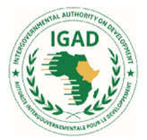

Kenya’s Progress on Resilience Building January 2014 to October 2023
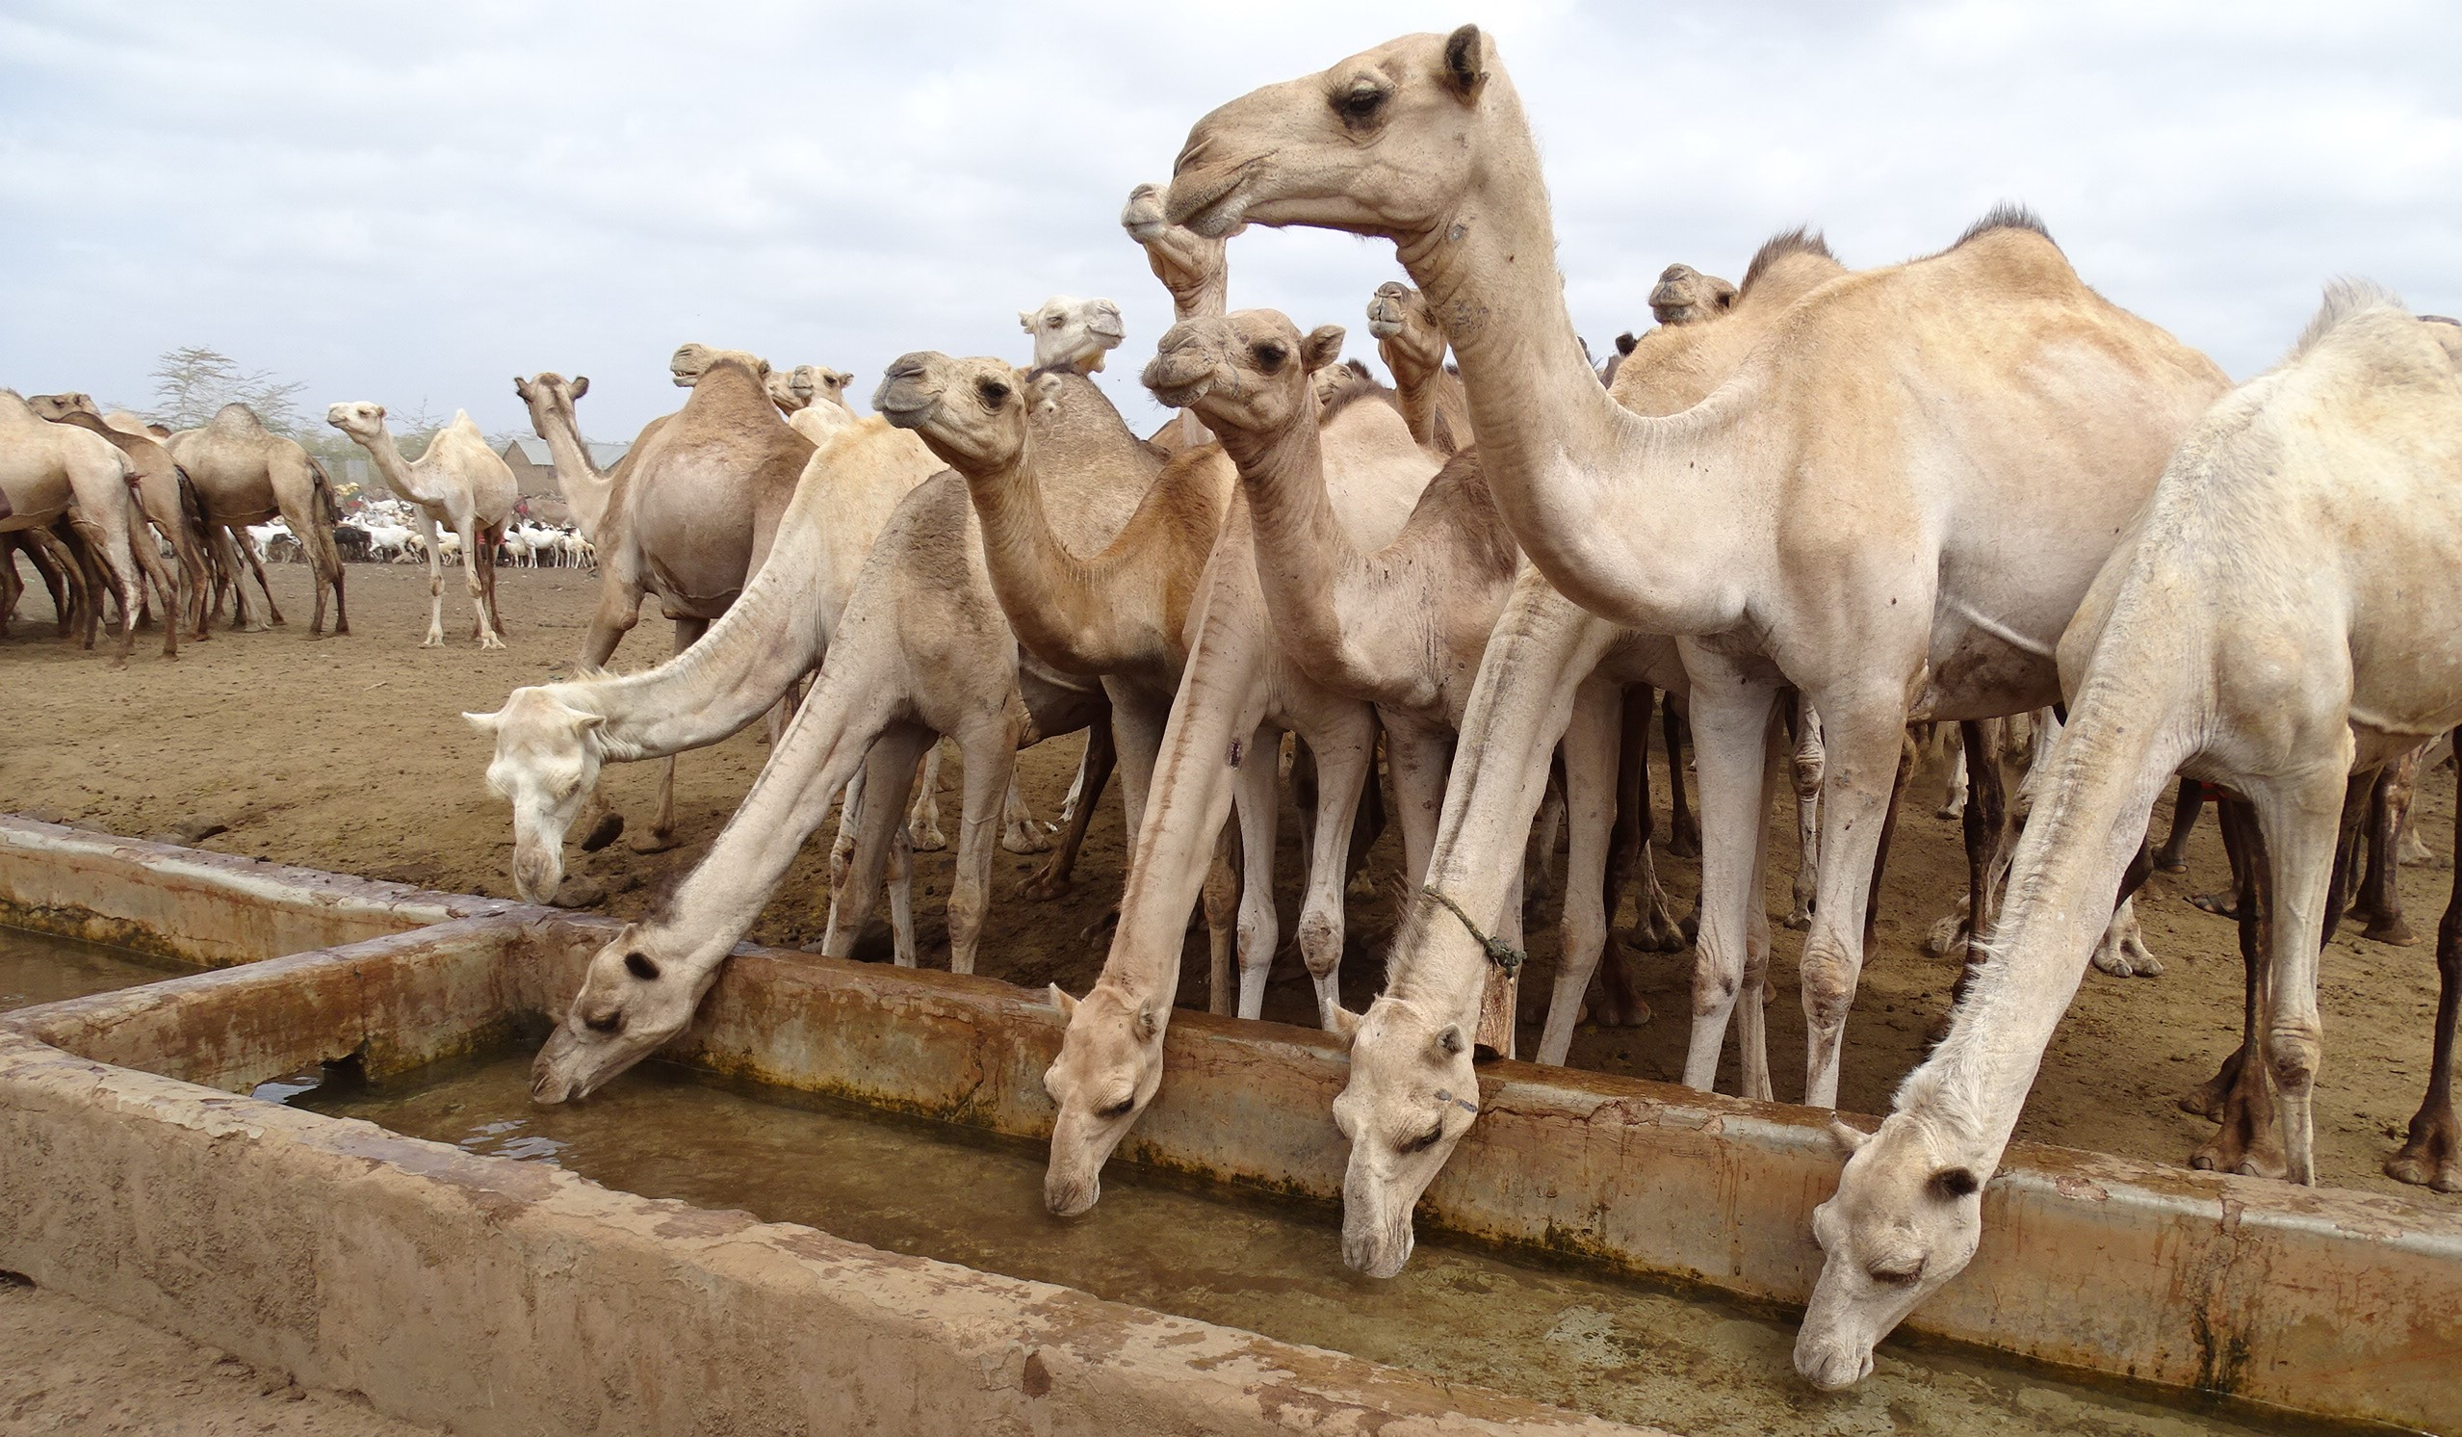
Tenth Anniversary of IDDRSI

Presented at the
16th IDDRSI Platform Steering Meeting Held on the 22-23 November 2023

Entebbe, Uganda
Kenya’s Progress on Resilience Building

January 2014 to October 2023

Tenth Anniversary of IDDRSI

Presented at the

16th IDDRSI Platform Steering Committee Meeting
22-23 November 2023

Entebbe, Uganda

TABLE OF CONTENTS

TABLE OF CONTENTS i
LIST OF ABBREVIATIONS AND ACRONYMS ii
LIST OF FIGURES iv
SUMMARY v
1. INTRODUCTION 1
2. FOOD AND NUTRITION SECURITY SITUATION 3
2.1 Drought and food security situation 3
2.2 Projected Food Security Situation 3
2.3 Impacts of improved drought situation 4
3. PROGRESS ON THE IMPLEMENTATION OF RECOMMENDATIONS OF 15TH PSC 6
4. PROGRESS TOWARDS RESILIENCE BUILDING 9
4.1 PIA 1: Peace and Security 10
4.1.1 Marking of state-owned firearms 10
4.1.2 County capacity on peace building and conflict management 10
4.1.3 Violent incidences involving illicit firearms 10
4.2 PIA 2: Climate Proofed Infrastructure 11
4.2.1 Accessing clean and safe water and sanitation services 11
4.2.2 Climate proofed road infrastructure 12
4.2.3 Irrigation and land reclamation 12
4.2.4 Access to electricity 13
4.2.5 E-learning 14
4.3 PIA 3: Human Capital 14
4.3.1 Access to education 14
4.3.2 Post basic education training 15
4.3.3 Mortality rate 16
4.4 PIA 4: Sustainable Livelihoods 17
4.4.1 Value of livestock and livestock products 17
4.4.2 Value of drought tolerant crops 18
4.5 PIA 5: Drought Risk Management 19
4.5.1 Social protection 19
4.5.2 Food security 19
4.6 PIA 6: Institutional Development and Knowledge Management 19
4.6.1 Institutional development 20
4.6.2 Knowledge management 20
4.6.3 Policy framework 20
4.6.4 Monitoring and evaluation 21
5 RESOURCE MOBILIZATION 22
5.1 Food Systems Resilience Project (FSRP) 22
5.2 Kenya Agricultural Business Development Programme (KABDP) 22
5.3 Resilience for Food & Nutrition Security Programme in the Horn Africa (BREFONS) 22
5.4 Dryland Climate Action for Community Drought Resilience (DCADR) 22
6 CONCLUSIONS AND RECOMMENDATIONS 23
6.1 Challenges 23
6.2 Lessons Learnt 23
6.3 Recommendations 23

LIST OF ABBREVIATIONS AND ACRONYMS

ASALs Arid and Semi-Arid Lands
CIDP County Integrated Development Plan
CPF Common Programme Framework
CPP Country Programming Paper
CSO Civil Society Organization
DRSLP Drought Resilience and Sustainable Livelihoods Programme
EDE Ending Drought Emergencies
EMMS Essential Medicines and Medical Supplies
EU European Union
FAO Food and Agriculture Organization of the United Nations
FCDC Frontier Counties Development Council
HINI High Impact Nutrition Interventions
HoA Horn of Africa
HSNP Hunger Safety Net Programme
ICT Information and Communications Technology
IDDRSI IGAD Drought Disaster Resilience and Sustainability Initiative
IGAD Intergovernmental Authority on Development
KEMSA Kenya Medical Supplies Authority
LAPSSET Lamu Port-South Sudan-Ethiopia-Transport
MTP Medium Term Plan
MTR Mid – Term Review
NACONEK National Council for Nomadic Education in Kenya
NDEF National Drought Emergency Fund
NDMA National Drought Management Authority
NOFBI National Optic Fibre Backbone Infrastructure
NoKET Northern Kenya Education Trust
PCF Partnership Coordination Framework
PIA Priority Investment Area
PPG Pastoralist Parliamentary Group
PSC Platform Steering Committee
SALWs Small Arms and Light Weapons
SIVAP Small Sale Irrigation Value Addition Project
TLU Tropical Livestock Unit
TTC Teachers Training College
UHC Universal Health Coverage
UNDP United Nations Development Programme
UNSCR United Nations Security Council Resolutions
WFP World Food Progamme

LIST OF FIGURES

Figure 1: EDE-CPF programme framework 1
Figure 2: Changes in the Food Security Situation between March and September 2023 3
Figure 3: Current and projected food insecurity phase classification 4
Figure 4: Progress towards the EDE goal 9
Figure 5: Marking of state firearms and violent incidences reported 11
Figure 6: Access to water and sanitation services 11
Figure 7: Kainuk-Lodwar highway in Turkana County before and after tarmacking 12
Figure 8: Hectares irrigated 12
Figure 9: Access to electricity 13
Figure 10: Access to education 14
Figure 11: University qualification and TVET enrolment 15
Figure 12: Mortality rate 15
Figure 13: Value of livestock sold in formal markets 16
Figure 14: Value of livestock products 17
Figure 15: Value of drought tolerant crops 17

SUMMARY

Drought frequency and intensity continue to worsen in Kenya with the latest episode (2020 – 2023) being the worst in over four decades having four consecutive failed seasons and a fifth season performing dismally. As a result, the number of people facing acute food insecurity reached 5.1 million in November 2022 and 2.5 million livestock died. To cope with such drought that are more evident in the future given the effects of climate change, the country has put in place systems to ensure resilience building and effective response.

Towards ending drought emergencies, the country’s achievements since 2016 are highlighted below per priority intervention area. To promote peace and security (PIA1), 98% of state-owned firearms had been marked as at 2021 to eliminate their illegal use. The capacity of counties on peace building and conflict management was strengthened by training 205 peace building trainers, The National Policy for Peacebuilding and Conflict Management was institutionalized whereas the UNSCR 1325 and article 55 of the Kenyan Constitution on the inclusion of women and youth in matters of peacebuilding were cascaded to county peace committees. An important outcome was that violent incidences involving illicit firearms reduced by 47% between 2016 and 2021.

Under the climate-proofed infrastructure (PIA2), the population accessing clean & safe water and sanitation services increased by 20% and 12% respectively between 2016 and 2023. As at 2021, the number of incidences of water borne diseases decreased by 13%. Road infrastructure improved with 1,228 km of tarmac constructed between 2016 and 2021 reducing significantly travel time by up to 71% in some counties. To enhance food security, hectares irrigated increased by 32% between 2016 and 2023.

For human capital (PIA3), primary school completion rate was at 82% in 2023 and transition from primary to secondary schools increased by 14%. In addition, the proportion of students qualifying to join University increased by 21%. Available health data shows that mortality rate of children under the age of five years reduced by 12% between 2016 and 2021 whereas that of infants declined by 4% in the same period. Unfortunately, neonatal mortality increased by 64% requiring corrective interventions.

Sustainable livelihoods PIA4) recorded an improvement in the value of livestock sold in formal market in the ranging from 7% (Kshs. 79 billion for cattle in 2023) to 42% (Kshs. 0.51 billion in 2023) for fish. The value of livestock products sold in formal markets also increased ranging from 24% (Kshs. for 20 billion in 2023) to 30% (Kshs. 32 billion in 2023) for eggs. Similar increase in value was observed in the value of drought tolerant crops traded.

Under the Drought risk management (PIA5), the Hunger Safety Net Programme was expanded to cover eight counties from four pioneer ones. Consequently, the number of beneficiaries increased from 84,206 households in 2016 to 118,803 in 2023, a 41% growth. Food security deteriorated owing to the protracted 2020-2023 drought situation with 9.2% of the population requiring humanitarian assistance in 2022, a proportion reduced to 5.3% in 2023.

Under the 6th PIA (institutional development and knowledge management), seven ASAL institutions were operationalized. Of importance is National Drought Emergency Fund (NDEF) that is meant to ringfence Kshs. 2 billion annually for resilience building and response. Since operationalization in 2021, NDEF has received Kshs. 863 million from the exchequer. To enhance information sharing, a drought risk management knowledge management system has been developed.

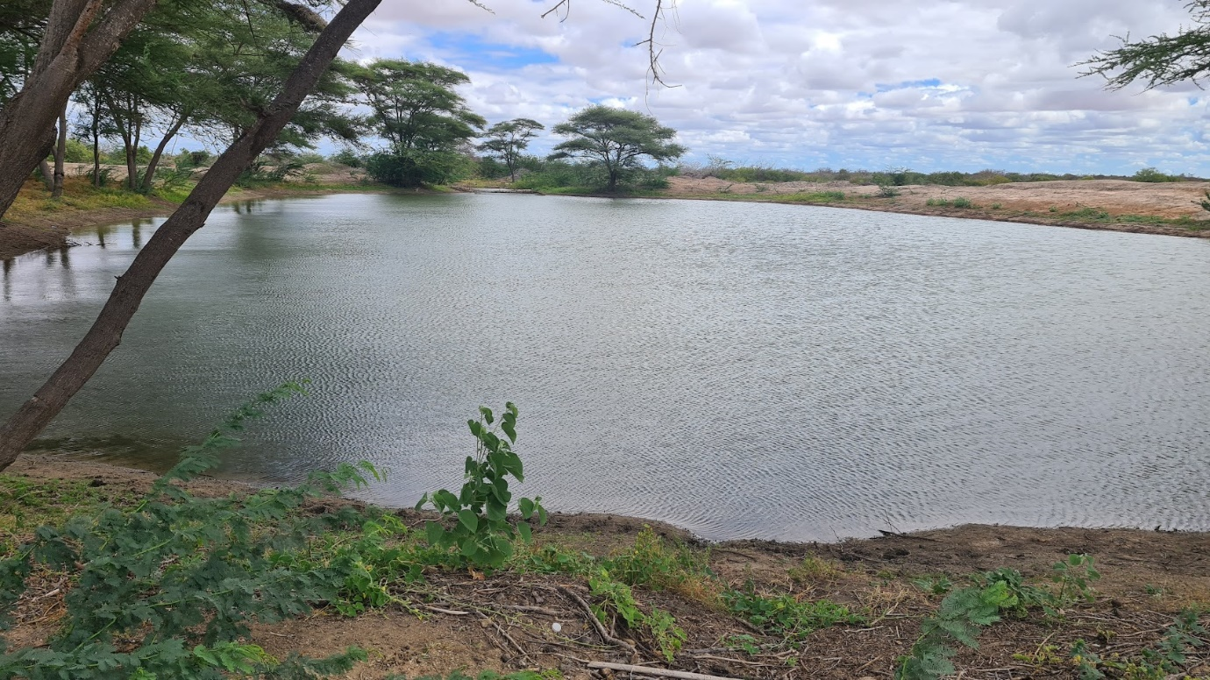
A sustainably managed water pan in Tana River County (Photo source: NDMA).

INTRODUCTION

Droughts are a common phenomenon in Kenya and with climate change, their frequency has increased and impact on livelihoods worsened. Since Kenya’s independence, drought incidences have more than doubled calling for elaborate efforts to contain their negative effects. The 2010/2011 drought crisis in the Horn of Africa [HoA] was the turning point in drought management because it was one of the worst droughts, affecting 13 million people. Thus, governments and partners committed to invest in resilience building by addressing the constraints resulting in growing vulnerability among the ASAL communities and improve their response during drought. Recommendations by a paper presented during the 2011 IGAD Summit of Heads of State and Government culminated into the birth of the Ending Drought Emergencies (EDE) in Kenya. The spirit of the EDE initiative is that, while drought is an unavoidable natural phenomenon, its impact can be mitigated. Therefore, droughts need not, and should not, lead to famine and other disasters. The spirit of the EDE initiative is reinforced by the fact that, droughts set in slowly and can be precisely predicted.

Building on relevant existing policies and laws in Kenya including the Constitution of Kenya 2010, the Kenya Vision 2030, Development Strategy for Northern Kenya and other Arid Lands, and Sessional Paper No. 8 of 2012, on the National Policy for Development of Northern Kenya and Other Arid Lands, a series of consultations between the Government of Kenya and Development Partners led to the development of the Common Programme Framework [CPF] for Ending Drought Emergencies that was launched in 2015. The framework guided EDE interventions and had three areas of emphasis: eliminate the conditions that perpetuate vulnerability, enhance the productive potential of the ASALs, and strengthen institutional capacity for effective risk management.
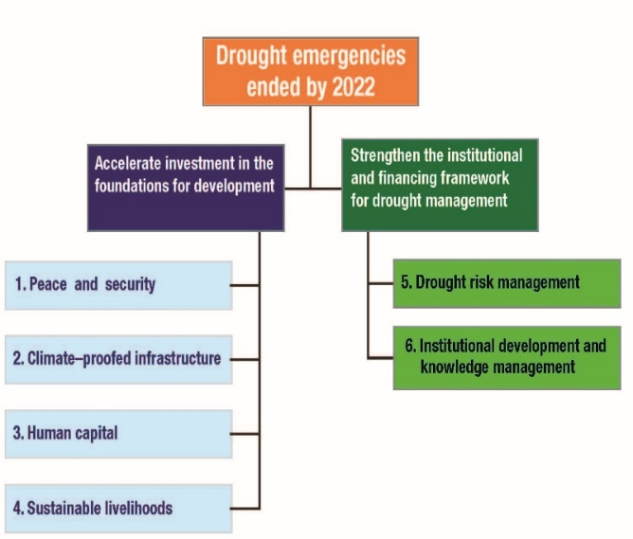
The EDE had two priority areas and six pillars (Figure 1) with an aim of accelerating investments in the foundations for development and strengthen institutional capacities for drought risk management (DRM). The CPF set out priorities for each of the six pillars.

The EDE initiative has been implemented in 23 Arid and Semi-Arid (ASAL) counties of Kenya since 2013, with the objective of putting in place mechanisms and frameworks to effectively manage drought risks so as to avoid the cycle of losses to life and property occasioned by emergencies linked to droughts. The initiative is part of the IGAD Drought Disaster Resilience and Sustainability Initiative (IDDRSI) implemented by Member States of the Intergovernmental Authority on Development (IGAD). Its implementation in Kenya is coordinated by the National Drought Management Authority (NDMA).
Figure 1: EDE-CPF programme framework

The EDE initiative contributes to regional and global initiatives that aim to end drought emergencies as well. At the regional level, IGAD coordinates implementation of the IDDRSI strategy. At the global level, EDE Kenya chapter contributes to the Sendai Framework (2015 – 2030) that advocates for managing of disaster risks as opposed to managing disasters themselves. Moreover, EDE contributes directly to 10 Sustainable Development Goals [SDGs], SDGs 1-8, 16 and 17.

EDE focuses on “eliminating the conditions that perpetuate vulnerability, enhancing the productive potential of the region, and strengthening institutional capacity for effective risk management”.

The EDE has been implemented in Kenya through 5-year Development Plans, namely the Medium-Term Plan (MTP) II for the Vision 2030 that covered the period 2013-2017 and the MTP III that covered the period 2018 – 2022. We highlight in this report some of the achievements made in implementation of the EDE-CPF towards the country’s goal of resilience building and ending drought emergencies.

FOOD AND NUTRITION SECURITY SITUATION

2.1 Drought and food security situation
The food security situation has improved across the ASAL counties over the past six months with the population facing acute food insecurity and consequently requiring humanitarian assistance reducing from 4.9 million in February, 2023 to the 2.8 million in August 2023. The improvement is largely attributed to the good performance of the March-April-May 2023 rain season.

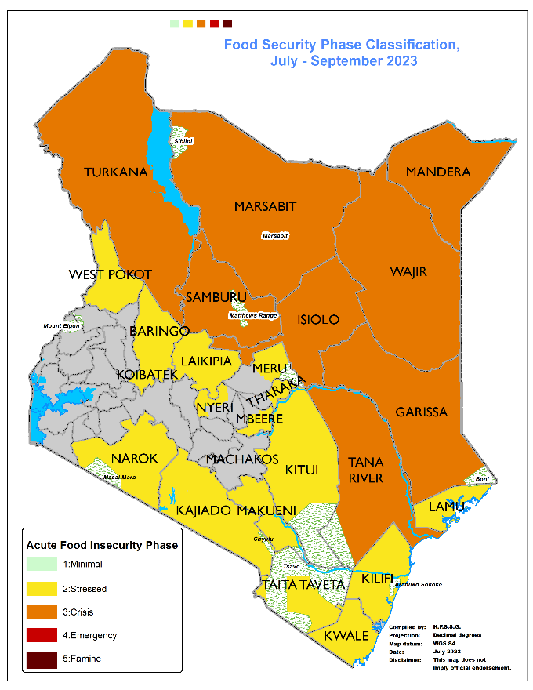
March 2023 September 2023

Figure 2: Changes in the Food Security Situation between March and September 2023

2.2 Projected Food Security Situation
The current forecast of the October – December 2023 rainfall season predicts over 90% likelihood of an El-Nino. Thus, food security is expected to improve even further from the March to May 2023 season that performed relatively well. During the period October 2023 to January 2024, the number of people in need of humanitarian assistance is projected to reduce to about 1.6 million.

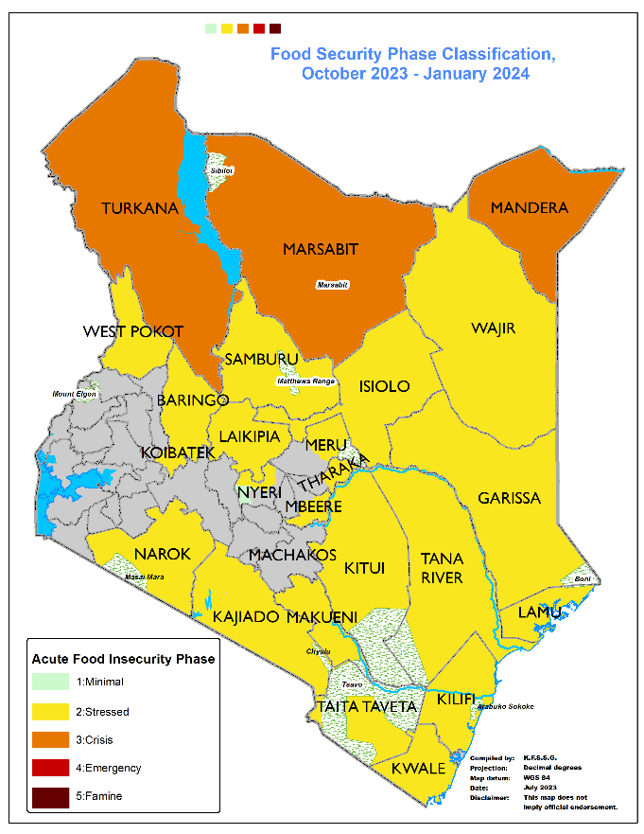
Figure 3: Current and projected food insecurity phase classification

2.3 Impacts of improved drought situation
Food Security: The number of people facing acute food insecurity has dropped from 4.9 million in February 2023 to 2.8 million people in August 2023, a number projected to drop further to 1.6 million by January 2024 given the October – December 2023 favorable rainfall season.

Health and Nutrition: Integrated Phase Classification for Acute Malnutrition (IPC AMN) analysis conducted in July 2023 showed that malnutrition situation had improved in most arid counties compared to the same period the previous year. The number of children aged 6-59 months requiring treatment for acute malnutrition had decreased from 970,214 in February 2023 to 945,610 in July 2023. In addition, 144,940 pregnant and lactating women required treatment from acute malnutrition, an increase from 142,179 recorded in February 2023, showing a lag time before improvement is realized. The improvement in nutrition situation is mainly attributed to scale up of interventions to address malnutrition outcomes and improved food security including milk availability and food stocks resulting from the good performance of the long rains (March – May 2023) in several counties.

Livestock: Livestock productivity improved driven by availability of forage and water. The condition of pasture and browse was generally fair to good resulting in fair to good livestock body condition in most parts.

Agriculture: Production of major crops registered an improvement from the previous seasons driven by above average rains and availability of subsidized fertilizer, a government initiative to boost food production. The total acreage planted was within long term average (LTA) for beans but 11-12% above the LTA for other crops such as maize and green grams.

Water: Recharge of open water sources for domestic use was 70-100% of their capacities with 65-80 percent of the open water sources holding adequate water volumes. Parts of the South Eastern Counties as well as the lowlands of Taita Taveta experienced a recharge of 40-70%.

Human-wildlife conflict: Stray elephants destroyed over 300 hectares of sorghum in Tigania West in Meru County and over 1,000 hectares of farmland were destroyed in Kitui and in Kibwezi East in Makueni County. In Makueni County, one human fatality occurred because of human-wildlife conflict in Kibwezi East sub-county. In Kitui County, approximately 54 heads of sheep and goats were lost to hyenas and leopards.

Flooding: A summary of the key data (cumulative from 01st October 2023) as at 19th November 2023 shows that, 27,205 households had been displaced, 9 people were injured and another 61 people lost their lives, whereas 982 goats and 208 sheep were reported dead. Thousands of hectares of farmland was submerged and infrastructure, more so roads and water facilities damaged.

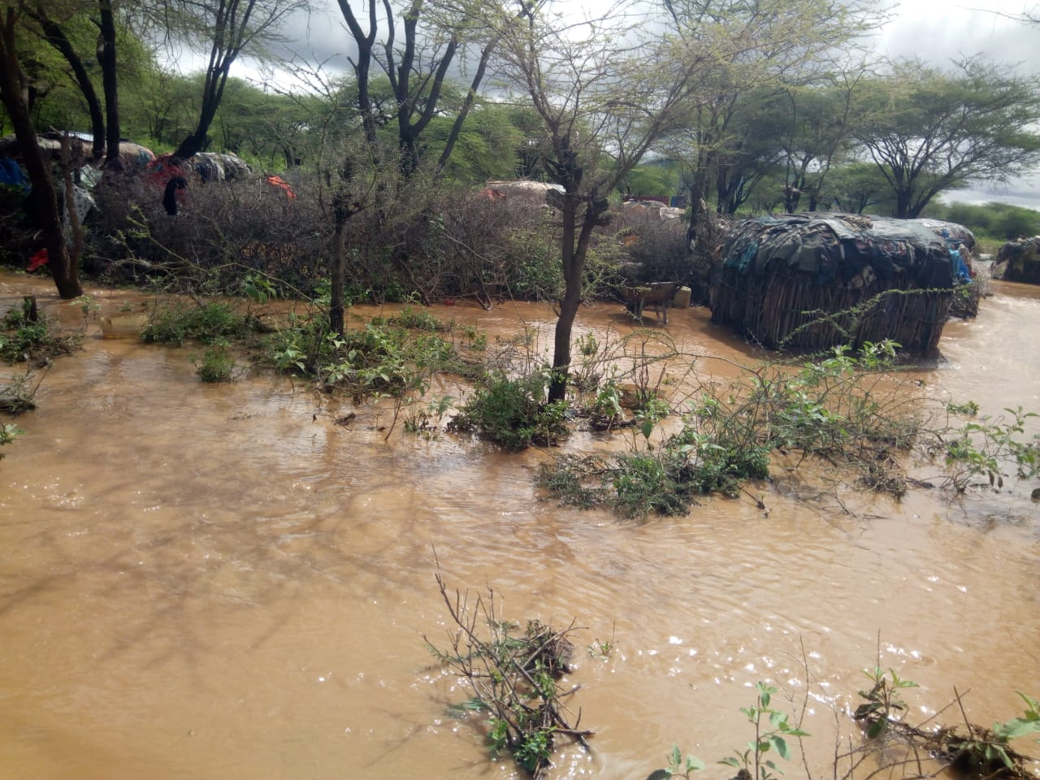
Floods in Samburu County (Photo Source: NDMA).

PROGRESS ON THE IMPLEMENTATION OF RECOMMENDATIONS OF 15TH PSC

The 15th PSC meeting was held in Khartoum, Sudan on 30th November – 1st December 2022. The following is the progress that Kenya has made towards implementation of the recommendations of the 15th PSC.

15th PSC Recommendation | Kenya’s Achievement
15.2 Calls upon Member States, IGAD and Development Partners to mobilize resources in a sustainable manner to enhance cross-border interaction and cooperation that addresses vaccination of livestock, pests and diseases control, conflict prevention and resolution through supporting local peace and development. | - Kenya is undertaking review of its peacebuilding architecture with the aim of ensuring sustainable conflict prevention and resolution.  - Presence of security personnel and security operations have been increased in areas prone to banditry attacks.  - National and Community Peace Structures are continuously being strengthened as well as Advancing Non-Violent Conflict Resolution Mechanisms. This includes prioritizing interventions that will contribute to addressing the drivers of conflict and insecurity.
15.3 Urges the Member States to step up their coordination efforts to cover projects implemented by various ministries and agencies to represent the status of resilience at the country level.  Further urges the Member States to set up relevant stakeholder coordination mechanisms for proper planning, implementation, monitoring, evaluation and learning of resilience projects to improve resilience programming for optimum prioritization and synergy. | - Kenya has commenced formulation of phase II of the EDE initiative that will cover the period 2023-2032.  - Based on lessons learnt during implementation of EDE I, priority is given to reviewing the coordination structures to ensure challenges of coordination are addressed and that there is synergy and harmonized implementation of resilience building and response interventions across sectors and stakeholders.
15.5 Calls upon all stakeholders to intensify investment in water development to ensure that communities in the ASALs have sustainable access to safe water through bringing “water to the people” approach that would also address their water needs for for livestock, crop and fruit production. | - Water is one of the enablers for the Kenya Government’s Bottom-Up Economic Transformation Agenda (BETA). In this respect, emphasis is being laid on investment in water infrastructure. A number of large water projects are on the pipeline for implementation during 2023-2027 in various counties.  - The National Government in collaboration with partners is currently implementing 85 water projects and 12 sewerage plants aimed at increasing accessibility to clean and safe water and sanitation services in the ASAL counties. This is in addition to projects being implemented by County Governments.
15.6 Urge Member States and Development Partners to improve the infrastructure (roads, markets, energy, health, education and ICT) to create a conducive environment for the ASALs. | - Infrastructure development remains a key priority of the Government as it is the foundation for achievement of the overall Bottom-Up Economic Transformation Agenda.  - A number of infrastructure projects are prioritized in the 4th Medium term Plan for the Vision 2030 to be implemented during 2023-2027. This includes scale up of water harvesting in which one large dam will be constructed in each county with the aim of increasing access to water for domestic use, livestock production and irrigation.  - The government plans to set up 25,000 free public Wi-Fi hotspots in markets across the country to facilitate e-commerce.
15.7 Calls on Member States, Partners and the private sector to enhance investment in safeguarding livelihoods and prevent hazards from turning into humanitarian crises. | - At the peak of the drought, up to 4.9 million people were affected and required humanitarian assistance. To mitigate effects of this drought, the Kenya Government, with support of development partners and the private sector spent over KShs 82 billion in drought response interventions during the 2021-23 drought.  - Learning from the drought that was the worst in four decades, emphasis are being placed on resilience building. The ten-year phase II of the EDE is expected to address challenges faced during phase I and accelerate achievement of the goal of ensuring that drought does not turn into humanitarian crises.
15.8 All stakeholders are urged to give livelihood adaptation and the building of resilient food systems that would reduce poverty, food insecurity, displacement, and ultimately, conflict over natural resources through increased budgetary allocation for investment in resilience. | - Kenya continues to give priority to resilience building and adaptation to climate change. The ongoing review of the EDE is expected to focus on accelerated investment in these priority areas, with focus on high impact interventions.  - Kenya continues to mobilize resources for drought resilience and climate change adaptation. Among the newly launched projects are: Resilience for Food & Nutrition Security Program in the Horn Africa (BREFONs); Food Systems Resilience Project; Dryland Climate Action for Community Drought Resilience (DCADR); and Towards Ending Drought Emergencies – Ecosystem Based Management (TWENDE).
15.9 Member States and Development Partners to commit to developing and promoting transformative gender-responsive national and regional livelihoods and food security programmes. | - Affirmative action to ensure women, youth and people living with disabilities have access to procurement of goods and services is enforced through performance contracting on public entities.
15.10 Member States and partners are urged to continue investing in Post-Harvest Loss Management and associated capacity development to the Member State institutions. Further urges the Member States to domesticate the regional post-harvest loss and management strategy. | - The Government has purchased 100 grain dryers at a total cost of Kshs. 2 billion to be used by farmers across the country to mitigate against post-harvest losses which usually claim about 30% of the produce harvested.
15.11 Member States to remove barriers and strengthen trade between member states to facilitate the movement of foodstuff from food surplus to deficit regions. | - Kenya has active multiple free trade agreements at different levels, demonstrating its commitment to international trade.  - As a member of the World Trade Organization (WTO), African Continental Free Trade Area (AfCFTA), Common Market for Eastern and Southern Africa (COMESA), Tripartite Free Trade Area, and East African Community (EAC) Customs Union, Kenya engages in both bilateral and regional trade agreements.  - Additionally, Kenya is currently in discussions for the Kenya-USA Strategic Trade and Investments Partnership and the KE-EU-EPA (Economic Partnership Agreement). Moreover, Kenya benefits from the African Growth and Opportunity Act (AGOA) framework, which enables it to access the United States of America market.
15.12 Member States are urged to bolster the roles of research and extension systems in promoting resilient agriculture to bridge the current gaps in pastoral and agro-pastoral production systems. | - Kenya prioritizes research and extension systems. In this respect, Kenya Agricultural Livestock and Research Organization (KALRO) is funded to deliver its mandate.
15.13 Member States, and Development partners to take further action, including investment to strengthen early warning systems, contingency plans, and capacity building training. | - The drought early warning system was enhanced by making it responsive through development of early warning triggers across 23 ASAL counties. Additional indicators for remote sensing were incorporated into the system including forage condition index (FCI), pictorial evaluation tool (PET) and the digitizing the system.  - Livelihood zones were profiled and drought updates generated and disseminated monthly to stakeholders for early action. The system is being used for decision making nationally and also regionally.  - Drought early warning system recently won recognition under WFP’s South-South Innovation Challenge as being completely digital compared to others in the Global South.

PROGRESS TOWARDS RESILIENCE BUILDING

Kenya has been implementing the drought resilience building initiatives since 2013, with improved progress tracking starting in 2015 following the formulation and launch of the Common Programme Framework for Ending Drought Emergencies (EDE CPF). This section provides a progress brief made towards ending drought emergencies based on outcome level indicators.

Kenya tracked four high level indicators for determining the progress towards ending drought emergencies namely: Number of people requiring food assistance as a result of drought emergencies; Number of human deaths attributed to drought per 100,000 population; Proportion of livestock population lost (dying) as a result of drought; and Kenya manages drought without resorting to emergency appeals. The 2010/11 drought which occurred before the EDE CPF was less severe compared to the 2015/16 and 2020-23 droughts. However, loss of livelihoods, more so livestock was significantly higher, with some counties losing up to 70% of their livestock compared to a maximum of 30% loss recorded in some counties during the 2015/16 and 40% in worst affected counties in the 2020/23 drought. The 2020-23 drought was the worst in four decades, with five rainfall seasons failing consecutively, and coupled with other calamities such as Covid-19 and desert locust invasion. Furthermore, no human deaths were recorded as a result of the drought episodes.

Undesirably, the number of households requiring food assistance increased owing to the unprecedented severity of 2020-23 drought coupled with the other calamities mentioned above that eroded resilience that had been built over time. The economic gains from livestock were also equally affected by the 2020-2023 drought (Figure 4).

Figure 4: Progress towards the EDE goal

The above achievements notwithstanding, it was clear that the country was still far from achieving its drought resilience agenda and putting an end to drought emergencies, as the Head of State declared drought as a national disaster in September 2021. Kenya’s 10 year progress ending drought emergencies is as follows.

4.1 PIA 1: Peace and Security
The overall outcome of PIA 1 is to ensure effective response to peace and security threats through enhanced peace infrastructure to respond to conflicts and mainstreaming peacebuilding and community security in long term development initiatives. The priority area also provides early warning to Government agencies to ensure early action. The indicators tracked were; 1) number of illicit small arms recovered/surrendered; 2) percentage of state-owned firearms marked; and 3) the number of violent incidences involving illicit arms reported. Available data for PIA 1, was up to September 2023.

4.1.1 Marking of state-owned firearms
The Government planned to mark 100% of its firearms by 2023 to ensure that they are not used illegally. As of 2022, 98% of government firearms had been marked (data for 2022 and 2023 was not available). In 2023, the government acquired more arms reducing the proportion of the marked arms to 97%. Marking of the firearms was coupled with complementary interventions including recovery of illicit small firearms where between 2016 and 2023, a total of 20,108 illicit firearms were recovered. In addition, the 23 ASAL counties where NDMA operated had operational peace committees and had mainstreamed peace building in their County Integrated Development Plans (CIDPs).

4.1.2 County capacity on peace building and conflict management
To enhance the capacity of counties to mediate peace, capacity of 205 trainers was built between 2016 and 2023. The National Policy for Peacebuilding and Conflict Management was approved by the Parliament in 2019. During the reporting period, the UNSCR 1325 and article 55 of the Kenyan Constitution on the inclusion of women and youth in matters of peacebuilding were cascaded to local peace committees. A total of 21 peace dividend investments including abattoirs, haystacks, boreholes, market infrastructure and water points were implemented in insecurity hotspots. Sharing of such investments is expected to reduce animosity between beneficiary communities.

4.1.3 Violent incidences involving illicit firearms
Owing to the various investments explained in sub-sections 4.1.1 and 4.1.2, the number of violent incidences involving illicit arms reported reduced by 47% between 2016 and 2021 (Figure 5). The general observation is that as more state firearms are marked, lesser violent incidences involving illicit firearms are reported pointing to a possible misuse of state firearms that are not marked. In 2019, violent incidences were at lowest owing to the Covid-19 containment measures especially lockdowns. However, the number of violent incidences and deaths from violent incidences increased between 2021 and 2022 owing to worsening drought situation resulting in resource-based conflicts, coupled with high political unrest during the electioneering year (2022); and cross border conflicts with communities from Ethiopian.

Figure 5: Marking of state firearms and violent incidences reported

4.2 PIA 2: Climate Proofed Infrastructure
The overall outcome of PIA 2 is to ensure that deficit of climate-proofed infrastructure and its maintenance is identified, planned and progressively addressed in a coordinated and comprehensive manner at all levels. The following are the selected indicators of PIA 2 given availability of data: 1) increased access to clean and safe water; 2) Number of kilometres of climate-proofed road infrastructure constructed; 3) number of hectares of land irrigated; 4) increased access to electricity; and 5) enhanced e-learning.

4.2.1 Accessing clean and safe water and sanitation services
The population accessing clean and safe water increased from 58% in 2016 to 78% in 2023 (Figure 6). Similarly, the proportion of the population accessing sanitation services increased from 66% in 2016 to 78% in 2023 (Figure 6). As at 2021, the water borne diseases incidences had decreased by 13% from 53,000 in 2016, to 45,874, due to increased Government and partner investment in water access and sanitation services as part of containing the spread of COVID-19 pandemic.

Figure 6: Access to water and sanitation services

4.2.2 Climate proofed road infrastructure
Road infrastructure is important in linking the ASAL counties to the rest of the country and across borders for development and service delivery. Between 2016 and 2023, 1,777 km of climate-proofed roads were constructed, with remarkable impact in reducing travel time. For example, before the Kainuk-Lodwar highway was constructed (Figure 7), it took 7 hours to travel from Kainuk to Lodwar but it now takes 2 hours (71% reduction in travel time) with the highway complete.

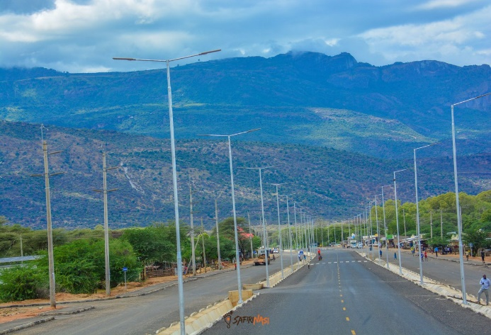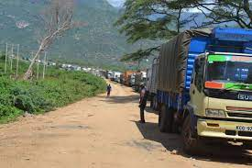
Figure 7: Kainuk-Lodwar highway in Turkana County before and after tarmacking

4.2.3 Irrigation and land reclamation
To sustain food security, two indicators were earmarked for tracking; the number of number of hectares irrigated; and number of hectares reclaimed for food and pasture production. As at the year 2023, a total of 277,600 hectares were being irrigated, a 32% increase from the 209,601 hectares irrigated in 2016, although the trend was inconsistent (Figure 8). A total of 114,262 hectares had been reclaimed by 2023.

Figure 8: Hectares irrigated

4.2.4 Access to electricity
Available data was up to 2021 and shows that, access to electricity is an enabler of development as business mushroom with the connection to the grid. Various interventions were implemented with the target of connecting electricity to 250,000 households in 14 counties (West Pokot, Turkana, Marsabit, Samburu, Isiolo, Mandera, Wajir, Garissa, Tana River, Lamu, Kilifi, Kwale, Taita Taveta and Narok) between 2017 and 2022. By 2021, 142,303 households were connected to electricity (57% performance against target). The planned target was not achieved due to unavailability of funds and slow implementation of investments owing to Covid-19 containment measures. A total of 120 mini grids were planned to be constructed throughout the 14 Counties but the investment did not take off due to the protracted procedures of acquiring land.

Access to electricity had mixed results (Figure 9). On the one hand, the duration of power outages (SAIDI) per customer per year reduced by 63% to 60 hours in 2018 but increased thereafter by 98% to 119 hours in 2021, an undesired trend. On the other hand, the number of outages (SAIFI) per customer per year more than doubled between 2016 and 2021, requiring corrective interventions (Figure 9).

Figure 9: Access to electricity

4.2.5 E-learning
To enhance e-learning, the Government trained 91,100 teachers and deployed 1,012,555 solar powered laptops in various primary schools. Data on the number of children accessing the laptops was not available at the time of this report.

4.3 PIA 3: Human Capital
The overall outcome of the Human Capital PIA is a healthy, skilled, innovative, resourceful and motivated human capital in the ASALs through: 1) increased capacity and number of appropriately trained and experienced professionals working in ASAL counties; 2) integrated alternative interventions, including emerging technologies, in the provision of health, nutrition, Water, Sanitation and Hygiene (WASH) and education services into government systems at national and county levels; and 3) increased demand for equitable and quality health, nutrition, WASH and education services through community education and empowerment. The following achievements were realized during the reporting period.

Education

4.3.1 Access to education
The education sector pursued two outcomes, to improve access to education and improved quality of education; and both indicators performed well. Transition from primary to secondary schools increased from 81% in 2016 to 95% in 2023. Primary school completion rate was at 82% (Figure 10).

Figure 10: Access to education

One of the government investments that improved access to basic education in the feeding programme implemented in all arid counties as well as in Kenya’s pockets of poverty.

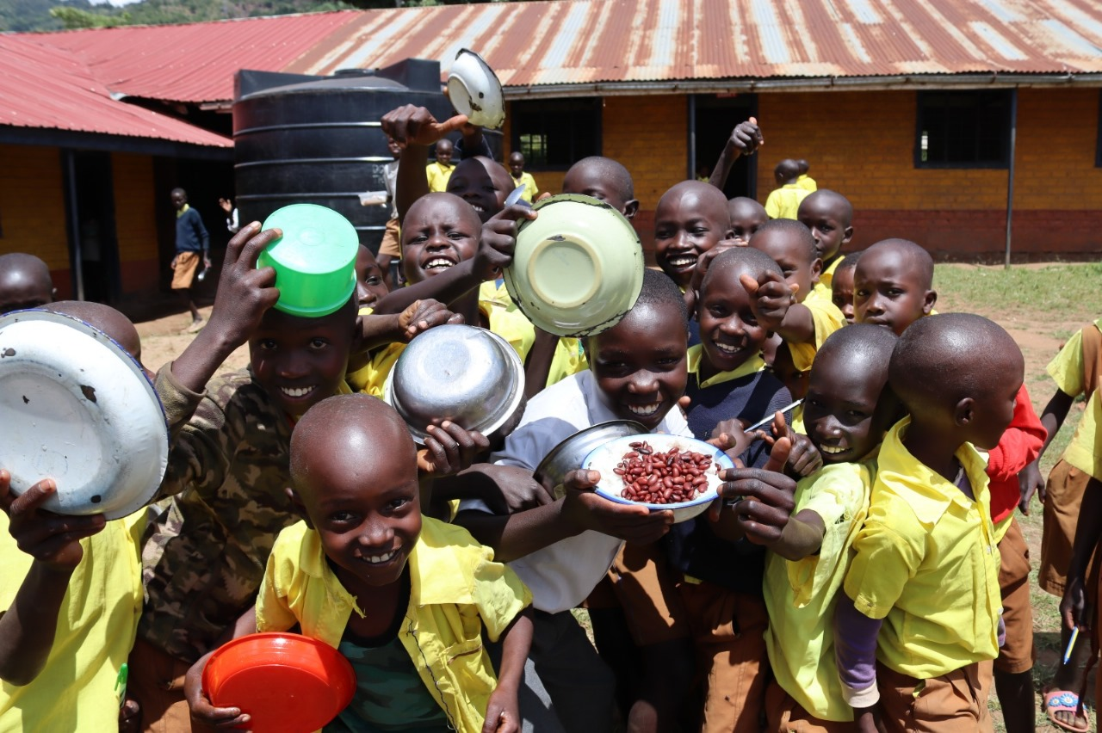
Provision of school meals is progress made by the government of Kenya to mitigate effects of drought and severe hunger that impact negatively on enrolment and retention of learners in school in ASALs counties. Currently the programme is benefiting all the leaners in Arid counties, pocket of poverty and urban informal settlements formerly municipalities and cities in Kenya.

4.3.2 Post basic education training
The proportion of students qualifying to join University increased by 21% while the number of students enrolling in Technical and Vocational Education and Training (TVET) grew from 430,598 in 2019 to 484,567 in 2023, indicating future increase in professionals in the ASALs (Figure 11).

Figure 11: University qualification and TVET enrolment

Health

4.3.3 Mortality rate
Between 2016 and 2023, neonatal mortality reduced by 7%, infant mortality reduced by 8% whereas mortality of children under the age of five years reduced by 18% (Figure 12). Maternal mortality reduced marginally by only 2% during the same period.

Figure 12: Mortality rate

4.4 PIA 4: Sustainable Livelihoods
The objective of the Sustainable Livelihoods priority area is to enhance resilience of ASAL livelihoods to the effects of drought and climate change, with its focus being to promote secure and sustainable livelihoods that help families spread risk and prevent asset loss. Livestock is of particular emphasis given its importance in drought-prone areas and the substantial losses experienced by the livestock sector during drought emergencies. The expected outcomes are 1) increased income from livestock and livestock products, and 2) improved management of water, crops and rangeland resources.

4.4.1 Value of livestock and livestock products
The value of livestock sold in formal markets increased marginally between 2016 and 2023 (Figure 13). The value of cattle sold increased by 7% to Kshs 79 billion; value of goats and sheep sold increased by 16% to Kshs 20 billion; value of camels sold increased by 5% to Kshs 2.2 billion; value of fish sold increased by 42% to Kshs 0.51 billion; and the value of chicken sold increased by 8% to Kshs 5.2 billion. The growth was not consistent over time with the peak being 2021.

Figure 13: Value of livestock sold in formal markets

The value of livestock products sold increased other than beef and honey (Figure 14). However, the trend followed a modest incline requiring strategies to accelerate trade. Comparing the baseline (2016) with 2023, the value of goat and sheep meat sold increased by 24% to Kshs. 20 billion; value of eggs sold increased by 30% to Kshs. 32.4 billion; whereas the value of hides and skins increased by 78% to Kshs. 980 million and 114% to Kshs. 410 million respectively.

Figure 14: Value of livestock products

4.4.2 Value of drought tolerant crops
The value of drought tolerant crops increased for sorghum, millet and cassava but reduced for green grams (Figure 15). Peak values were recorded in 2021, probably signaling recovery from the Covid-19 pandemic. A major limitation is that the crops were traded unprocessed. Their value can be enhanced if processed e.g., Cassava to flour and starch.

Figure 15: Value of drought tolerant crops

4.5 PIA 5: Drought Risk Management
The outcome of the drought risk management priority area is to have institutions, mechanisms and capacities that build resilience to drought and climate change developed and strengthened. The specific results are to; 1) enhance early response; 2) reduce vulnerability to drought and climate shocks in ASALs; 3) enhance community capacities to plan and mobilize resource for DRM. The number of days in response activation lead time after early warning system declaration of drought "Alert" phase reduced by 47% to less than 24 days in 2023. Strategies to reduce the lead time further include providing real time drought early warning information and having basket funds for early action.

4.5.1 Social protection
In reducing vulnerability to drought risk and climate change, the Hunger Safety Net Programme was expanded from the initial four counties (Turkana, Marsabit, Wajir and Mandera) to include four additional counties (Isiolo, Garissa, Samburu and Tana River). The number of beneficiaries also increased from 84,206 households in 2016 to 118,803 in 2023, a 41% increment.

4.5.2 Food security
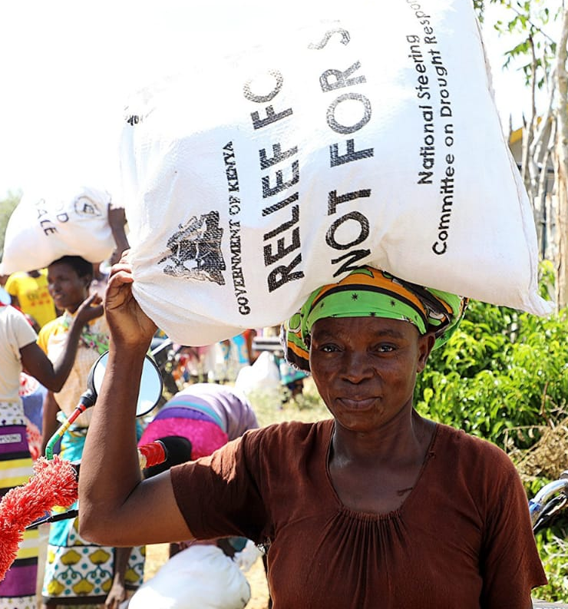
The average proportion of the population in need of food assistance 9.2% in 2022 given the 2022-2023 drought and reduced to 5.3% in 2023 (Figure 4). In response to the drought, vulnerable communities were supported with assorted food items (Figure 16). To improve preparation in responding to drought, communities in the 23 ASAL counties where NDMA operates were supported to develop drought contingency plans as well as action plans in 115 wards, a 150% growth from the 46 contingency and action plans available in 2016. Provision of drought information continued; county and national drought early warning bulletins were produced and disseminated monthly whereas food security assessments were conducted bi-annually; for the short and long rains.

Figure 16: Food provided to affected households

4.6 PIA 6: Institutional Development and Knowledge Management
PIA 6 ensures robust ASAL institutions exist and support EDE investments, policy and decisions. The PIA sustains synergy among the other 5 PIAs of the EDE in addition to tracking and reporting implementation progress and evaluating performance towards ending drought emergencies. Planned results were to: 1) establish and/or strengthen priority ASAL development institutions; 2) operationalize management and accountability structures for the EDE initiatives; 3) secure evidence-based policy and legal reforms that facilitate achievement of the EDE goal; 4) mainstream EDE priorities within the Kenya Vision 2030 Medium Term Plan III; 5) promote evidence-based investment choices; 6) assess the impact of Kenya’s progress towards the EDE goal; and 7) increase public and stakeholder awareness of the EDE and build wider understanding of the conditions necessary to achieve drought resilience in Kenya. The following results were achieved during the reporting period.

4.6.1 Institutional development
Seven institutions, National Drought Management Authority (NDMA); National Council for Nomadic Education in Kenya (NACONEK); National Drought Emergency Fund (NDEF); ASAL Stakeholder Forum (ASF); Frontier Counties Development Council (FCDC); Northern Kenya Education Trust (NoKET); and Pastoralist Parliamentary Group (PPG), were operationalized. The NDEF is of specific importance because it ringfence resources for resilience building and response. It was operationalized through the Public Finance Management (National Drought Emergency Fund) Regulations 2021 and the NDEF Guidelines 2022 as a common basket of resources for drought resilience, response and recovery. Since operationalization, the National Treasury has allocated NDEF Kshs. 863 million, 50% of which was earmarked for resilience building, 40% for response and 5% for recovery activities.

4.6.2 Knowledge management
To enhance coordination, an integrated knowledge management system (IKMS) was developed. The system enables stakeholders to access reliable drought and food security information for decision making. The system hosts EDE and related investments to guide prioritization future programming. Stakeholders’ capacity on its utilization will be strengthened.

4.6.3 Policy framework
Resilience building requires a robust policy environment. To guide investments in the ASALs, 14 policies were instituted.
- Partnership Coordination Framework (PCF) – 95% complete awaiting signature.
- Public Finance Management (National Drought Emergency Fund) Regulations 2021.
- Resilience Programming Framework (RPF) – 80% complete awaiting validation and signing.
- Water Act No.43 of 2016.
- The Irrigation Act 2019 under which the National Irrigation Authority (NIA) was established.
- The National Water Policy being the Sessional Paper No. 1 of 2021 was reviewed and finalized in 2021.
- The National Irrigation Services Strategy (NISS) 2021-2025 was been finalized.
- The Irrigation Guidelines 2020 were finalized and published.
- Water and Sanitation Strategy.
- Water Resources Management Strategy.
- Water Harvesting and Storage Strategy was finalized.
- Hydrologists Act 2017.
- The Hydrologists Registration Board (HRB).
- Sessional Paper No. 05 of 2014 - National Policy for Peacebuilding and Conflict Management.
- County Climate Change Fund (CCCF) policies instituted in 20 out of the targeted 23 ASAL counties.

4.6.4 Monitoring and evaluation
The mid-term review of the EDE (EDE MTR) initiative was completed in December 2021. A number of lessons from the experience of implementing EDE phase one were documented including;
- Integration of EDE into development plans at national and county levels is necessary but not sufficient without the requisite resources and integration of stakeholders especially the private sector.
- Multi-stakeholder collaboration and partnerships within and across sectors is a foundation for building resilience to drought risks and enhancing development in the ASALs with the need to strengthen integration and active participation of county governments through the Council of Governors at the national level.
- Effective knowledge management, planning, implementation, monitoring and evaluation of investments for EDE is conditional on the application of appropriate results framework, tools and skills.
- Clarity of institutional roles is paramount to minimize duplication of effort, which is an inefficient way of resource use.
- NDMA is a strong technical coordinator of drought risk management as per its mandate. However, NDMA does not have the necessary political power requiring a rethinking of the placement of initiative.
- Devolution creates new opportunities for EDE to take full advantage.

A key observation of the review was that the goal of the first phase of the EDE phase to end drought emergencies by 2022 was not achieved and therefore recommended an extension to 2032. The EDE National Steering Committee adopted the recommendation, the EDE technical working group developed an action plan and stakeholder consultations were completed in October 2023. The next steps will involve designing the second phase of the EDE initiative.

RESOURCE MOBILIZATION

Since the 15th Steering Committee meeting, the following are some of the new projects that have been initiated.

5.1 Food Systems Resilience Project (FSRP)
The FSRP project will be implemented in Garissa; Baringo; Marsabit; Wajir; Mandera; West Pokot; Lamu; Isiolo; Turkana; Samburu; Laikipia, Tana River and Elgeyo-Marakwet Counties at an estimated cost of Kshs 18 billion from the World Bank. The starting date is July, 2023 and will end in June, 2028. The objective of the project aims is to strength the resilience of food systems by addressing underlying challenges such as overreliance on rain-fed production, land degradation, post-harvest losses, and inadequate aggregation of agricultural produce. The objective will be achieved through increasing food production capacity, promoting sustainable natural resource use, enhancing market access, fostering resilience-focused public policies and improving coordination.

5.2 Kenya Agricultural Business Development Programme (KABDP)
KABDP is a Kshs 5.66 billion funded by SIDA in 34 counties, starting in December, 2023 and ending in November, 2028. The goal of the programme is to contribute to the growth of the agriculture through adoption of innovative, commercially oriented and modern agriculture and livestock enterprises for poverty reduction and sustainable food and nutrition security. The purpose of the programme is to promote innovative and commercially oriented agricultural value chains for increased incomes and sustainable food and nutrition security. The specific objectives are to: increase marketed volumes, enhance business development knowledge and skills, and strengthen agricultural business development environment of Priority Agricultural value chains (PAVCs).

5.3 Resilience for Food & Nutrition Security Programme in the Horn Africa (BREFONS)
BREFONS covers Upper Eastern, North Eastern and North Rift regions and is estimated to cost Kshs 4.694 billion funded by the African Development Bank. Its implementation was to start in September, 2022 and end in December, 2027. The objective of the Programme is to build resilience for food and nutrition security in the Horn of Africa mitigating the effects of recurring droughts in the Northern ASAL Parts of Kenya which is characterised by inadequate water for humans and livestock, insufficient livestock feed owing to low precipitation.

Dryland Climate Action for Community Drought Resilience (DCADR)
DCADR aims to enhance resilience to drought and other effects of climate change of vulnerable communities. The four-year project is funded by the GoK and the EU. Implementation started in March 2023 and will end in February 2028 in 23 ASAL counties at a cost of Kshs. 2.25 billion. The specific objectives are to; 1) increase scale, effectiveness and relevance of preparedness, response and recovery interventions; 2) leverage innovative partnerships for resilience building, and 3) strengthened NDMA’s capacity to perform its core mandate.

CONCLUSIONS AND RECOMMENDATIONS

Delivery of the achievements reported in earlier chapters was faced by a number of challenges. Even then, a number of lessons were learnt and will inform future programming. Based on the challenges and lessons learnt, next steps are suggested.

Challenges
- Prolonged droughts resulted in diversion of funds from resilience building to response.
- Insufficient access to reliable data on some indicators such as the proportion of livestock that died as a result of the droughts persisted affecting related decisions.
- Inadequate and/or delayed funds disbursements slowed implementation.
- Weak coordination across sectors and at national and county levels encouraged duplication of efforts reducing resource use efficiency.

Lessons Learnt
- Resilience programming requires extensive consultations to ensure inclusivity.
- Reliable data is paramount for evidence-based decisions.
- Coordination should be about ‘who is doing what where with what resources’ to enable sequencing, layering and integration of interventions.
- Availability of contingency funds for drought response is essential for early action.

Recommendations
- There is need to formulate 3rd generation country programming papers as well as the regional programming paper to incorporate new developments towards drought resilience building in the region.
- Review cross border coordination structures with the aim of addressing weaknesses and strengthening synergy in planning, budgeting and implementation of resilience programmes.
- Ring-fence resources for resilience building ensure sustainability.
- Establish contingency funds to facilitate timely response.
- Prioritize high impact resilience interventions that can catalyse the desired change.

The Nairobi Strategy: Enhanced Partnership to Eradicate Drought Emergencies’, adopted at the Summit on the Horn of Africa Crisis, Nairobi, 9 September 2011.
Turkana, Marsabit, Samburu, Baringo, West Pokot, Isiolo, Garissa, Wajir, Mandera, Kitui, Makueni, Narok, Kajiado, Kwale, Kilifi, Lamu, Meru, Nyeri, Embu, Tana River, Taita Taveta, Tharaka Nithi, Laikipia.
https://resilience.igad.int/
United Nations Disaster Risk Reduction, 2015. Sendai Framework for Disaster Risk Reduction 2015 – 2030. Accessed at https://www.unisdr.org/files/43291_sendaiframeworkfordrren.pdf.

