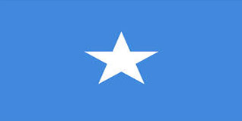
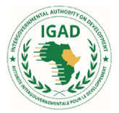

Progress Report of Resilience Projects
From January 2014 to October 2023

Tenth Anniversary of IDDRSI

16th IDDRSI Platform Steering Committee and 9th General Assembly Meetings
22-24 November 2023
Entebbe, Uganda

Table of Contents

Table of Contents 2
Executive Summary 4
Introduction 5
The Current Food and Nutrition Security Situation 7
Key Drivers of Food Insecurity in Somalia 8
Food Security Response 11
Drought Situation and Response in Somalia 14
Drought Response 16
Overview of humanitarian Situation and Response in Somalia 17
Humanitarian response in Somalia 17
Source: UNOCHA SOMALIA - humanitarian response in Somalia / Overview 17
2.0 Progress on the Implementation of Recommendations of 15th PSC 19
3.0 Updates the Implementation of the Resilience Projects: January 2014 to October 2023 20
3.1 PIA 1: Natural Resources and Environment Management 20
3.1.1 Water Resources Development and Management 20
3.1.2 Rangeland Management and Pasture Development 21
3.1.3 Securing Equitable Access to Natural Resources 22
3.1.4 Environmental Management and Bio-diversity 23
3.1.5 Development of Renewable Energy Access to affordable, reliable, sustainable and renewable energy ensured 24
3.1.6 Land Governance 25
3.2 PIA 2: Market Access, Trade and Financial Services 28
3.2.1 Transport and Market Development 28
3.2.2 Securing Livestock Mobility and Trans-boundary (regional and cross border) Trade 30
3.2.3 Access to Secure and Affordable Financial Services 31
3.2.4. Strengthening Regional and Cross-Border Trade 32
3.3 PIA 3: Enhance Production and Livelihood Diversification 32
3.3.1 Livestock Production and Productivity 32
3.3.2 Crop production and Productivity 34
3.3.3 Fisheries and Apiculture development 34
3.3.4 Income Diversification 35
3.3.5 Productive Safety Net 36
3.3.6. Trans-Boundary Disease Control & SPS Measures and Standards 37
3.4 PIA 4: Disaster Risk Management, Preparedness and Effective Response 37
3.4.1 Early Warning Systems and Response 37
3.4.2 Contingency Planning 38
3.4.3 DRR (Prevention, Mitigation & Preparedness) and Climate Change Adaptation. 38
3.4.4 Hazard, Risk and Vulnerability Mapping 38
3.5 PIA 5: Research, Knowledge Management and Technology Transfer 39
3.5.1 Support to Adaptive Research 39
3.5.2 Advisory and Extension Systems 40
3.5.3 Knowledge Management and Communication 40
3.5.4 Promote the Network of National and Regional Dry land Collaborative, Applied and Adaptive Research Centers 40
3.6 PIA 6: Conflict Prevention, Resolution and Peace Building 41
6.1 Peace Building and Mediation Mechanisms 41
6.2 Conflict Resolution 41
3.7 PIA 7: Institutional Strengthening, Coordination and Partnerships 42
3.7.1 Coordination and Platform Management 42
3.7.2 Institutional Strengthening and Capacity Building 42
3.7.3 Enhancing Partnerships 45
3.7.4 Resource Mobilization 45
3.7.5 Monitoring, Evaluation and Learning (MEL) 45
3.8 PIA 8: Human Capital, Gender and Social Developments 47
3.8.1 Access to Health and Nutrition 47
3.8.2 Access to education and training 48
3.8.3 Promote Gender Equality, Women’s Empowerment and Social Inclusion 49
3.8.4 Social Safety Nets 51
3.8.5 Migration, and Displacement and Social Inclusion 51
4.0 Challenges and Lessons Learnt during the Last Ten Years 53
4.1 Challenges 53
4.2 Lessons Learnt 54
5.0 Recommendations for the Implementation of IDDRSI from 2024 to 2027 55
6. Partnerships 56

Executive Summary
Despite measurable progress and appreciable advancement in recent years, Somalia continues to face a variety of natural disasters, conflict and economic disruption, crises, and development challenges, and it is ranked as the most vulnerable country to climate change of 181 countries, limiting the country's ability to achieve long-term peace, stability, resilience, sustainable food and nutrition security.

The Intergovernmental Authority on Development (IGAD)’s Drought Disaster Resilience and Sustainability Initiative (IDDRSI), launched in 2012. This is 15 year multi-phased, multi-national investment program financed by the African Development Bank (AfDB), which is being implemented to address the negative impact of recurrent drought in countries of the Horn of Africa region. IDDRSI builds the resilience of drought-prone communities in the face of food insecurity, poverty, and environmental degradation. IDDRSI aligns with IGAD’s regional programming paper and member countries’ own programming papers, which were developed to end drought emergencies, increase resilience to drought, and build sustainability in the region.

The Federal Government of Somalia is deeply dedicated to contributing to the goal of strengthening Somali communities' resilience and has gained agreement with all key stakeholders that a "triple nexus" strategy must be reinforced. The IGAD Drought Disaster Resilience Sustainability Initiative (IDDRSI) and its Priority Intervention Areas (PIAs) were designed on the basis of their potential to contribute enhancing resilience to overall related PIAs, which are fully aligned with the objectives of other programming frameworks, including regional, continental, and global strategies, such as the IGAD Regional SDGs.

Somalia's development goals are outlined in the country's ninth National Development Plan (NDP9, 2020-2024). The NDP9 is a comprehensive and nationally owned poverty reduction plan aimed at reducing poverty and inequality via inclusive economic growth, job creation, improved security, law and order, and political stability. The NDP9 is founded on four pillars:
- Pillar 1: Inclusive politics – strategies and interventions that strengthen the effectiveness political processes in Somalia, thereby increasing inclusiveness and reducing violent conflict.
- Pillar 2: Security and the rule of law – strategies and interventions that reduce insecurity across Somalia and to strengthen citizens’ access to an equitable and affordable system of justice.
- Pillar 3: Economic development – strategies and interventions that accelerate inclusive growth across the sectors of the economy, with particular emphasis on creating opportunities for women and young people.
- Pillar 4: Social development – strategies and interventions that improve access by Somali citizens to health, education, and other essential services, including social protection systems.
Policy and structural reform initiatives since 2016 have stabilized the economy, although growth remains sluggish. Political stability, security, and the rule of law, as well as sustainable development, which includes economic, social, and environmental sustainability, are also very low. Without a doubt, Somalia needs to enhance institutional capacity and quality, manage natural resources, safeguard the environment, achieve social inclusion, raise sustainable output and productivity of productive sectors, encourage commerce, and construct infrastructure and long-term resilience.

Introduction
The Country Programme Paper (CPP) of Somalia aims to enhance livelihoods resilience to drought in Somalia taking advantage of the positive direction realized in the emerging strategies of the development partners, and their focus on developing joint interlinked strategies. The CPP is in line with the IGAD Drought Disaster Resilience and Sustainability Initiative (IDDRSI) 15-year regional strategy for ending drought emergencies in the region.

The revised CPP is a 5-year strategy (2019-2024) identifying priority areas of intervention with structured and categorised specific strategic investments and interventions to build resilient communities, infrastructure and systems both at sub-national and national level. The CPP focuses on the entire states, administrations and districts of the Federal Republic of Somalia (Puntland, Galmudug, Hirshabelle, South West State and Jubaland) Banadir Regional Administration and Somaliland.

The country was torn by over two decades of civil strife, war, and the absence of a functioning national state. Since the collapse of the government in 1991, most public infrastructure and institutions have deteriorated or destroyed. Mobility, whether customary livestock based pastoralism or distress afflicted flight from insecurity or crisis has become a defining feature of contemporary Somalia. However, with the establishment of the 2011 Provisional Constitution, and the creation of 2012 establishment of the Federal Government Somalia has entered into a period where longer-term peace seems possible. Somalia has had a sustained period of political, economic, and security related progress. Somalia has seen continued progress on the state formation process.

The 2011 famine in Somalia brought into sharp focus the need to support and improve vulnerable communities’ ability to withstand shocks. A concerted effort to build household and community resilience was considered the best approach to reduce the impact of future crises both in Somalia and throughout the Horn of Africa.

The Country Programming Paper he revised CPP puts forward eight priority areas of intervention outlined in components: (1) natural resources and environment management, (2) market access, trade and financial services, (3) enhanced production and livelihood diversification, (4) disaster risk management, (5) research, knowledge management and technology transfer, (6) peace building, conflict prevention and resolution, (7) coordination, institutional strengthening and partnerships and (8) human capital, gender and social development.

The livestock sector alone accounts for more than 60% of GDP in Somalia, and the country's economy is heavily dependent on productive sectors (livestock, crop production, forestry and fisheries). The livestock sector is the largest sector of the economy, the largest employer in rural areas with nomadic cultures, and the main driver of exports--80% of the foreign currency earnings excluding cash remittances from Somalis in the Diaspora. Additionally, 70% of the populations in Somalia are dependent on livestock for their livelihoods. This overdependence on agriculture sector has made the economy highly vulnerable to natural and external shocks, including droughts and floods, locust invasions and fluctuations in demand for livestock exports.
Somalia is a low-income, food-insecure country and considered to be the most vulnerable to climate change of 181 nations that has struggled to make the arduous shift from "failed" to "fragile" status over the last decade(s). Around half of the population in Somalia lives in rural areas and relies on animal herding and crop agriculture for a living. The rural population is split in half, with half following nomadic pastoralist lifestyles and the other half following agropastoral lifestyles that include a combination of settled crop production and animal grazing. Somalia has the sixth-highest percentage of poverty in sub-Saharan Africa, where nearly seven out of ten people live on less than USD 1.90 per day, mainly poverty level of rural areas and IDP settlements are both pervasive and severe. Pastoral destitution principally driven by feed and water scarcity, as the natural resource base in the rangelands is shrinking fast.
The country impeded by external shocks, widespread insecurity, frequent climate-related disasters, environmental degradation, armed conflict, weak governance and limited state capacity, underfunded in fundamental social services along population growth exceeding economic performance. This affects about 80% of the population and it is a key contributor of a rapid rate of urbanization which has put significant pressure on urban centres to provide public services which will result majority of Somalis will be living in urban areas by 2040. Thus, agricultural transformation is a key for resilience building and higher growth, which requires large investments in irrigation infrastructure and improved livestock production methods, including climate smart technologies.
Source: African Development Bank, National Bureau of Statistics (2021)
Multiple shocks during the period 2017-2021 have disrupted the growth trajectory (Figure 1). Between 2016 and 2020, growth averaged 2.6% compared to 4.6% during 2013-2015 but remains volatile and much lower when compared to countries emerging out of conflict at similar stages, like Liberia. The growth trend is attributed to insecurity, poor business climate, and lack of investment. Gross fixed capital formation averages about 20% of GDP, comprising foreign direct investment (FDI, 9%), public investment (5%) and the rest being private domestic investment. FDI is a major driver of technology transfer and at this level is too low to generate sufficient productivity growth and structural transformation.

The economy of Somalia had been recovering prior to the pandemic; growth for 2020 and was projected to rise to 3.2% from 2.9% in 2019, buoyed by better agricultural performance and strong consumer spending. Growth in 2020 contracted by 0.3% due to the combined impact of aforementioned, particularly COVID-19 containment measures that disrupted trade and financial flows (Figure 1).

The Current Food and Nutrition Security Situation
Somalia has over 17 million people with an economy based on agriculture, approximated to be 90% of the total population. 70% of the populations in Somalia are dependent on livestock sector for their livelihoods. Agriculture provides food, employment, and incomes totaling 80% of the GDP and 90% of the foreign currency earnings, excluding cash remittances from Somalis in the Diaspora respectively. (note, the livestock sector alone contributes 60% of the GDP and 80 % of the foreign currency earnings).

Somalia still faces a rapidly unfolding humanitarian catastrophe due to the longest and most severe drought of at least 40 years. Additionally, Somalia's inhabitants endure conflict and widespread insecurity, disease outbreaks and poverty, and food insecurity in the region, making it the top and the most vulnerable states in the Horn of Africa (HoA) to the effects of climate change. The Notre Dame Global Adaptation Initiative (ND-GAIN) ranked Somalia, 185 as the most vulnerable country to the climate change impacts and other development challenges and the 122nd least ready country to adapt in 2021.

Nearly half of Somalia's population currently requires immediate humanitarian and protection assistance. The current drought has devastated the agriculture sector —that is, 90 percent of Somalia's exports —and led to the increased displacement of poles and loss of livelihoods. The intensity of recent drought is equivalent to that of 2010/11 and 2016/17. Low productivity or even no output from farming practices, that is, Crop and livestock production, led to high inflation of essential commodities; hence, the humanitarian community struggles to keep pace with growing needs. Across the countries covered by the IPC, an additional 88.6 million people were Stressed (IPC Phase 2) and needed livelihood support and resilience building, including 30.7 million from the IGAD region.
Regional food security situation, as of August 2023
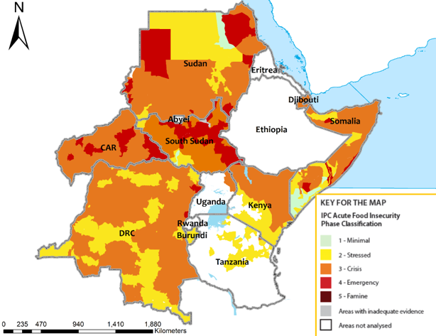Source: IPC-GSU for East and Central Africa
This is in addition to 2.2 million people expected to be in Emergency (IPC Phase 4) and not less than 300,000 people in Catastrophe ((IPC Phase 5). At least 1.8M of infants the country are likely to face severe undernourishment in the next one year (between July 2022 to June 2023), approximated at 54.5% of Somalia's total population of children.

The nutrition status across Somalia, and in the Horn of Africa region, remains grappling with multiple drivers, that is, food insecurity, poor feeding habits, inadequate health and nutrition services, inadequate water, hygiene, and sanitation (WASH) practices, a high infectious diseases prevalence, and conflict and insecurity, among others; making the nutrition situation in Somalia critical.

The famine situation in Somalia is aggravated by numerous factors such as severe drought, widespread insecurity, and economic pressures. However, results from the latest multi-partner Integrated Food Security Phase Classification analysis show a slight improvement in the conditions; Even though at least 5 million people are in crisis or worse consequences of catastrophic hunger.

Climate risks in Somalia have led to food insecurity, conflict, poverty and instability, and generally an alarming loss of livelihoods. Lately, massive land and environmental degradation and other crucial ecosystems have further increased the dangers of climate change. The quality of pastures, ecological buffer capacity, sustainability, and parasite distribution, emerging and re-emerging livestock diseases have risen due to climate change. The adaptive capacity has been reduced due to inadequate water management facilities and practices, inefficient water harvesting facilities, erratic and unpredictable rainfall patterns, and high ambient temperatures, thus fueling resource use conflicts. The National climate plans and actions must instill and demonstrate progress toward a resilient and prosperous Somalia and its local communities by 2030. In the face of ever-increasing climate risks, Somalia has to accelerate and embrace effective practices towards sustainable climate-smart (mitigation and adaptation) solutions and livelihoods of communities, for instance, pastoralists and agro-pastoralists.

Above all, the country's high vulnerability to climate variability and change risks is the low awareness of the risk factors and slow response and action. This is because of limited access to and adoption of integrated early warning systems, climate-smart technologies, and response frameworks and protocols. There is also a critical need for more resources (knowledge, personnel, technology, and finance) required at the community level. The Federal Government of Somalia (FGS)and Federal Member States (FMSs) war campaign against shabaab terror groups has already limited ongoing field activities and movement in the areas, particularly in Hirshabale and Galmudug states and recently campaign of South West in Somalia. This may spread food insecurity and malnutrition in Somalia for a short period, affecting about 50% of the total population.

Key Drivers of Food Insecurity in Somalia
The impact of the Russia-Ukraine conflict, climatic shocks, violent conflict, and insecurity are the main drivers of food insecurity in Somalia. Even though a large-scale humanitarian response exists, the reprieve in Somalia's food crisis is an issue. To date, 3.7 million people, or 22 percent of Somalia's population, face high food insecurity, classified in IPC Phase III(Crisis) and Phase IV (Emergency).

The key drivers of acute food insecurity in Somalia include:
- the combined effects of below-average and poorly distributed rainfall,
- flooding, the extended impact of multi-season drought in pastoral areas,
- limited household access to food due to income constraints and
- elevated food prices,
- continued insecurity, and
- conflict in many parts of central and southern Somalia and Lasaanod (Sool), and
- low coverage of humanitarian assistance.

However, forecasts indicate an increased El Nino likelihood of average rainfall during the 2023 (October-December) season across most of the country, which is likely to cause adverse impacts on livelihoods, food security, and nutrition outcomes along the riverine.
Generally, humanitarian assistance has continued and still is critical in preventing worse food security and nutrition outcomes in many areas. There is fear that aid is likely to decline further between October and December 2023 unless additional funding is secured. The findings for acute malnutrition show that the situation has generally improved compared to the same season in 2022. a Critical situation (IPC AMN Phase 4), Twenty-two population groups were also classified as Serious (IPC AMN Phase 3). In contrast, ten other population groups were organized in the Alert situation (IPC AMN Phase 2), and in just one population group, the case was classified as Acceptable (IPC AMN Phase 1).

Despite the relative improvement in the nutrition outcomes in Somalia, the prevalence of acute malnutrition remains high, with the GAM rates above 15% in many areas. The improvements over previous years are a result of the following:
- improved harvest in the Gu season,
- better rainfall performance in the agropastoral areas
- improved livestock body conditions,
- increasing sale prices for animals and improving
- household income.

The Ukraine-Russia conflict
Somalia is in distress due to the Russia-Ukraine conflict, which threatens the country's global food security, especially in Sub-Saharan African nations that import food primarily reliant on wheat and fertilizer from Ukraine and Russia. Somalia has been severely impacted and 90% of Somalia's food imports in 2023 are produced and shipped from Ukraine.

As a result of a decrease in supply since the start of the Ukraine conflict, Somalia has been in turmoil and is suffering from a severe food shortage. Food imports have been suspended due to the Ukraine war and the closure of shipping ports, and food contributions have not been received, resulting in food shortages and price increases.

Furthermore, the international community's emphasis and response to Somalia's multiple problems has been diluted. According to UNOCHA, in June 2022, just 3.2 percent ($47.1 million) of the needed money ($1.5 billion) for Somalia's Humanitarian Response Plan (HRP) had been received. Funding for Somalia has been reduced due to the diversion of financial resources in support of Ukraine.

Somalia's Fragility and Insecurity
Somalia is a fragile and conflict-torn country, usually called a transition state. This suggests that its sensitivity to internal or external pressures exceeds its capability to prevent, respond to, and recover from them, creating a risk and perhaps leading to instability and conflict.

Violent extremism and terrorism, political insecurity, high rates of poverty and unemployment, low human capital, institutional capacity gaps, service delivery shortfalls, food insecurity, and climate change impacts, including competition for dwindling resources, particularly water, and pastures, all contribute to Somalia's insecurity and fragility.

Changes in the Climate
Climate change is primarily to blame for the present food crisis. Climate and climatic shocks, such as drought, floods, and increased desert locusts, imperil agricultural output and pastoral resources. A multi-season drought of unprecedented proportions has affected approximately 90% of the country's districts (66 out of 74). Food and water scarcity have become more pressing and critical throughout the year.

Water scarcity
Water insecurity eventually affects 3.2 million individuals facing severe water shortages. Extreme aridity and water scarcity are increasing livestock deaths, harsh animal conditions, and cattle fatalities due to starvation, malnutrition, and drought-related diseases. Due to a critical water deficit, families have migrated to urban and peri-urban centers without guaranteed food and nutrition. According to reports, the extreme drought has also escalated clan violence and displacements.

Escalating Food Prices
The Ukraine crisis has implications for food security because Russia and Ukraine are important in global food markets, such as wheat, maize, rapeseed, sunflower seeds, and sunflower oil. Furthermore, Russia is a significant exporter of nitrogen fertilizers and pesticides and the second largest supplier of both potassic and phosphorous. Other factors contributing to Somalia's food and nutrition insecurity include access to veterinary services, feed, pasture, and water.

High fuel prices and logistics disruption
The rise in fuel costs has driven the cost of transport and food items. Food price increases are causing households' purchasing power to dwindle. Most families sell their properties and other valuable assets to obtain food and other necessities. The price of a food basket has already risen, particularly in Somalia and the whole region, which relies significantly on wheat from Black Sea basin nations, and the disruption in shipments threatens food security even further. Since January, shipping charges on some routes have more than doubled.

Increased natural resource-based conflict
Due to the natural resources scarcity such as pasture and water, as the natural resource base in the rangelands is shrinking fast, there is also an increased risk of inter-communal conflict.

Food Security Response
The overriding food security challenge facing Somalia is widespread and extreme poverty. According to the NDP9 2019–2025 assessment, 69 percent of Somalia live below the $1.90 international poverty line, and 49 percent of the Somali population cannot meet the average food requirements even if they spend all their income on food.

Due to their severe poverty, the majority of Somalis are incredibly susceptible to the shocks they are frequently subjected to, such as:
- drought,
- displacement,
- poor health,
- loss of income or assets,
- political instability,
- insecurity, and
- Lawlessness.

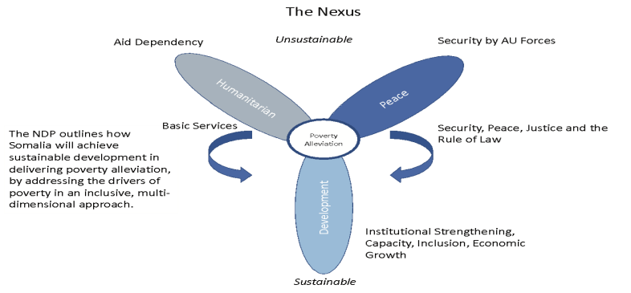
Source: NDP9 (2019-2025), Figure 33: Humanitarian-Development-Peacebuilding Nexus, pp. 111
The four pillars of the NDP9's poverty strategy are organized to address the causes of poverty to solve the problems and the issues of food insecurity and poverty through a range of policy and resilience programs, measurement, and intervention.
- Inclusive and Accountable Politics,
- Improved Security and the Rule of Law,
- Inclusive Economic Growth and
- Improved Social Development—The best method

The interventions that the government is committed to implementing include.
- Interventions that strengthen the effectiveness of political processes in Somalia;
- Strategies and interventions that reduce insecurity across Somalia (
- Strategies and interventions that accelerate inclusive growth across the sectors of the economy, with particular emphasis on creating opportunities for women and young people and
- Strategies and interventions to increase Somali individuals' access to social protection security and programs, health care, education, and other essential services.
The government recognizes that the primary contributor to conflict in the country is food insecurity; thus, building and advancements of peace and stability are essential for food security and the long-term sustainability of food systems. Somalia remains one of the most volatile, vulnerable, unstable, and insecure country the Horn of Africa. Millions of people are at risk of famine due to violent conflict, radical extremism, and insecurity. People are forced to migrate and find alternative livelihoods and sources of income. Famine (IPC Phase 5) is likely to occur in Somalia If:
- there is widespread failure of crop and livestock production (
- food prices are further continuing to rise dramatically, and
- humanitarian assistance is not to reach the most vulnerable communities.
However, the country has made significant progress toward strengthening institutional capacity, increasing production and productivity of productive sectors, and rebuilding long-term resilience.

The government's efforts to combat hunger must co-exist with creating stability and building healthy and prosperous societies. In reality, political peace, security, and establishing the rule of law are government goals in the conditions and circumstances necessary for successful initiatives to promote and climate-proof economic growth.

People should have access to quality foods, health services, safe drinking water, sanitation, and other hygienic practices to promote food security. The risk of sickness, including waterborne diseases such as diarrhea, which have a negative impact on metabolism and impair the body's ability to absorb food, is considerably reduced by increased usage of healthcare facilities, better access to safe sources of drinkable water, and improved sanitation.

Social development is required to support and sustain economic progress through the development of human capital, social protection, and disaster risk reduction. In contrast to being fundamental components of human capital, productivity and, by extension, food consumption depend significantly on both health and education. National food security in the country requires a plentiful supply of affordable and nutritious food to secure food for the growing population.

Most Somalis rely on agriculture for their livelihood, and 70% of the population in Somalia depends on the livestock sector alone. Their livelihood contributes 60% of the GDP and 80% of the foreign currency earnings, and 70% of the population in Somalia is dependent on livestock for their livelihood. Due to subpar seeds, degraded soils, lack of fertilizer and other necessary inputs, a lack of mechanization, and inadequate transportation infrastructure, crop yields in this region are among the lowest in the world. Farming must be transformed from subsistence to business, requiring appropriate policies, laws, institutions, and financial inputs.

It is crucial to enhance farming communities' capacity to deal with the effects of climate change since smallholder farmers lack the resources to adjust to rising temperatures and severe climate conditions like droughts and floods. Investing in weather forecasting systems, effective irrigation technology, and heat- or drought-tolerant crop types can assist in increasing farm productivity under increasingly harsh climatic circumstances.

Many rural areas possess farms that need to be more significant to guarantee food security or a sufficient income for the family due to the fragmentation of agricultural land brought on by population pressure. Smallholder farmers face the threat of being evicted from their farms and need more motivation to improve their land due to their poor and insecure tenure rights. To ensure the viability of commercial agriculture, a reform of customary land-tenure systems is required to leverage the transformation of agriculture and raise agricultural productivity levels. This tenure system should include a consolidation of farm plots.

In Somalia, the absence of variety in crop production and, more broadly, in revenue-generating activities continues to be a significant issue. The government is committed to developing and strengthening the agriculture processing sector and other agricultural value chains. These have a considerable potential to provide value and create jobs. The government must adjust its industrial and development policies for the private sector to attract more agribusinesses and investors. They must, in turn, collaborate closely with smaller farms and direct related economic sectors.

Food insecurity, physical isolation, and limited access to formal safety nets make communities more susceptible to climatic shocks to their agricultural system, especially when they experience catastrophic weather events. Therefore, the government is collaborating with its partners to improve the ability to deliver food during emergencies for vulnerable populations and the underprivileged who struggle to afford a healthy diet. Plans include food quality, beneficiary registries, distribution methods, and storage. The government increased food aid programs during the drought of 2021/22 beyond previously anticipated levels to reach at least 2-3 million people each month.

Empowering women and improving their role in household decision-making procedures can influence food security outcomes. Women having greater access to economic resources can ensure more investment and financial resources in productive activities, raising household income.
The impact of women's economic empowerment on the distribution of resources within households may be much more significant.

Short-term and humanitarian responses predominate in Somalia's prolonged food crisis, yet development paradigms are always proper. The government's response must consider the effects of these interventions to combine humanitarian and development efforts (interventions for resilience). The other main objective of the government is to strengthen disaster management to alleviate food insecurity nationwide. The specific strategic interventions proposed to improve and maintain the government's disaster risk management capacity include:
- Implement National Disaster Management Policy
- Promote gender equality in disaster risk reduction
- Improve coordination capacities of humanitarian response agencies at national and sub-national levels
- Fully implement priorities set out in the Somalia Recovery and Resilience Framework (RRF)
- Design and implement an early warning system, working with existing systems

Urban Planning aims to contribute to the effort to combat food insecurity in the country's urban areas. The provision of essential services to all Somalis, including the displaced and underserved, will need the support of long-term city planning services.

Drought Situation and Response in Somalia
Since the 15th of the IDDRSI Platform Steering Committee and for the country's progress reporting on 30 November 2023, Somalia has been devastated and grappling with one of its worst droughts. Over 80 percent of Somalia faces severe drought conditions. The drought severity levels are comparable to 2010/11 and 2016/17. It is estimated that around 7.8 million Somalis face a lack of water and food shortage. Half of Somalia's population could reach 8 million in months.
The worsening multi-seasonal drought that has racked the nation since late 2020 is to blame for the deteriorating situation. Water shortages, crop failures, elevated prices for essential commodities and water, livestock mortality, and significant levels of displacement have resulted from four failed rainy seasons in a row. Suppose food prices continue to rise and humanitarian aid is insufficient to reach the most vulnerable communities, particularly marginalized groups (i.e., gender, youth, elderly, disadvantaged groups, people with disabilities, and indigenous communities). In that case, the country will be further at an increased risk of famine.
However, there has improved rainfall during the 2023 March-May season and benefited cropping activities such as livestock body conditions and production, thus reducing the impacts of the five-season drought in northern Somalia, the arid and semi-arid lands (ASALs) of Kenya, and Somalia. Dry spells and unreliable rainfall distribution in some areas affected crops in critical growth stages, leading to low production. In addition, improved rainfall seasons, in some parts of Ethiopia and Somalia has led to destruction of properties, that is, agricultural lands, homesteads, assets and even displacement of people due to river overflows and flash floods.

Despite the 2023 MAM seasonal harvests are estimated to be averagely above the normal harvest, food security needs in the areas affected by the drought are still high. Several families in those area still faces severe challenge in accessing food, due to significant losses of livelihoods, depletion of assets (including livestock) and widespread population displacements.

The levels uncertainties are high based on the previous droughts records, as most of the drought-impacted households across the region will struggle to reconstruct their livelihoods, and the displaced are doubtful whether they return to their original home due to the sluggish recovery process. Forecast above-average rains in the eastern region during the 2023 October-December (OND) rainfall season, primarily due to an El Niño and a positive Indian Ocean Dipole (IOD), which are expected to have a positive impact on food security as water will be available for crop production and livestock. Massive flooding is expected in the rural areas, likely to damage crops and infrastructure, displace people, thus increasing incidences of human and livestock diseases. There is also a fear in Somalia and other parts of the region that could contribute to post-harvest losses and the proliferation of desert locusts since a few swarms have already been observed in northern Ethiopia.

Resource-based conflict, political and insecurity continued to compromise food security across the region, including northern Ethiopia, Somalia, South Sudan, and Sudan.

Somalia Rainfall Forecast
Receding Flash Floods and Sustained Risk of Riverine Flooding along Juba and Shabelle Rivers

Juba River:
Significant fluctuations in water levels along the Juba River have been observed. The Juba River surpassed the high-risk thresholds by 10 cm at Luuq on 21st October before decreasing below moderate risk level as of today. Downstream at Bardheere Station, the water level rose from 8.00 m on 21st October to 9.00 m and crossing high-risk threshold (8.20 m) on 22nd October before receding back to 8.00 m today. The downstream flow of the flood wave has led to a 1.1 m rise in the water level at Bualle which currently poses no immediate threat of riverine flooding. Moderate to heavy rains (50 – 100 mm) are expected over the catchment of Juba River within Gedo region and near-border areas with Ethiopia between 23rd and 29th October. The rains over the upper catchment in Ethiopian Highlands may exceed 200 mm posing high risk of riverine flooding towards the end of the forecast period. There is a high risk of flash flooding due to potential localized heavy rains over western parts of Bakool, central parts of Gedo, and Saakow district in Middle Juba region.

Shabelle River:

The water levels along the upper Shabelle River have shown a reducing trend in the recent time. On 21st October, the water level at Beletweyne (6.44 m) which is 6 cm under the moderate flood risk threshold. The levels have since dropped to 6.10 m now. On the other hand, the downstream flow flood wave has led to rise the water level at Bulo Burte from 4.95 m as at 21st October to 5.28 m while the water levels at Jowhar station have also risen at the same time from 3.95 m to 4.28 m. However, both reading at the stations, are still below riverine flood risk thresholds. Moderate rainfall (31.5 mm) caused flash floods that affected Badda Cas IDP camp interrupting livelihood activities. Moderate rainfall of about 50 mm is expected over Shabelle River catchment within Hiraan region and near-border areas with Ethiopia. Coupled with the heavy rains recorded one week ago, the heavy rains (more than 150 mm) forecast over the Shabelle River upper catchment in Ethiopian Highlands, are likely to pose high risk of riverine flooding at Beletweyne towards the end of October and beginning of November 2023.
Rainfall probabilistic forecast for October-December (OND) 2023
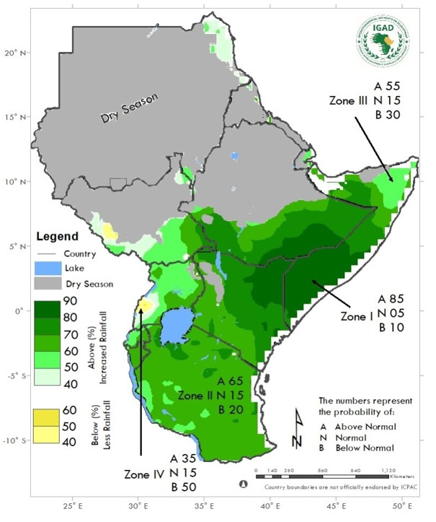
Source: ICPAC
The expected enhanced rains based on these phenomena present favorable prospects for agricultural production, providing some relief to areas affected by the recent drought. However, there is also risk of flash floods, riverine overflows, and landslides, leading to population displacement, increased human and livestock disease outbreaks, and destruction of farmlands, shelters, and critical infrastructure, including roads.

Drought Response
In 2023, the Humanitarian Response Plan (HRP) and budget for Somalia is estimated at US$2.6 billion, likely to assist 7.6 million vulnerable people across the country, representing about 90 percent of people in need. The HRP covers 739,800 newly displaced people, 1.1 million people displaced for more than a year, 3.2 million shock-affected urban people, 4.4 million shock-affected rural people, and 51,300 refugees, asylum-seekers, and returnees.

The significant impediments to humanitarian operations, has been conflicts and insecurities outside major population centers across Somalia. Partners are working with local authorities and communities to reach out to people in need wherever they are and to allow people to access humanitarian assistance. Therefore, all parties must fulfill their obligation to secure the people or civilians and objects and facilitate humanitarian access, including removing any impediments to aid, per international humanitarian law.

Overview of humanitarian Situation and Response in Somalia

Humanitarian response in Somalia
Humanitarian Need Overview:
Population | 17M
People in need | 8.3M
Acutely Malnourished Children Below 5 | 1.5M
Humanitarian Response Plan:
People Targeted for Assistance | 7.6M
Total requirements (USD) | 2.6B
Funding update:
Total requirements (USD) | 2.6B
Funding total (USD) | 1B
Funding gap (USD) | 1.6B
Funding coverage (%) | 39.55

Source: UNOCHA SOMALIA - humanitarian response in Somalia / Overview

Insufficient funding is still hindering humanitarian efforts and capacity to reach more people In need since the last country progress report on the 15th of IDDRSI Platform Steering Committee and for the country progress reporting 30 November 2022, additional funding is, therefore, urgently needed to avert the worst outcomes. With the limited resources available, the government and Humanitarian partners have only secured $1B, and this is funding coverage of 39.55%, which is not favorable compared to funds secured during our last reporting period in November 2022, where the total requirement of funds was$1.46B, and secured $1.03B, which 71% of the progress coverage achieved.
Multiple and frequent outbreaks of cholera and measles is rampant the region, risking increased sickness and deaths. Not less than 12,142 cases and 30 associated deaths were recorded between January and 13 August 2023, with 54% of all cases among infants in the the Banadir region, and Belet Xaawo, Kismayo, Afgoye, Baidoa, and Afmadow districts.
Notwithstanding short-term developments, drought conditions in Somalia, the worst to be feared in the country during the 2023 October-December (OND) rainfall season, wetter than usual conditions are forecast across most eastern parts of Somalia and other region, mainly owing to an El Niño and a positive Indian Ocean Dipole (IOD). While this presents positive prospects for agricultural production, it could also trigger widespread flooding in flood-prone areas, causing population displacements, damage to farmlands, shelters, and other infrastructures, disruption of livelihoods, and increased human and livestock disease outbreaks. The government and international partners are committed to responding to the crisis. Still, insufficient funding hinders humanitarian efforts, and additional funding is urgently needed to avert the worst outcomes.
Actions to Overcome Challenges of the Drought, Food and Nutrition Security
There are several pathways that Somalia could use to unlock opportunities for economic growth and climate change. These opportunities include:
- Effectively adopting and implementing a multi-sectoral approach in resilience programming can contribute to community and country resilience capacities. For example, the IDDRSI-related project uses a 'resilience-building effort across many sectors, such as market, financial services, agriculture (livestock), environment, and government.
- Enhancing measures to address security and safety concerns nationwide for political stability.
- Implementing reforms to restore public debt sustainability levels for a better credit rating improves the sovereign credit rating to crowd in more capital from external investors.
- Investing in social protection, social capital formation, and promoting alternative income-generating activities to move people out of shock-prone livelihood strategies.
- Adopting climate-smart technologies that intensify agricultural production. as well as strengthen agricultural production.
- Strengthening the institutional capacity to provide adequate strategic and regulatory oversight on economic and finance issues.
- Strengthening economic and financial governance of natural resources as Somalia prepares to manage more revenue from natural resource rents, notably from the fisheries, forestry, and minerals sectors.
- Harnessing renewable energy generation from wind wave energy and solar energy and leveraging forest and land resources to support the transitions towards green growth.
- Implementing measures aimed at reversing the land degradation trend.
- Providing sufficient investment frameworks to restore degraded fish stocks and tackle Illegal, unreported, and unregulated (IUU) fishing, maritime security, and avert deep ocean piracy.
- Effective timing of humanitarian support assistance for households' recovery. This measure will reduce dependence on methods, for instance, seed stock consumption, drawing down on savings, aid from family members, selling livestock, and buying food on credit.
- Incorporating the gender dimension of resilience through women's economic empowerment and creating conditions for the acceptance of women's participation in decision-making.

2.0 Progress on the Implementation of Recommendations of 15th PSC
Since 15th of the IDDRSI Platform Steering Committee and for the country's progress reporting on 30 November 2022 and this is the 10th Drought Disaster Resilience and Sustainability Initiative (IDDRSI) 15-year regional strategy for ending drought emergencies in the region, the Federal Government of Somalia, in collaboration with development partners has continued to promote, support and coordinate national and regional resilience interventions aimed at building drought resilience. The government also ensured the country’s resilience initiative and the joint resilience action to be aligned and mainstreamed across the government's agenda in the country’s National Development Plans for 2017-2019 and 2020- 2024 (NDP- 8 & 9), IGAD Regional Strategy, the AU Agenda 2063 which also incorporates the 2030 Agenda for Sustainable Development's guiding principles.

The Country’s development plan and aforementioned initiatives, strategies along with its SDGs development targets made in progress and were mapped against and linked with priorities, road maps, and monitoring and evaluation frameworks. However, the full monitoring and evaluation of Somalia's progress in implementing resilience projects at national, regional and global agenda levels is not efficient, and possible due to weak statistical systems.

According to the African Development Bank, SDG-specific baselines, targets, and indicators are notably lacking from the NDP-9’s result framework. Beyond doubt, similar challenges are existing IDDRSI and resilience project in CPP Somalia which lacks baselines and targets, in which The Federal Government of Somalia considers very important to be undertaken “ a Baseline Survey for the M&E of the Resilience Project in CPP Somalia and Preparing Associated Tool for Data Collection”. As stated by NDP-9, the Government's intends to use localized SDG targets to harmonize with a common global framework and "making alignment of funding and interventions straight-forward with the added benefit of simplifying/streamlining reporting" which need to be realized.

FGS acknowledges that increasing the resilience of the country requires a coordinated approach among all parties (development partners and stakeholders across all sectors). This strategy aims to undertake longer-term development interventions that address the root causes of recurrent human and nature induced humanitarian crises. The progress towards achieving the Sustainable Development Goals (SDGs) can only be realized through collective and coordinated efforts across all development partners including the UN and as well as with the Somali government and people.

Since the foundation of the central authority in 2004, measures have been taken, resulting in the adoption of a temporary constitution in 2012, the formation of a parliament, and the development of a federal political system. These have achieved tremendous success in terms of institutional capacity building, raising production and productivity in productive sectors, and advancing trade and financial industries.

The total Mo Ibrahim Index of African Governance (IIAG) score rose from 8.0 to 19.2 in 2019. According to the 2020 IIAG, Somalia had the seventh biggest improvement in IIAG scores from 2010 to 2019 (5.7%). Ratings for human development and the basis for economic opportunity have both increased, with notable advances. However, there are still significant issues in the areas of security and the rule of law, both of which are improving.

3.0 Updates the Implementation of the Resilience Projects: January 2014 to October 2023

3.1 PIA 1: Natural Resources and Environment Management
Major Projects implemented with budget utilisation in USD

3.1.1 Water Resources Development and Management
Water is essential for the existence, functioning, survival and productivity of all life and ecosystems. Much of the 2030 Agenda for Sustainable Development is supported by Sustainable Development Goal 6, which calls for ensuring the universal access to water and sanitation and their sustainable management. Water scarcity and feed is the main cause of pastoral destitution in Somalia, also becoming a greatest issue in most regions of Somalia, as the natural resource base in the rangelands is shrinking fast. This has far-reaching effects on, among other things, economic growth, food security, health, ecosystems, poverty eradication, and gender equality.
To enable realistic improvements in livestock production, water and feed resources ought to be considered in the broader development perspective and not just as an emergency response to drought. The Summary of implementation progress of major crucial planned activities and tasks of the Natural Resources Management Drought Resilience and Sustainable Livelihoods Program DRSLP II project (Somalia) is expecting to be completed by the end of this year.
However, the water scarcity in Somalia can also add stress to over-extract groundwater resources in order to meet their water needs, as more wells and boreholes are created unnecessary to meet water demands in ways that harm the environment. The Federal Government of Somalia successfully developed and implemented the National Water Resources Strategic (NWRS), which provides a framework for a plan of action for the development and management of water resources.
The NWRS also offers a number of plans, goals, and initiatives for the water sector for 2021–2025 periods. The NWRS targets to unlock key and critical actions which are aligned with the Provisional Constitution (2012), Sustainable Development Goals and sectoral policies and laws. The NDP-9 is the key driver for the NWRS over the next 5 to 10 years. The Federal Government of Somalia has made outstanding success in the areas of listed below;
- Strengthened and increased contribution of water to national cohesion, development, growth, and well-being.
- Improved integrated management of water resources.
- Effectively implementing the resilience building process through encouraging sustainable development.
- Further improved process and procedures for ensuring productivity, equality, and sustainable services
- Established and advanced monitoring and Information Management System.
- Advanced the Sustainable Water Resources Management in Somalia Program's to lay the foundation for an Integrated Water Resources Management (IWRM) strategy.

3.1.2 Rangeland Management and Pasture Development
The Federal Government of Somalia with the engagement of federal member states has been made remarkable progress toward the on-going implementation of remaining crucial activities of DRSLP II project.
- Sand dunes stabilization in Godob Jiraan (Pilot Location) - 10km2
In this reporting period, the implementing agency “ SCI” terminated the Contract of the Sand Dunes Stabilization in Godobjiraan – Ten (10) Square Kilometers, in Nugaal region in Puntland due to community related challenges which was due to conflict between the government-appointed District Commissioner, which divided the community. This resulted in continuous challenges in implementing this activity. The implementing agency requested the relocation of the funds to another activity within the same component, which is gully erosion control in severely degraded potential valleys capable of supporting many pastoralist households in Nugaal Region, and NO discussion and process is in progress and would be finalized in the next quarter.

In this connection, SCI has carried out a joint gully erosion technical assessment and analysis with the Ministry of Environment, Agriculture and Climate Change (MoEACC) to identify the sites having the most pressing gully erosion and affecting the rangeland of the pastoral community in Nugaal region. The team visited several villages and consulted with the local authorities and the pastoral communities. As a result, the team found out that the rangelands in the Qabaal village area are severely degraded and need an urgent rehabilitation.

During the assessment, 6 out of the prioritized sites during the consultation meeting with Qabaal community, namely, Legdeero, Kurtumo and Qaydaruus were identified as the most potential and severely degraded rangelands. These assessed and selected sites were prioritized based on the rangeland rehabilitation site selection criteria and community priorities. The interventions proposed to capture both physical/engineering and biological measures. Save the Children in consultation with the Ministry of Environment and Climate Change (MoEACC) developed the BoQs and designs of the proposed interventions and will start the next steps of the process including the requisition of the of the Bank’s No Objection and the tendering process.

- Gully Erosion control: Vegetation, fencing, Diversion Banks in three locations (15 Km)
In this reporting period, the implementing agency started the tendering process for the construction of the proposed gully erosion control structures in Jedad and Libaaxo(10Km). Tender evaluation is ongoing and planned to be finalized.
African Forestry and Wildlife Commission (AFWC) and 7th African Forestry and Wildlife Week
Somali delegates led by the Hon. Minister Hassan Hussein Mohamed (MP) of the Federal Ministry of Livestock, Forestry & Range (MoLFR) attended and participated in the 23rd session of African Forestry and Wildlife Commission (AFWC) and 7th African Forestry and Wildlife Week on 22-26 August 2022, Kinshasa, Democratic Republic of Congo.
The Hon. Minister’s statement indicated clearly the main common challenges facing the Somalia’s forestry and wildlife for the last three decades, in which he shared these challenges have been recognized by not only in Somalia, but many countries of the greater Horn of Africa, as well as other countries of our African continent, furthermore the Hon. Minister added that more forest governance and management in the Africa has not resulted in significant improvement in conservation or reversing the trend of deforestation and forests degradation in the continent.

The minister affirmed the country’s progress and commitment of the Federal Government of Somalia toward forestry and wildlife in which Somalia has recently achieved a country’s Range Management Strategy, National Charcoal Policy of Somalia, also participated the Regional Forestry Policy and Strategy of IGAD, that addresses these challenges, which also compliments the existing national policies, regional, continental and global frameworks. The minister underscore the important contributions of forests to economic development in Africa, as well to environment, social and culture therefore healthy forest ecosystems and environmental services are vital for sustainable forest production in Somalia or elsewhere in this continent. The following recommendations are proposed by Hon. Minister Hassan Hussein Mohamed for Livestock, Forestry and Range of the Federal Government of Somalia;
- Strong relationships are required among reputable African Forestry and Wildlife Commission for knowledge sharing, as well as knowledge and technology transfer and human resource development in areas of sustainable forest production while restoration and improvement of forest and rangeland ecosystems.
- More cooperation with the United Nations organizations and agencies and with developed countries and their governments along with other donors to strengthen the forestry and wildlife sectors in Africa, such as joint programs or ventures for public awareness and promotion of more efficient climate resilient forest production systems.
- A comprehensive report to document the success stories and best practices in each country and per regions of the continent.

The Minister appreciates the Food and Agriculture Organization of the United Nation (FAO) and other partners and for its continued and unsurpassable support to continent, particularly, Somalia; he also thanked the Commission member countries and the participants’ organizers and other stakeholders for this successful meeting. Finally the Minister concluded his statement that Somalia is very committed to sustainable development forest and wildlife and “the path to resilience and sustainability and scaling up humanitarian, development action and resilience”

3.1.3 Securing Equitable Access to Natural Resources
Water scarcity intensified by the climate change and its effects, although there is hope of progress when institutions are strengthened and investments undertaken. Recurrent floods and drought have negatively impacted the watersheds and their ability to store, treat and slowly release water naturally. To enhance water management and conservation, the Ministry of Energy and Water Resources; and the National Disaster Risk Management need to work on flood and drought risk management measures.
In urban areas, the authorities in-charge should or need establish urban service delivery model to support rapid urbanization and rural-urban linkages. Other strategies include: investment to improve water and land management, to enhance agriculture and related practices. Besides, the adoption of new technologies can improve and secure rural livelihoods through farmer led irrigation and manual drilling of wells. The economies (rural and urban) need to be supported by reasonable, inclusive and reliable water supply that is safe and essential for human capital development.
In this reporting period, the progress toward the Food and Nutrition Security Resilience Programme (FNS-REPRO) are as followed;
- The key activities progresses under component of “improved inclusive access and management of local natural resources”.
  - Facilitated establishment of community grazing systems that accommodate fodder harvesting and storage, proper stocking, and application of range management principles.
  - Form natural resource management committees drawn from community members and leaders in each of the 6 villages.
  - Development of natural resource management plans that will govern grazing, fodder harvesting/processing and storage.

Achievements:
All the above activities are completed successfully and the NRM committees within the 7 FNSREPRO villages are leading the efforts towards improved grazing practices with support from local authorities at the regional and District level with oversight of the National government. The Federal Government of Somalia proposed a long-term resilience and human capital development strategy, as well as committed to further build and sustain governments’ capacity to respond to recurring crises while promoting more integrated ways of working with the government and partners to secure equitable access to natural resources which will increase sustainable production and productivity for ending hunger through capacity-building and support for policy development and delivery systems. Some of the resilience projects that are implemented in the country including the regional and cross boarder projects, the following thematic areas were also and achieved:
- Implemented sustainable livelihood approaches in the context of access to different natural resources in Somalia
- Achieved access to natural resources and made rights of inclusivity real
- Implemented and succeeded livelihoods and access to natural resources.

3.1.4 Environmental Management and Bio-diversity
Somalia is one of the most vulnerable countries in the horn of Africa to climate change because its livelihoods are directly dependent on productive sectors (livestock, agriculture forestry and fisheries) which are very susceptible to climate change and climate variability. If the effects of climate change are not effectively addressed, they will continue harm Somalia's livelihoods and environments. Therefore, it is crucial that all local and international parties involved in the country’s development including peace-building process should adequately take into account, environmental management and biodiversity; and climate security issues in their research, planning, and programming.

In Somalia, this entails promoting the role of women and young people as peacemakers, mainstreaming environmental peace-building and risk-management strategies, incorporating climate considerations and ecosystem restoration into state policies, service delivery, the security sector, and the rule of law, and enhancing local adaptive capacity by implementing new sustainable practices. This entails measures to strengthen humanitarian–development– peace triple-nexus responses to climate change; mainstreaming environmental management, biodiversity, peace-building and risk-management strategies; promoting the role of women and youth as agents of resilience, peace and stability in Somalia; including climate considerations and ecosystem restoration into state policies, service provision, the security sector and the rule of law; and reinforcing local adaptive capacity by introducing new sustainable practices and supporting all other relevant stakeholders (public, private and civil society).

3.1.5 Development of Renewable Energy Access to affordable, reliable, sustainable and renewable energy ensured

Decades of conflict severely damaged power generation, transmission and distribution infrastructure built prior to the 1990s. Currently, only 35-40% of the population has access to electricity - with a significant disparity between urban areas (70% electrification) and rural areas (10%). Diesel generators supply over 90% of power generation. The high costs of diesel coupled with technical losses of 25-45% contribute to some of the highest electricity tariffs in Africa, averaging $0.45-1.0/kWh compared to $0.15/kWh regionally. This poses a major impediment to demand growth and affordability for consumers. Heavy reliance on biomass energy, mainly fuelwood and charcoal, for cooking also leads to widespread deforestation and land degradation.
Energy Sector Overview:
- Installed electricity generation capacity expanded from 115 MW in 2015 to 400 MW currently, but supply still falls far short of actual demand, resulting in frequent load shedding.
- 55 private energy service providers operate localized diesel-based 'island' grids, accounting for over 90% of power supply. Technical losses range from 25-45% on these grids.
- Renewable energy sources like solar, wind and hydropower represent only 5% share in the energy mix presently but potential is high given Somalia's significant solar, wind and hydro resources.
- Lack of an integrated national power transmission backbone severely limits the expansion of distribution grids and access, while also affecting feasibility of regional power imports.
- Average electricity tariffs of $0.45-1.0/kWh are 3-5 times higher than the regional average, hampering electricity demand growth. Biomass energy remains a cheaper cooking fuel option for much of the population.
- Weak technical, financial and institutional capacities in the energy sector after decades of conflict and instability. Large investments needed in grids, diversifying power supply, climate proofing of infrastructure etc.

Progress and Potential Opportunities/Achievements:
- Policy Framework: Recent policy and regulatory frameworks established including the National Energy Policy 2020, Electricity Act 2023, and formation of the National Electricity Authority as sector regulator.
- Private Sector: Private energy service providers invested over $300 million since 2010, helping expand diesel-based electricity generation capacity.
- Renewable Energy: Early-stage adoption of solar PV and wind energy for electricity generation, paving way for greater renewable energy penetration. This growing shift towards cleaner and sustainable electricity generation, with an emphasis on harnessing solar and wind energy sources, presents opportunities for expansion.
- Regional Cooperation: Regional cooperation strengthened after joining the Eastern Africa Power Pool in 2022, opening avenues for larger cross-border projects.
- Local Initiatives: Grassroots initiatives and micro-grids have extended electricity access to some underserved rural regions, underlining the importance of community involvement in the sector.
Challenges: Access to Electricity and Tariffs
- Inadequate and inequitable electricity access between urban (70%) and rural (10%) populations.
- High tariffs stemming from expensive diesel generation and 25-45% grid losses, hampering demand growth.
- Heavy biomass dependence for cooking leads to deforestation. Lack of affordable sustainable cooking energy options.
- Weak technical and institutional capacities in energy institutions after decades of conflict.
- Climate change exacerbating droughts/floods, severely impacting agriculture, livestock and key economic sectors.

Strategic Goals, Targets and Integrations:
Somalia's energy sector has ambitious plans for the future, anchored in a supportive policy environment and strengthened regulatory authority:
- Increase household electricity access from 35-40% currently to 80% by 2030, with a strong focus on decentralized renewable energy solutions for underserved rural areas.
- Diversify the energy mix to at least 50% share for renewable energy sources like solar, wind, hydro and geothermal by 2030, tapping into Somalia's significant renewable energy potential.
- Promote energy efficiency measures across generation, transmission, distribution and consumption to optimize available supply and reduce costs.
- Implement sustainable clean cooking solutions to benefit 2 million households currently dependent on unsustainable biomass, to curb deforestation.
- Enhance technical, financial and operational capacities of energy sector entities to create an enabling environment for investments. Mobilize public and private capital investment of $500 million by 2030.
- Mainstream climate resilience across energy policy, planning and infrastructure development to strengthen adaptation for key economic sectors vulnerable to climate shocks.
- With the target to increase 7 million Somali people in 2027.

3.1.6 Land Governance
Table 1: Expected Outcomes: Land Governance in the IGAD region enhanced & the capacity of the national and cross border local institutions strengthened
Strategic Interventions:
➢ Harmonise land government frameworks on land use in areas with transboundary implications. | IGAD is implementing a conflict sensitive land use planning project in the Somali Cluster. The project covers Gedo region of Jubbaland State (Dollow and Beled Hawa), Somali Regional State of Ethiopia (Dollo Ado, Dollo Bay and Barey) and Mandera County of Kenya (Banissa, Mandera North, Mandera East and Lafey)  To strengthen regional convergence through inclusive and conflict sensitive land use and management, IGAD through the Land Governance Programme and with support of SDC undertook the following:  - Established cluster coordination office in Mandera and is in the process of finalizing the hosting of project field office by the Jubbaland Land Authority. One shared staff has been agreed upon and an additional staff; a legal officer will be recruited by IGAD to support strengthen land governance and enhance effectiveness in resolving land disputes in the region.
➢ Undertake capacity needs assessment at national and cross border areas |  | IGAD undertook a baselines assessment on the status of land governance in the Somali Cluster. The assessment looked at the perception on land tenure security, the awareness and knowledge in the area of land governance and access to land justice. The baseline also identified stakeholders and their capacity.  The baseline report is informing the project interventions
➢ Organize capacity development trainings for national and cross border institutions |  | The project is planning to train local government officials and the district ad hoc committees on gender responsive land dispute resolutions. The officials will also be trained on land governance and conflict transformation.
Other activities implemented by partners (Somalia) as followed;
- Achieved transformational change and increased the participation of women in leadership, decision-making, and resource management.
- On-going new forestry policy and strategy at national level
- Validated Rangeland Strategy and Management at national level.
- FGS requested assistance from its partners for reviewing the risk and current forest management and systems in the country.
  - Identified innovative strategies
  - best available on forest fire prevention and control through effective forest management plans
  - Public awareness, responsibility and concern
- FGS has shown interest the use of forest monitoring technology also requested from it partners to mitigate risks and optimize forestry operations with forest monitoring;
  - monitoring forest health remotely
  - getting notified about any changes and risks

- IGAD Regional Land Rights Conference - Land and conflict
Somalia and other member states participated in the IGAD regional land rights conference - land and conflict of the land conflict in the horn of Africa which is promoting access to justice for peace; sustainable development and climate change adaptation took place on 24 – 28 October 2022 in Uganda, in which were organized by the Intergovernmental Authority on Development (IGAD) and the International Development Law Organization (IDLO) into these three below segments;
- The regional policy conference on land-based resource conflicts
- The conference of the Chief Justices of the EAC region
- The meeting of Sectoral Ministers from the IGAD region.

The overall objective of the conference aimed to enable High Level Policy Makers to exchange country and cross-country policy experiences and lessons learned with a view to establishing a regional Agenda and national policy priorities that comprehensively respond to land conflicts. It also focused on improving land governance in the IGAD region, realizing transnational land governance in the IGAD region through capacity development on innovations in land administration, strengthening gender equality and land monitoring.

- The FGS’s Participation of Land Governance Activities at Regional Level

- The Federal Government had made contribution to overall activities of IGAD Land Administration program at regional level which seeks to improve the performance of the land administration function in the IGAD region, moving these closer to convergence and enabling the implementation of cross border initiatives that have a bearing on land. The Director of Department of Pastoral Development and Resilience participated in IGAD Land Administration program and activities, as well as improved the coordination mechanism effectively and contributed to the project activities to deliver these following four results:
- Enhanced Capacity Development of IGAD Region on gender responsive land administration.
- Strengthened gender mainstreaming in land administration for the IGAD Region.
- Strengthened Capacity of the IGAD Region to implement land monitoring.
- Strengthened IGAD Land Governance project coordination and Implementation

- FGS MoLFR participated in the validation of four land administration tools workshop on 29th – 1st of January 2023 in Arta, Djibouti. Below are listed tools that has been successfully validated by The Director of DEP-PDR and other directors of IGAD member countries;
- Technical guide for the design of the Geodetic Reference Framework
- Technical guide development and application of open-source tools in Land Administration
- Practice manual on computerization of records and system as well as archival mainstreamed by Gender
- Regional guidelines on access to land information and records.

- FGS has also participated in the validation workshop of regional land monitoring report and further brought attention to pastoral and resilience issues of IGAD region on 2nd- 3th of January 2023 in Arta, Djibouti.
- The Directors of land responsible institution participated in the Directors of Land Platform Meeting on Tuesday 27th June 2023, with the national colleagues who are also member of Land Platform Steering Communities. The country team have worked effectively with other teams of member states, and contributed to activities, in which all members and IGAD consensually agreed with these following points:
- Priorities the Development of the National Land Policies for all Member States. (Not sure about Ethiopia)
- Support those countries that need Land Sector Strategic Plans – South Sudan, Somalia and Sudan
- Undertake the mainstreaming of the gender responsive tools developed in the last two years into the operations of the Land Administration Systems in the IGAD Member States
- Work on the National Women’s Land Rights to scale up gender equality on land – Land ownership, use and management
- Increasing financing for the Land Sector
- Special focus to the most fragile states – Somalia, South Sudan, and Sudan - Develop a structured mechanism for cooperation between countries.
- Land Governance team in Somalia with other teams of the regional member states committed to strengthen effective coordination mechanism and proposed if agreeable, that teams to held a monthly Directors Platform meeting to address any emerging issues and mark progress and further discussed about the subject matter and also noted:
- Land Commissions to convene and agree on a road map and actions that are designated for them
- Fragile states to meet and agree on road map. Also a joint discussion with them
- All Land Policies to be completed by June 2024. The Land Policy conference slated for October 2024.
- Solicit in country support to supplement the budget provided for by IGAD. Make use of NGOs for consultations.
- Quarterly online discussions
- TORs for NLP development to be developed in July
- Funds disbursement will be made based on IGAD procedures.

3.2 PIA 2: Market Access, Trade and Financial Services

3.2.1 Transport and Market Development
During reporting period, the progress of Supporting Resilient Smallholder Farming Systems (SRSF) under SIDA joint project of FAO and WFP are as followed;
Activities implemented and achievements:
- Trainings and Cost-Sharing Model
- 600 lead farmers received refresher training on marketing concepts in Beletywene, Jowhar and Baidoa. It was Trainer of Trainers (ToT) training.
- 6,900 farmers in Beletywene, Jowhar and Baidoa received peer to peer cascade farmer training on marketing concepts for smallholder farmers. The training was delivered by lead farmers trained under the ToT training.
- The TOT training covered two days, one day on PHLM, one day on Market Information System (MIS) involving both practical sessions and group work exercises.
- 30 Cooperatives deposited a total of $12,000 into their cooperative bank accounts as part of the cost-sharing model for the Post-Harvest Loss Equipment that Cooperatives received. The model was reviewed by the Federal Government of Somalia (FGS) and the Federal Member States. The cost-sharing model also used VSLA groups trained by FAO to have farmers contribute a share for ownership of PHL equipment received. Contributions have been channelled back to farmer VSLA for farmer's use through farmer loans. (shared by FAO above)
- A comprehensive training module on general marketing concepts for smallholder farmers was developed jointly by the World Food Programme (WFP) and the FGS MoAI. The curriculum covers topics such as branding and marketing strategies, market-oriented planning, advantages to collective marketing and effective product messaging. The module was designed to enable a TOT approach whereby WFP provides trainings to lead farmers who, in turn, provide training to other peer farmers at scale. The curriculum was developed in English and translated into Somali with support from the FGS MoAI senior adviser and Supporting Resilient Smallholder Farming Systems (SRSFS) cooperating partners.
- Market Information Channels
- Two major marketing channels were used to enhance access to information to farmers on post-harvest loss management practices and markets. Two channels deployed are the Radio and SMS messages.
- 7500 farmers were reached with 22 500 text messages direct to their mobile phones.
- Three radio stations were used to deploy farmer messages in Beletywene, Jowhar and Baidoa to 7500 smallholder farmers.
- Business forums for Cooperatives to Market grain
- A total of six (6) agribusiness trade fairs were hosted in Beletywene, Jowhar and Baidoa where 30 Cooperatives from the three districts displayed their produce. Each of the trade fairs was attended by other value chain actors such as agro-dealers, grain traders, financial institutions, and agriculture academic institutions. Each trade fair recorded an attendance of approximately 400 participants.

- Sale of Grains by Cooperatives
- 24 Cooperatives (5000 farmers) under the SRSF project in Beletywene and Jowhar made sales of maize and sorghum from aggregated harvest through the purchase of their grain by traders. The following sales were recorded:

District | Maize | Sorghum
Beletywene | 2016MT | 504 MT
Jowhar | 1512MT | 168MT
TOTAL (Volume) | 3528 MT | 672 MT
TOTAL (Value) | USD 98,010 | USD 22,990

The summary of implementation progress of major crucial planned activities and tasks of the Natural Resources Management Drought Resilience and Sustainable Livelihoods Program DRSLP II project (Somalia) to be completed by the end of the project is shown in annexes.

- Construction/rehabilitation of 100km feeder road (34km- Maid hinterlands, 33km-Gabiley to Caada and 33km Baki to Borama road)
In Borama- Baki feeder road (33km), SCI completed the tendering opening and evaluation process. However, all bidders were missing one or two vital selection requirements as such no bidder satisfactorily met all the criteria. Moreover, during this quarter, The Road development Agency (RDA) in Somaliland (SL) completed the technical assessment of Erigavo-maydh feeder road. Data collection, analysis and interpretation was completed and as such RDA developed the technical designs, Bills of Quantities (BOQs), surveying data, technical specifications and the technical narrative report of the feeder road based on the assessment’s findings. The implementing agency further processed and managed the remaining activities needed for the implementation of scheduled activities, as well as planed to further process and manage Erigavo-Maydh 34km feeder road implementation.

In the reporting period, the implementing agency “SCI” also completed the tender evaluation and selection process and awarded the contract to two construction companies for the Construction/ Rehabilitation of Feeder Roads (55km)- Dhahar - Sheerbi-Xingalool in Puntland and further progressed other scheduled activities as planned.

3.2.2 Securing Livestock Mobility and Trans-boundary (regional and cross border) Trade
Trans-boundary pastoralism towards IGAD clusters of building resilience between Somalia and Ethiopia are progressed and achieved;
- Promoted interest in establishing fair and effective mechanisms to regulate and support trans-boundary mobility and trade.
- Recognized the potential and reasons for trans-boundary pastoralism for promoting resource utilization and sustainable rangeland management against drought and shocks;
  - Exploit different pasture, water and other resources according to the season.
  - Rest and rotate pastures to ensure sustainable management
  - Recognized the reasons for trans-boundary pastoralism toward risk and threat minimization
  - Seek security, shelter and protection against livestock raids and conflict –
  - Manage the effects of drought and other risks by accessing regions with historical use rights or diversifying risk
In this reporting period, DRSLP II project (Somalia) progressed and achieved remarkable progress toward project implementation in Somaliland and Puntland as detailed below:

- Construction/rehabilitation of three (3) Livestock market enclosures equipped with loading ramps, water points and shelters in Borama, Burao and Hargeisa
The construction/rehabilitation activities of livestock market enclosures in Burao, Borama and Hargeisa of Somaliland progressed smoothly and with pace. In Hargeisa livestock market, the construction of two twin loading/unloading ramps, 3 livestock auction shades (32mx12m), four watering troughs, rehabilitation of the overall perimeter wall with 7 main gates, construction of quarantine and treatment pens, construction of 45m3 elevated water tank with 500m transmission water pipeline and a watchman room is almost complete, with few finishing touches only remaining for the facilities to be completed and handed over to the relevant government authorities. Currently, 95% of the construction works in Hargeisa livestock market is completed.

In this reporting period, SCI also completed the construction/rehabilitation of livestock market enclosures equipped with loading ramps, water points and shelters in Qardho, Puntland and executed 100% of the construction works including some variations that the SCI engineers added on the original BoQ. Save the Children is now planning to hand over the newly constructed livestock market facilities to the government and the community on the first week of August 2022 subject to stakeholders’ approvals.

- Construction of four (4) certification and quarantine units in Borama, Salaxley, Farawayne and Wajale
During this reporting period, the quarantine and livestock health certification facilities were constructed in four villages along the border between Somaliland and Ethiopia to ensure the health and wellness of animals crossing from the Ethiopian border. These facilities will enhance livestock access to international markets and will also help the country’s compliance to international livestock trade. In this reporting period, the construction activities of all four quarantine and livestock health certification facilities were completed and subject to handing over to the relevant line ministry.

- Construction of three (3) shades for mobile veterinary teams
In this quarter, SCI completed the tendering process of three sheds for mobile veterinary clinic service. Tender opening, evaluation and preparation of reports were finalized, too. Currently, the tender is at the awarding stage and SCI will finalize the contracting process before 20th July,2022. Upon the contract awarding, three mobile veterinary sheds will be constructed at three target villages (Dila under Borama district, Baligubadle under Hargeisa district and Odweyne town under Burao district). This is to ensure that the outreach teams providing mobile veterinary clinical services in the remote livestock productive areas have a resting and temporary accommodation services in the field.

In this reporting period of DRSLP II project progress in Puntland, SCI completed the Construction of Certification Points and Quarantine Units in Qardho and executed 100% of the construction works, and is planning to hand over these facilities to the Ministry of Livestock and Animal Husbandry (MoLAH) in the first week of August 2022. These facilities will play a significant role in the ministry’s efforts of ensuring the health and wellbeing of livestock for export. The health and overall conditions of all livestock exported through the port of Bossaso will be checked, certified, and approved for shipment while sick livestock will be put under the quarantine facilities for further clinical examinations and treatments. SCI has also proposed the construction of a new bore hole for these facilities to ensure the livestock and the communities using them get access to water since the facilities cannot access the normal water systems in the town and for sustainability purposes in the long run since water prices are considerably high in Qardho.

3.2.3 Access to Secure and Affordable Financial Services
Access to affordable financial services is critical for Somalia’ poverty reduction and economic growth, hence countries with deeper, more developed financial systems have higher economic growth and larger reductions in poverty and income inequality. It is certain that access to and use of basic financial services can improve incomes, increase resilience and improve the lives and quality of life for poor people, particularly, women especially benefit and gain from it.
- Few financial services, with the exception of money transfers and some micro-credit are available to Somali pastoralists, due to their inability to pledge collateral.
- Index-Based Livestock Insurance is on progress and not complete available at all, and is something new that recently introduced by Somalia government and its partners. Overall area of capacity is requiring to be developed for government to implement the country’s livestock insurance which is now on progress.
- Furthermore, traditionally women in pastoral and agro-pastoral communities have faced even greater barriers than men in accessing finance.
- There is a need to increase financial access throughout livestock value chains, including via enhancing financial literacy, formal financial credit services, and innovative digital financial services provision.
- Moreover, adoption of risk transfer instruments like livestock insurance, as for example is already the case in Kenya, would be a useful tool for managing drought shocks in pastoral areas.
During the reporting period, Village Savings and Loan Associations in Rural Areas (VSLAs) of the Supporting Resilient Smallholder Farming Systems (SRSF) has been achieved remarkable progress under SIDA joint project of FAO and WFP. The activities implemented during semiannual period of reporting are as followed;
- In Baidoa, the 2500 farmers have been organized into 84 VSLA groups in Baidoa.
- The VSLA groups have received training on various modules, which include the following:
  - Module 2 focuses on budgeting and money management.
  - The third and fourth modules on saving and sharing purchases, social funds, loans, and fines.
  - Module 5, consisting of VSLA constitution drafting
- The VSLAs goal is to provide members with simple savings and loan options in each of the three districts
- Savings, loan payments, and repayments are all ongoing.

3.2.4. Strengthening Regional and Cross-Border Trade
The Federal Government of Somalia with engagement of Federal Member States made remarkable progress on issues of regional and cross border trade and promoted Horn of Africa initiatives;
- Strengthened the on-going capacity of community-based governance systems, civil society, and government institutions through;
  - Resolving conflicts, addressing grievances, and reducing resource-based conflict through the development and implementation of conflict management plans will contribute to conditions for accelerated economic growth and well-being.
- Succeeded and progressing the initiatives aimed at regional and cross-border cooperation toward resilience, trade, peace building and conflict resolution;
  - Mediation, memoranda of understanding, treaties, protocols, and domesticating regional policies and laws, such as community bylaws.

3.3 PIA 3: Enhance Production and Livelihood Diversification

3.3.1 Livestock Production and Productivity
The current large livestock population estimated at 56 million heads, which has been putting a major strain on limited natural resources such as rangeland, vegetation cover, and water. With diverse composition of vegetation resources, the country occupies a land area of 638,000 KM2 in the HoA. Only 13% of Somalia’s land is arable, that is, 8% is cultivated and, 98% as rangelands. Eighty percent (80%) of the landmass in the country’s climate profile is generally arid and semi-arid lands (ASALs) with bio-modal rainfall, characterized very small, by low erratic rainfall, in which commonly elevated areas have an annual average rainfall of up to 500-600mm per annum, however, the majority of the country has an average that is only estimated 100–200 mm, with the majority of the rain falling in sporadic heavy.

70% of the populations in Somalia are dependent on livestock for their livelihoods. It provides food, employment and incomes and contributes 60% of the GDP and 80% of the foreign currency earnings excluding cash remittances from Somalis in the Diaspora. The country is among the most vulnerable countries in the Horn of Africa (HoA) to climate change. The Notre Dame Global Adaptation Initiative (ND-GAIN) ranked Somalia, as the second most vulnerable country to the climate change impacts and other development challenges and the 73rd least ready country to adapt in 2019.

Much resilience has been witnessed in the livestock farming sector, for instance, over the period, the exports for Somalia to GCC states; from the livestock sector (sheep and goats) have accounted for 75% of the national exports. The Pandemic, 2021-2022 drought, to some extend affected livestock numbers and the rural community livelihood. Even though the proximity to GCC countries is an advantage to Somalia, there is need for improvement of standards in sanitary and phytosanitary to prevent threats of import bans from trading partners. The Key achievements from the regional projects managed by IGAD ( ICPALD) and partners where Somalia benefitted
The regional Project name | Achievements and impacts for Somalia
Standard Methods and Procedures (SMP)  ( USAID )  Completed | - SMP developed for 9 TADs  - SMP developed for export quarantines  - Training provided to veterinary staff on SMP on priority diseases  - Training for Quarantine staff of Berbera , Bosasso, Jezira and Kisimayo done  - Learning mission to Namibia on LITs and to Botswana and South Africa on feedlots  - Cross border MOU to control TADs along the borders of Somalia and Ethiopia signed by Ministers. This collaboration is helping to undertake harmonized surveillance and synchronized vaccination
Surveillance for trade sensitive diseases ( STSD) EU)  Completed | - TOT training on surveillance provided
 | - Training on Livestock identification and traceability ( LITS) done
 | - Developed national Strategy of Somalia on PPR control and eradication
Live 2 Africa project (EU)  Completed | - Developed national strategies on rangeland management for Somalia
 | - Developed national strategy on Animal welfare for Somalia
Livestock and meat project (Italian ) from IGAD to MENA  Completed | - SOMET participated on the GulF food fair in Dubai, promoted its products and got new buyers
Enhancing meat export  IGAD -FAO LOA  Ongoing | - Mubarak abattoir from Somalia participated on IGAD exporting and MENA ( middle East and North Africa ) importing platform and got new buyers and selling meat  - Mubarak abattoir facilitated to visit Namibia feedlot and export slaughter house and learned on how to improve compliance for export to EU
BREFONS (AfDB) | - As a follow up Cross border MOU signed by Somalia and Ethiopia Ministers, vaccination calendar updated for synchronized vaccination. This is a base for future collaboration to export healthy animals to Gulf countries

3.3.2 Crop production and Productivity
Somalia’s agricultural development is likely to improve food security status of the country and enhance trading activities. The key sectors for livelihoods in Somalia, include livestock and crop production by rural areas. Over the past decade, there has been low crop production that only accounted for about 40-50% of the Per Capita Cereals needs. However, there is high recovery potential as before the instability in the country.

3.3.3 Fisheries and Apiculture development
The Somali fisher sectors hold substantial potential to the country’s economy if there is improved governance. The marine ecosystem is productive due its long Indian Ocean coastal strip with upwelling seasons. Nevertheless, poor governance, inadequate regulatory environment, strained coordination between federal government and regional ministry of fisheries and the non-existence of monitoring and surveillance have lowered production of the sector. In collaboration with partners, Somalia is committed to deliver an integrated package of activities of revitalizing the Somali economy and contributing to sustainable investments in the fisheries sectors.

Apiculture business opportunities in Somalia have improved in the entire beekeeping value chain , because of its national global demand and significant growth opportunities. Bees and bee product do play a vital part in agriculture, as they aid pollination and increase yield, quantity of seeds, size, and quality of crops in close proximity to hives. The non-wood forest products such honey production chain diversifies rural populations' sources of income, boosting their adaptability to climate change difficulties and increasing their income options.

The resilience projects in Somalia had positive impact and contributed in the process of instilling the value of prosperous society into strong and self-resilient communities, a good example of Resilient Fisheries, Livestock, Value Chain for Inclusive and Sustainable Growth in Somalia project” began on January 20, 2021. Within the fisheries and livestock industries, the project initiative intends to create new jobs, increase and diversify livelihoods, develop inclusive economic possibilities, and restore primary infrastructure. Activities will take place across Somalia, with an emphasis on Somaliland, the Central North, Shabelle, and the Juba River areas. The Federal Government of Somalia has already made substantial contribution of tackling the marginalization of the fishers sector and contributing to sustainable development with innovative solutions as detailed below;
- Built on previous progress in enhancing employment and food security for Somalis by sustainably expanding the fisheries and livestock industries including honey producers.
- Contributed to fisheries value chains for inclusive and sustainable growth in Somalia.
- Focused on increased quantity, quality and consistency of production; marketing; expanding access to markets; and building skills and capacities
- The project plans to work with pastoralists, fisherfolk, and honey producers by providing agricultural inputs such as seeds or tools and support with technical training.

Government strategies and procedures would improve the production of the sector:
- Development of agreements on shared resources and revenues – Will strengthen cooperation between governments
- Enhancement of legal framework – prevents illegal framework and unregulated fishing practices
- Support regional and intergovernmental forums e.g Indian Ocean Tuna Commission
- Promote fishery governance a bridge to Blue Economy Development for sustainable use of oceans.

3.3.4 Income Diversification
The improving livelihood and income opportunities along the fodder value chain is one of the fascinated on-going implementing activities in Somalia, particularly, the Food and Nutrition Security Resilience Programme (FNS-REPRO) which funded by the Government of the Netherlands to FAO is a four years programme of USD 28 million that contributes directly to the operationalization of the United Nations Security Council 2417 by addressing the “cause-effect” relationship between conflict and food insecurity. The programme became operational in October 2019.

In this reporting period, the output 2 of improved livelihood and income opportunities along the fodder value chain of FNS-REPRO. The key activities and achievements under this output are listed below;
- Facilitated the formation of fodder producer groups from the village fodder producers, lead farmers and aggregate those into cooperatives with up to 50 percent memberships are from women and youth.
- Empowered the existing lead Farmers and establishing Agro Pastoral Field School (APFS) networks to manage and sustain knowledge delivery on best practices to farmers as well as strengthen provision of extension services at community level
- Provision of fodder production and processing inputs (fodder seeds, basic fodder processing and baling machines, tillage hours, etc.)
- Capacity development through training on fodder production, seed production, crop residues and value-addition (i.e. Fodder production- planting, management, harvesting and processing), seed harvesting and purifying techniques and crop residues processing (feed blocks and pellet making)
- Establishment and rehabilitation of fodder storage and processing infrastructure (fodder storage and processing facilities will be constructed/ongoing in the target villages and linked to the established producer groups).

The following activities have been achieved remarkable since last reporting;
- The activities above have been completed successfully and fodder producer groups/cooperatives are functional. The fodder producers awaiting to harvest fodder for processing at the 17 Livestock Development Hubs constructed by the project an equipped with simple fodder processing machines and tool.
- The project held the 4th National Programme Steering committee (NPSC) which is a governance structure at the national level. The NPSC is chaired by the Minister of Livestock and Fishery Development (MoLFD) and brings together the FAO project team and donor representatives government is working with 8 private sector actors at the regional and national level to ensure. A team of FAO staff and a representative of the private sector attended the high- level strategic learning events in the Netherlands in September. The linkage with the private sector as a way of ensuring sustainability was discussed and discussions are on-going at the country level on how to engage with them.
- The project team participated in the Fifth Global Steering committee (GPSC) to discuss strategic issues related to the project.
- Initial communication between FNS-REPRO team and the private sector (live animal traders, fodder traders, dairy farms, agribusiness dealers, feed importers and financial services providers and the discussions are ongoing on how to facilitate linkage with the fodder producers

3.3.5 Productive Safety Net
The Federal Government of Somalia endorsed to “realize a timely, sustainable, safety net against catastrophic climate-related shocks of floods, droughts and disease outbreak”. The overall objective of Index-Based Livestock Insurance for Somali Livestock is defined as “Strongly consensually reduced communities’ exposure and vulnerability to catastrophic climate shocks by building resilience, protecting pastoralist livelihood and providing an opportunity for timely early response through crowding-in investments from the private sector and partners support ” Short term specific objectives is defined “getting support for preparatory phase with the aim of testing the approach as a pilot study in 1 year time” he remarkable progress that has been achieved during Index-based insurance for Livestock in the Somalia is as followed;
Implemented activities
- Undertook study on rangelands, grazing patterns, range dominance and land cover in Puntland Somalia
- Awareness creation among target participants through workshops and media
- Established partnership between government and private sector
- Designed the insurance packaged and implement
- Conducted clustering exercise to establish insurance unit areas in Somalia. (Puntland)
- Pastoral friendly awareness creation tools developed
- Designed pastoral specific insurance package designed.
- Clustering of Insurance unit areas conducted
- Convened inter-ministerial meeting involving 7-line ministries at federal level
- Institutional support to federal and federal member state through office equipment and capacity transfer.
- Organized stakeholder awareness creation workshops Public and private sector at federal and Federal member states.
Achievements
- Increased pastoral uptake of index-based insurance in Somalia
- Pastoral specific insurance package designed.
- Clustering of Insurance unit areas conducted
- Federal level IBLI task force created.
- Federal Member state level technical working group created
- Five stakeholder awareness creation workshops conducted at federal and federal member state levels.
- Equipped IBLI office in MoLFR

Challenges
- Lack of awareness of index-based insurance in Somalia
- Inherent negative cultural and religious believes on conventional insurance people seems to doubt the Halalness of the index-based insurance.
- Building trust takes time, and trust is needed when it comes to pursing anything nnovation related.
Recommendations
- Government committed and participates fully in program design and implementation
- Government hasten engagement process of private and public sectors
These are some of the activities recently completed:
COOPI - Cooperazione Internazionale facilitated formation of producer/marketing associations for products and services (of whom the Livestock Marketing Association are a part of). The main aim of the establishment of producer associations or groups was to facilitate farmer’s engagements with markets for more profitable farming and achieve increased economic capacity or income of poor farmers to better provide for their children/families. They were also provided with training to support associations to meet their goals and this training played a vital role in solving techno-managerial challenges with respect to farm produce marketing, input arrangements, providing technical knowledge to farmers, leveraging government and non-government support to enhance asset base for farmers etc. These producer associations (including LMAs) are in the process of obtaining registration certificates by the MoLFR SWS.
- Conducted refresher training for CAHWs and so far undergoing registration and certification with the MoLFR.
- Plan to Provide Livelihoods grants for groups – livestock marketing groups, small-scale value chains (fodder, milk processing, bee keeping, Vet services, sweet potato processing etc.)
- Planned to have Livestock associations/cooperatives established and linked to livestock markets.

3.3.6. Trans-Boundary Disease Control & SPS Measures and Standards
The Government of Somalia is committed to control trans-boundry disease control and working together with partners to control the spread of contagious livestock diseases, particularly zoonoses, which can be naturally transmitted.
- Promoted and participated in the regional initiatives to control of trans-boundary and trade-limiting livestock diseases, harmonization of approaches, including sanitary and phytosanitary measures standards within the region and between countries;
- Supported regional approach to fair and transparent local and export trade.

3.4 PIA 4: Disaster Risk Management, Preparedness and Effective Response

3.4.1 Early Warning Systems and Response
In recent years, various government entities in Somalia have launched a number of projects to help the country mainstream catastrophe risk reduction. The most remarkable among these initiatives, it was the establishment of Multi-hazard Early Warning Centre, in which is charged with coordinating disaster risk management initiatives in the country. The centre has taken the lead in state emergency management and local emergency management committees. One of the main tasks of the centre is produced are regular information products on climate such as rainfall and temperature forecasts, early warning on floods and droughts, cyclones, as well as projections on desert locust movement and diseases. Furthermore, SWALIM, an information management programme within the UN’s Food and Agriculture Organization in Somalia, provides early warning information through regular updates on water resources with a focus on drought and flood risk early warning; few activities are implemented recently;
- On-going process of further strengthening meteorological services to provide weather, climate and droughts information to the vulnerable communities.
- Developed early warning and response systems for effective climate and drought resilience building and management systems
- Changes in IGAD's climate are translated directly to its economic and social performance.
- FGS committed to improve these below listed preventive capacities by working together with other reputable regional partners, including
  - Intergovernmental Authority on Development (IGAD), which has the Conflict Early Warning and Response Mechanism (CEWARN) and;
  - AU, with its Continental Early Warning System (CEWS)

3.4.2 Contingency Planning
The Federal Government of Somalia is committed to produce innovative Drought Contingency planning (DCP) for stakeholders and partners implementing drought risk reduction programmes in Somalia. In fact, management process that analyses disaster risks and establishes arrangements in advance to enable timely, effective and appropriate responses. The country's intended contingency planning will result in organized and coordinated courses of action, with clearly defined institutional roles and resources, information processes, and operational arrangements for specific actors when needed.

3.4.3 DRR (Prevention, Mitigation & Preparedness) and Climate Change Adaptation.
To date, the disaster and climate related emergencies in Somalia are handled on the Ad hoc basis. The coordination between federal system and the regional government has been a challenge, thus constraining humanitarian assistance. The constraining factors in addressing disasters include: the non-existence of a national emergency alert and early warnings systems, limited capacity of the government to disseminate hydro-metrological information has resulted in low preparation against disasters.
The building of disaster preparedness and prevention capacities is essential in developing a national emergency alert system. This will prevent the loss of lives and property, enhance humanitarian activities (services and delivery), among others. Additionally, a fiscal disaster and risk assessment is important in identifying procedures of developing disaster risk financing mechanisms

3.4.4 Hazard, Risk and Vulnerability Mapping
Natural disasters have been more common in Somalia in recent decades, with greater intensity and complexity, and their consequences have had substantial consequences for the country. Floods and droughts are two natural cyclic phenomena that frequently strike the area, claiming the lives of people, crops, and livestock.
Key issues and impact:
- The humanitarian situation in Somalia is continuously worsening by a recent double climate disaster-drought in two thirds of the country.
- Floods and droughts are two natural cyclic occurrences that frequently affect areas on a regular basis, claiming the lives of people, crops and animal.
- The impact of political tensions in years.
- Experienced worst desert locust infestation in years.
- More than 70% of urban households reported a considerable drop in household income as a result of the pandemic's impact.
- COVID-19 decreased production and remittance resource inflows in the country, also resulted drop in economic performance of the country, as well as increased food consumption poverty levels by 18-20 per cent in urban Somalia,
- The COVID-19 outbreak impacted 30% of Somalia's small and medium-sized businesses, which are mostly owned by women. Small-scale manufacturing, urban agriculture, construction, and service industry supply chains were among the hardest hit.
- According to recent assessment, access to health care plummeted by 41.6 percent after the outbreak of the pandemic
- Women who labor in the informal sector for small and medium-sized businesses were particularly among the hard hit. Their stress was exacerbated by the fact that they had to care for their children. In terms of access to education and learning opportunities for school-aged children who stayed at home, girls suffered disproportionately compared to boys.

3.5 PIA 5: Research, Knowledge Management and Technology Transfer

3.5.1 Support to Adaptive Research
In this reporting period, the key activities under output 3 of enhanced knowledge, skills and capacity of local communities around nutrition toward FNS-REPRO are listed below;
- Reviewed of seasonal livestock marketing and fodder production calendars and seasonality of incomes from these livelihood components and their implications on nutrition.
- Discussed with communities and beneficiaries about on-and-off farm income diversification throughout the year and on the direct and indirect contributions of the selected value chain products to food system resilience in the targeted areas
- Supported establishment, through capacity development, of an innovation and knowledge/experience sharing platforms for improved adoption of an appropriate technologies and appropriate practices on fodder, animal health, and rangeland rehabilitation.

Progress towards these activities include;
- The activities implemented during reporting period include finalizing and improving the data collection tool for the seasonal reviews to enhance the quality of information from the survey to make it relevant to FNSREPRO.
- Implementing partners staff have been trained on nutrition sensitive agriculture and are working with nutrition champions to train and create awareness on production and consumption of nitrous food in households.
- Demonstration farms were established by the groups where group members are working together to grow different crops for consumption among the households.
- In June 2022, FNSREPRO Somaliland held the annual sense making and annual review events where information generated was reviewed and necessary changes made to improve achievement of the project objectives.

3.5.2 Advisory and Extension Systems
- Provided useful technical information about new technologies that can improve the climate smart agriculture toward productive sectors (crop-production, livestock, forestry and fisheries) including income and welfare of farmers and other rural people
- Progressed towards above mentioned activities of enhanced knowledge, skills and capacity of local communities around nutrition;
  - Preliminary reviews were undertaken by the two implementing partners (UVRDO and HAVOYOCO) on the effects of the seasonality of incomes on household food security leading to insights on how to improve fodder production as the main livelihood opportunity among most of the households.

3.5.3 Knowledge Management and Communication
Strengthening evidence-based learning through research, monitoring intervention outcomes, and developing a knowledge management system and communication for sharing lessons are all critical to improving resilience in Somalia. This can be accomplished by learning from others' innovative methods and producing, packaging, and analysing data for decision-making purposes. However, the country’s knowledge management and communication systems are not fully advanced in term institutions and resilience project, but through a regional approach and the existing IDDRSI knowledge management and communication can be developed. The country has made some progress and recently achieved these successes as detailed below;
- Strengthened knowledge management and communication of innovative practices toward on-going resilience projects.
- Strengthened collaboration, learning and adaptation of state, non-state actors, and communities.
Furthermore, to indicate some progress towards the Food and Nutrition Security Resilience Programme (FNS-REPRO): The key activities progresses under output of “Established and implemented learning mechanisms that reinforce field activities and facilitate improved policy and practice on food systems”:
Progress towards activities achieving this output:
- Food Systems Resilience Analysis (FoSRA) scoping report to be developed
- Special study (ies) to be undertaken by WUR research candidate(s) and report provided;
- Formation, management and facilitation of country-level Community of Practice developing Learning Journeys & Conduct Tailored to ToT training and in-depth training courses for key stakeholders at country level;
- Conduct a country based annual consultation and learning event to capture learning in line with the Learning Journeys initiated under the Country Community of practice
- Conflict analysis informing conflict sensitive design and implementation and supporting contributions towards localised sustaining peace;
Certainly, remarkable progress has been made towards the activities above listed are as follows, formation of country level community of practice and conducting engagement with key stakeholders to provide input to improve ongoing project activities.

3.5.4 Promote the Network of National and Regional Dry land Collaborative, Applied and Adaptive Research Centers
A Somali NGO called Dryland Solutions supported environment, biodiversity and climate adaptation efforts by establishing an ecosystem-restoration camp in Garowe, the capital of Puntland, to restore the Nugaal Valley. The camp will be located on a semi-desert grassland that has been ruined and degraded by deforestation, droughts, water shortage and conflict.

In addition to engaging national and international actors already active in Somalia to further establish and promote the network of dryland collaborative and applied centres for Somalia is also prioritized for the FGS. It is very important to explore new approach and revitalize relationship and partners. Taken together, these engagements of establishing Dry land collaborative, applied and adaptive research centers based creativity and innovation along with process and techniques may result in shared commitments for Somalia's climate, peace, and security solutions.

Progress towards the Nationally Determined Contribution on climate change
- The FGS highlights the significance of these efforts by creating climate-smart methods of enhancing fisheries value chains.
- Additionally, it urges strengthening adaptive capacities to deal with disasters that arise suddenly as well as the development of monitoring and early warning systems to measure sea level rises and their effects.
- Finally, it stresses the importance of continuing to support programs for restoring mangroves and shorelines.
- Developing the maritime industry and protecting against unreported, unregulated, and illegal fishing, in addition to environmental degradation can help Somalia building more adaptive capacity to build resilience and respond climate change while protecting natural valuable resources.

3.6 PIA 6: Conflict Prevention, Resolution and Peace Building

6.1 Peace Building and Mediation Mechanisms
Peace and security have remained elusive commodities in Somalia, particularly during droughts, when competition for scarce water and pastures can lead to violent conflict, hence pastoral destitution (poverty) is principally driven by feed and water scarcity, as the natural resource base in the rangelands is shrinking fast. Resource disputes, exacerbated by easy access to small guns, interrupt livestock and crop production as well as traditional migrations for pasture, water, and markets.

Actually, Somalia is clan based society competition with power and resource. These characteristics are absolutely reality; it is very complex, dynamic social-economic and political systems which the government already has taken into account during strategy formulation and resilience programming. Federal Government of Somalia, in collaboration with IGAD and its specialised institutions like ICPAC and ICPALD made valuable contributions to prevent conflicts and design smart resilience programing while doing everything possible to promote peace building and contribute to the objective of building resilience for Somali communities

6.2 Conflict Resolution
Over the years, Somalia utilized innovate approaches and collaborate with society at all levels to find the best practices and constructive solutions toward attaining peace and development with the help and assistance of Intergovernmental Authority on Development (IGAD) which has been played a critical and fundamental role in conflict resolution and peace building.
Government of Somalia concentrated the bottom up approach to solve the most pressing problems of the country through the radical efforts to attain peace and stability where peace building initiative are led by local communities themselves toward a better world.
- Encouraged by placing people’s heart of all conflict resolution activities, and prevent a deteriorating of conflict dynamics.
- improved the legal system of the country
- Enhanced the ability of the authorities to safeguard the rights of the population

3.7 PIA 7: Institutional Strengthening, Coordination and Partnerships

3.7.1 Coordination and Platform Management
The strengthening of institutions and procedures such as IDDRSI at all levels that contribute to resilience must take place in the context of an understanding of the complexity of the country. In Somalia’s IDDRSI platform at national level require to be strengthened and build its capacity for an effective oversight, coordination, ensuring a successful implementation of its crucial program, in addition, guiding the platform on policy issues and overseeing implementation of IDDRSI.
The IDDRSI Platform, its constituent sections, and partners must have access to research and skill development that will enable them to meet the challenges of drought and other social-economic-political factors with which they engage. There are already some successes and a few guiding concepts that will guide the development of future analytical competence and skills across the platform which need to be enhanced.

3.7.2 Institutional Strengthening and Capacity Building
Progress toward Capacity Building and Project Management of the Drought Resilience and Sustainable Livelihoods Program (DRSLPII project) in Somalia
- Reconstruction/Rehabilitation of Ministry of Agriculture (MoA) HQ office buildings)
Having completed all the contracted construction works under the ministry of Agriculture and irrigation (MoAI), Head Quarter (HQ) office and subsequent agreement on the design, modality, and timeframe for finishing up the landscaping, debris clearance and overall completion of the activity in the previous quarter, SCI, Mega general service (contractor) and MoAI organized discussions to further fine-tune the prospect of achieving all agreed tasks on the designated and agreed timeframe. During the reporting period, the construction activities, landscaping, debris clearance and installation of water extension pipelines and electricity for Ministry of Agriculture departmental offices in Mogadishu was completed. SCI infrastructure engineer conducted quality inspections and certified the work as satisfactory and it met the agreed design, quality and overall performance and was rated as exceeding expectations. The final completion payments including half of the retention performance was processed for the contractor. In addition, the procurement of furniture for the newly reconstructed Ministry of Agriculture (MoA) HQ office buildings tender was advertised after a series of discussions and joint market assessment by Save the Children. After three weeks, a tender evaluation process was initiated and only two bidders applied (Amira Construction and Timely Logistics).

After rigorous tender evaluation, only one bidder (Timely Logistics) managed to go beyond the preliminary evaluation as the other bidder lacked key requirements. After further intensive evaluations, however, on the bidder’s financial capacity, the prospective bidder was found to have more liabilities than assets hence the bidder has no financial capacity to deliver the contract and as such the committee unanimously agreed to readvertise the tender.
- Rehabilitation of Mogadishu Water Agency building
Having finalized contractual issues and agreeing on key responsibilities in the previous quarter, the federal elections, relocation of the military units residing in the facility and the transition period post-election further caused delays in moving tasks at the expected speed.

Despite these delays, community mobilization, site clearance and demolition of unnecessary structures were completed. In addition, the site being a former residence for a cohort of Somalia National Army (Harmacad) necessitated the need for clearance of explosive remnant. Mine clearance was completed to ascertain safety of all those involved in the construction activity as well as civilian populations. Finally, environmental and social safeguards assessment was completed, and mitigation and implementation plan drafted and approved. The allocation of monthly incentive support for the nominated site engineer and Monitoring and Evaluation (M&E) officer to coordinate activities, ensure quality and monitor ESIA on behalf of the ministry was agreed and finalized.

- Rehabilitation for the building of the Rangelands Agency, Minister of Livestock, Forestry and Range (MoLFR)
During the reporting period, Ministry of Livestock, Forestry and Range (MoLFR) organized several discussions with SCI to ensure that roles and responsibilities are segregated. In addition, the new location being inside Mogadishu seaport, necessary arrangements to facilitate movements during construction was also discussed extensively and agreed with the all the stakeholders. Finally, having submitted a comprehensive report including justifications to the IGAD/AfDB for the approval of No Objection (NO), SCI received the donor’s approved NO request, and the tender was subsequently advertised on 7th July 2022 and tender opening was planned for 7th August 2022.

- Reconstruction/Rehabilitation of Ministry of Agriculture & irrigation regional offices in Afgoye & Jowhar
During the report period, the tender was advertised, and tender evaluation was completed subject to further physical verifications of the prospective bidder. Only two bidders applied (Fenon star and Brother), however, Brother firm was lacking key legal document, as such could not move beyond preliminary evaluation. SCI and the Ministry carried out further advanced evaluation on the remaining company and through the subsequent rigorous tender evaluation process; a bidder has met all the required criteria. Final tender report is being prepared and will be shared with the donor (IGAD/AfDB) for approval.

- Capacity building training for Ministry of Livestock, Forestry and Range (MoLFR)
Animal Production Veterinarians Training (Training Animal production personnel on Animal Production systems, Strategies for improving Livestock Production in Somalia and Livestock Breeding) was agreed to be the first of the capacity building trainings to be given immediate implementation priorities. After unanimously agreeing on the implementation modality with MoLFR, and as part of the agreed modality, SCI carried out capacity assessments to six universities (Benadir University, Horseed University, Abrar University, Himilo University, Jobkey University and Jazeer University). Based on the findings of the assessment, Benadir University, Abrar University and Horseed University was selected to conduct the livestock production and health trainings. Identification of the trainees and preparation was planned and these activities are going well.

Progress towards the Food and Nutrition Security Resilience Programme (FNS-REPRO):
The key activities progresses under out of “enhanced knowledge, skills and capacity of local communities”. Progress achieved under this output included;
  - Reviewed of seasonal livestock marketing and fodder production calendars and seasonality of incomes from these livelihood components and their implications on nutrition.
  - Discussed with communities and beneficiaries about on-and-off farm income diversification throughout the year and on the direct and indirect contributions of the selected value chain products to food system resilience in the targeted areas
  - Supported establishment, through capacity development, of an innovation and knowledge/experience sharing platforms for improved adoption of an appropriate technologies and appropriate practices on fodder, animal health, and rangeland rehabilitation.

As reported during the 14th IGAD Drought Disaster Resilience and Sustainability Initiative (IDDRSI) Platform Steering Committee that the preliminary reviews were undertaken by the two implementing partners (UVRDO and HAVOYOCO) on the effects of the seasonality of incomes on household food security leading to insights on how to improve fodder production as the main livelihood opportunity among most of the households.

In order to improve the achievement of this output, the project is working with 18 nutrition champions who have been identified within the villages and with interest and capacity to create awareness among community members on production and consumption of nutritious foods for healthy diets. A total of 54 demonstration farms were established by the groups where group members are working together to grow different crops for consumption among the households.

During the reporting period, the Supporting Resilient Smallholder Farming Systems (SRSF) made remarkable progress and achieved capacity building of farmers under SIDA joint project of FAO and WFP. Implemented activities are as followed;

Capacity building
- 84 farmer field school sites have been established within the six cooperatives and are operational in Baidoa district.
- 42 farmer field school facilitators have been trained as ToTs in good agricultural practices (GAP), climate-smart agricultural (CSA) technologies, post-harvest loss management, market information systems, and food diversity and nutrition.
- The overall objective of the training was to raise awareness about good agricultural practices and provide them with a new perspective on agricultural systems that they could adapt to their own production.
- In Baidoa, 200 lead farmers from the FFS have been identified and trained in good agricultural practices (GAP), climate-smart agricultural (CSA) technologies, post-harvest loss management, market information systems, and food diversity and nutrition.
- The 200 lead farmers, in collaboration with 42 FFS facilitators and MoAI extension staff, continued to ensure a peer-to-peer cascade of the same in a variety of crops, such as sorghum, maize, cowpeas, and vegetables. Farmers in Baidoa were linked to other value chain actors through agricultural trade expo that was held on September 15, 2022 to improve smallholder farmers' access to information for market linkage.

Input and farm tool distribution
- The 2500 beneficiaries will be supported with 20kg sorghum seed, 10kg cowpea seed and 240g of assorted vegetables each
- Distribution of the tools to the farmers is expected to commence within the week.
- Farm tools to be distributed included a shovel, a hoe, a hoe stick, a panga, a watering can, hermetic bags, and a wheelbarrow.

3.7.3 Enhancing Partnerships
Only through enhanced partnership and collaboration can we achieve the Country Programing Paper (CPP) Somalia of the Priority Intervention Areas (PIAs) of IDDRSI strategy which aligned the national development goal and has progress towards the 2030 Agenda for Sustainable Development. To promote creative technical growth, fair trade, and market access, particularly for development of Somalia, international investments and support development partners are required. The Federal Government of Somalia is encouraging, sympathetic, creative, passionate, and most importantly, cooperative of building resilience communities for the people of Somalia that could contribute a better world through this integrated approach;
- Established and implemented learning mechanism that reinforces field activities and facilitates improved policy and practice on food system resilience implemented by Wageningen University of Research (WUR) through FNS-REPRO Project
- Determined to deepen friendly and brotherly ties between Turkey and Somalia, which is dynamic and strong that have helped to achieve tangible progress and remarkable successes over the years in several fields including peace, security, stability and state building and resilience on bilateral cooperation for strengthening the productive sectors and natural resource management in Somalia.
Gaps in current response toward Enhancing Partnership remained similar since last reporting period of the 14th IGAD Drought Disaster Resilience and Sustainability Initiative (IDDRSI) Platform Steering Committee hence it is vital to undertake these proposed guidelines.
- Revitalize relationships and building network(s), enhanced partnerships and cooperation with international institutions for example participating in knowledge and cooperation platforms, technical working groups, and committees that are aimed at regional and international initiatives and developing through this purpose for project and programs toward livestock and forestry sectors included NRM at all levels.
- Invigorate relationship and networks based on innovation and creativity as key priorities of fund development planning process that include relationship-building strategies; accountability, monitoring progress, and evaluating effectiveness. Particularly the engagement of government and community should also be predominant to achieve the desired goals.

3.7.4 Resource Mobilization
The Federal Government of Somalia committed to effective role that lies with innovative approach, it has a clear vision and strategy which is successfully implemented;
- more rationale allocation of resources;
- better management of public expenditure;
- enhanced mobilization of both internal and external resources;
- greater performance in public investments and strengthening of public enterprises productive capacity;
- Open and simple foreign exchange policies and regulation and prudent fiscal and monetary policies.

3.7.5 Monitoring, Evaluation and Learning (MEL)
The African Development Bank argues that the NDP-9's result structure noticeably lacks baselines, targets and indicators that are particular to the SDGs. There is no doubt, measuring towards resilience project in CPP Somalia of DDRSI is also lacking baselines and targets, hence both face similar difficulties. The Federal Government of Somalia perceives very crucial to be carried out "a Baseline Survey for the M&E of the Resilience Project in CPP Somalia and Preparing Associated Tool for Data Collection”.

The Federal Government of Somalia has recognized the importance of resilience projects toward the monitoring, evaluation and learning practices which is to apply knowledge gained from evidence and analysis to improve development outcomes and ensure accountability for the resources used to achieve them. Furthermore, FGS made remarkable progress and further implementing MEL and these activities and commitments are on progress of implementation;
- On-going process of rebuilding country’s institutions, particularly strengthening the collaboration, learning and adaptation of state, non-state actors, and communities.
- Progress were made to further strengthen capacity and systems of local, national and regional institutions
- Ensures a baseline survey for the M&E and learning of the resilience projects in CPP Somalia and preparing associated tool for data collection will carried out and utilized.
- Planed to further develop Monitoring, Evaluation and Learning (MEL) with the National Expert Panel for each institution.

Regional training on implementing land monitoring and tracking framework in the IGAD Region
Somalia has been participated in the regional training on implementing Monitoring and Evaluation of Land in Africa (MELA) on 12th – 14th October, 2022, Djibouti which supports the Land monitoring to track progress in implementation of the AU Declaration on Land Issues and Challenges in IGAD Member States. The Overall goal and objectives is to build the technical capacity of the National Land Monitoring Coordinators and National Working Group members on a set of land monitoring indicators and tools that enable collection and comparison of data and information at regional level over the long term. The overall purpose of this initiative is to enable land monitoring to support the improvement of land tenure security and land governance, in all IGAD Member States. Land governance includes land policies, legal frameworks, and effective institutional arrangements for land administration and for decision making concerning land allocation, land use, access, and control, and concerns the processes by which decisions are taken and the ways in which those conflicting interests in land are managed.

The team tasks that has been accomplished during the regional training are as followed:
- Exposed the NLMCs about the conceptual framework that enables the identification and aggregation of nationally and locally relevant indicators on land and the integration of these in global reporting efforts.
- Identified and structure a set of land indicators that will lead to the selection of a balanced and relevant range of indicators while recognizing the potentially complex links amongst them.
- Developed and agreed on a scientifically based approach for collecting, integrating, analysing, and interpreting land indicator information, so that the overall set of indicators, when taken together, has the potential to generate at national level relevant information that can be harmonized and used to produce a regional assessment that is comparable and enables policy decision making. This will include but not limited to determining what the common denominators are and how far disaggregation will be undertaken in data analysis and reporting.
The team task successfully achieved these outputs during the regional training.
- Completed country’ exercises on setting of land monitoring Indicators, definition, source of data /disaggregation, data collection methodology and tools that enable collection and comparison of data and information at regional level over the long term toward
    - Policy development/Reform;
    - Land tenure security, Land conflicts and land disputes;
    - Land administration services; Capacity and accuracy of land administration systems; and
    - Sustainable land use.
- A common set of indicators, data collection methods and information sources
- Reached consensus on the broader framework and methodology of the initiative.
- Reached consensus on reporting parameters and schedules.

3.8 PIA 8: Human Capital, Gender and Social Developments

3.8.1 Access to Health and Nutrition
Somalia has recorded the modest development within the health sector for the last past one and half decade (15 years); it still lags behind in the regional and global rating averages. The population dynamics in Somalia is as follows: life expectancy is 56 years, 692 per 100,000 per live births maternal mortality, high fertility rate i.e, 7.0 births per woman, and 28% rise infant births.
However, there non-communicable diseases are still a burden and accounts for 22% of daily adjusted life years lost. The people aged 50 years and above are most affected and at high risk of COVID19 infection. Women are classified as the most vulnerable to numerous issues such as gender-based violence (12%), difficulty service access while men are responsible for making health decisions in family. The basic maternal health is Somalia is extremely low as result of supply and demand constrains. Currently, it is estimated that only 21% of births occur in health facilities, up to 31% of mother receive antenatal care with only 11% of infants being vaccinated and same gaps are witnessed in the childhood illness treatment.
For a better future, there is need for investment in health service delivery and health sector at large to positively impact on health outcomes. This can be achieved through a high impact and cost-effective services with emphasis on health and nutritional services to address the high mortality rate and disabilities such as communicable diseases, malnutrition, reproductive health, maternal, neonatal, and infant health and disorders. Since the government have limited capacity to fully support health services, strengthen stewardship for the federal and regional health ministries is important. Roles and responsibilities also need to clarified between the federal and regional government for efficient service delivery and financing. Despite much focus was given COVID19, other essential services on health should be maintained. Finally, the gaps on human resources and capacity, infrastructure and health regulations need to be addressed.
In reality, Somalia has made substantial progress in developing and implementing resilience projects related to communities accessing health and nutrition and recently achieved these remarkable successes listed below;
- Strengthened the health delivery system and support skills development.
- Improving Somalia’s health system which will require the delivery of an essential healthcare package and strengthened of community health extension services.
- Improved and sustained health, nutrition, and hygiene practices.
Furthermore, the Baxnaano program delivered remarkable progress of Access to Health and Nutrition during this reporting period as summarized below;
Area | Implemented activities | Achievement | Identified challenges | Recommendation
Access to Health and Nutrition | Nutrition-linked Unconditional Cash Transfer to 200,000 households across the country through SNHCP program known locally as Baxnaano. | SNHCP has been rolled out across in 21 targeted districts across Somalia (including Somaliland) with coverage now extending to 893 rural villages. All project activities are closely coordinated with the district and state-level counterparts of the Federal Ministry of Labour and Social Affairs in all federal member states.  At the end of September 2022, 195,671 households corresponding to 98% percent of the total caseload of which 187,219 received their quarterly benefits. | Seasonal populations migration seen in the mostly drought affected areas which prevented the program from achieving 100% of its target coverage of the caseload. This also affected the predictability objectives of the program. | Greater ownership of the programme and empowerment achieved through direct participation of the communities in the targeting process through a representative Community Selection Committees(CSC.  Community level consultations also proven to restore a greater ownership of the program and its targeting process.  Joint announcement of the project by Cooperating Partners (CPs) and district authorities has been beneficial in clarifying government leadership and role of beneficiary communities.

3.8.2 Access to education and training
Somalia has one of the world's lowest rates of primary school attending, Just over 40% of children are in school, – and one of the world’s highest youth unemployment rates in the world. Due to high rates of child and maternal mortality, the spread of diseases that may be prevented, poor sanitation, chronic hunger, insufficient health care and life expectancy is low.

Human capital is a resilience capacity includes assets such as education, training, intelligence, skills, health, and other qualities valued by employers such as loyalty and punctuality that also empowers people to explore new and more secure sources of income and more correctly to say resilient livelihood opportunities. Resilient people and households need human capital to manage adversity and change. The Federal Government of Somalia, in collaboration with partners has been invested and progress these below mentioned access to education and training as detailed below;
- Increasing educational attainment of the country
- Process of revitalizing and developing vocational entrepreneurship and employment skills
- Ongoing process of strengthening financial capabilities.
- Boosting aspirations and self-confidence are critical in developing capacities to adapt and transform in the face of shocks and stresses.

3.8.3 Promote Gender Equality, Women’s Empowerment and Social Inclusion
There is an open gender disproportions among men women in Somalia. This is in term of socio-economic status, education among others. The gender inequalities are so high with at least 50% of women in rural area (72 percent) and 59% in urban areas lack formal education. This is as a result of poverty, distance to school, stereotypes and social norms and traditions - for instance, early marriages due cultural/social pressure, gender roles defining the place of the girl child (household support and caregiving while at same time giving greater social value to the boy child education) – above all the dominance of many male teachers in the education sector has constrained the admission and retention of the girl child into the education systems. It is approximated that 92% of primary school teachers are male which has contributed to even poor reproductive health and negatively affected maternal statistics. For instance, the maternal mortality rate in Somalia is 692 deaths per 100,000 live births as a result of early marriages and the fertility rates among the adolescents age groups. At least a third of women between 20-24 years, usually get married before attaining 18 years, a leading cause of early pregnancies. Even though the women have the ability to make substantial contribution economic growth, high fertility rate and substandard reproductive health have hindered their impact.
Generally, women and other minority groups face numerous challenges especially participation in decision making processes. The women representation in parliament have reached the set threshold due to high registration cost for barning the social norms and values especially gender-based violence. Strategies which involve social contracts can be employed to enhance a comprehensive decision-making process for all genders. Currently, social service model by non-state actors gives limited opportunities to the public to interact with state officials as a ways of influencing quality service provision. Therefore, actions such as enhancing the capacity and regulatory state of non-state actors, strengthening media markets, and enacting laws to support women protection is key Somalia’s social agreement and more cohesive and inclusive political process.
The Federal Government of Somalia has made commitments and efforts in realizing gender rights and inclusion as well as empowerment of women through participation in decision making highlighting the roles for peace building and rebuilding of Somalia. Somalia has made substantial progress in developing and implementing these polices strategies and plans protecting, as well as focused on vulnerable groups and situations.

The implementation of these policies and enforcement of the legislation are important aspects of social protection. The recently designed or on-going country’s rural resilience program’s contribution to gender equality, women empowerment and social inclusion has identified four key entry points to enhance livelihood diversification thereby resulting in socio-economic benefits for women (in male and female headed households) and youth through:

- design and implementation of gender sensitive infrastructure and services for example installation of boreholes and use of solar systems and biodigesters to reduce labour intensity burden on women, child care barrier and time poverty constraints;
- development of agribusiness value chains as strategies for livelihood diversification targeting both women and youth and access to productive resources like financial services, entrepreneurship training, markets and market linkages and climate smart agricultural practices through their cooperatives and groups;
- transformation of socio cultural gender norms through GALS Approach and Methodology to support women’s role in decision making and leadership in their agro pastoral communities;
- recruitment of a Gender Expert in the PIU to ensure gender mainstreaming of the GAP activities along the program components and strengthening the capacity of key stakeholders in the implementing FGS ministries to address the gender issues during the project implementation, monitoring and evaluation periods.

Additionally, the Federal Government of Somalia is committed to include gender expert(s) for each resilience projects that will be implemented in Somalia. The gender expert will is responsible to build the capacity of PIU and regional implementing staff and focal points on issues around gender mainstreaming to close the gender gaps identified resulting in empowerment of women and achievement of gender equality. By the end of the each project , there should be targeted achievement of at least 30% - 50% participation by women depending on the country’s commitment and number of women reached for each particular project with increased income for women and economic empowerment due to increase in per capita income among women compared to men.

As of current reporting period, the Baxnaano program implemented activities according to action plan of implementation to promote gender equality women’s empowerment and social inclusion which achieved remarkable progress of promoting gender equality women’s empowerment and social inclusion, however there are some identified challenges and recommendation are summarized below:

Area | Implemented activities | Achievement | Identified challenges | Recommendation
Promote Gender Equality, Women’s Empowerment and Social Inclusion | SNHCP targets the vulnerable members of the society, specifically mothers with children under 5 years. | As of the current reporting period, 561,657 of the beneficiaries are women in which 16% have also benefited from nutrition related referrals service outside the programme | Lack of a single source of reference for all available and referable services (Nutrition, education, health etc.) in the areas | More coordination between government agencies and partners to produce one

3.8.4 Social Safety Nets
The social protection system, Baxnaano program and unified social registry in Somalia are likely extending its jurisdiction and back the objective of human capital. The Baxnaano program covers less than 10 percent of Somalia’s population, which is quite low compared to their needs. However, the initiative could be upgraded if there is financing to reach 30-40% of the population and targeted youth social safety.
The unified social registry may also be coordinated by the disaster risk management systems for rapid response to any potential crisis. On the other hand, social protection systems may change from humanitarian relief to social safety led by government composed of human capital objectives, cash transfer support and approval of health and education services. The shifting Baxnaano program to the government needs FGS developing to safeguard such as data protection and data privacy as well the launching of digital ID systems to enhance secure and effective verification social protection program beneficiaries. Besides, the Baxnaano program is likely to enhance capacity of institution in both regional and federal ministries of labor.
Overview of the Progress across Project Areas
- Project location covers South West, Somaliland, Hirshabelle , Galmudug and Puntland.
- Progress of developing a Unified Social Registry; a database of poor and vulnerable persons with aim of supporting social programmes to determine;
  - eligibility,
  - facilitate inclusion; and
  - enable intra-programme coordination of benefits
    - Enable the country to respond effectively
    - Ensure many citizens as possible access Social protection services.

Baxnaano Drought Response Intervention
The humanitarian situation in the country is still dire with the on-going drought affecting a large number of the population since last reporting since the last reporting of 14th IGAD Drought Disaster Resilience and Sustainability Initiative (IDDRSI) Platform Steering Committee. The overall humanitarian caseload reported that over 7,071,270 individuals are in IPC3+. The Baxnaano program has received additional financing from the World Bank for the drought response and is able to activate its shock response aspect taking advantage of the existing building blocks for the program to respond to the drought in an effective manner. With the additional financing and on-going caseloads in the program, the program is able to cover 2,994,282 (42 %) of the existing caseload of persons affected by the drought classified to be in IPC 3 and above.

3.8.5 Migration, and Displacement and Social Inclusion
People may react to climate change and other external shocks, including droughts and floods, locust invasions by changing their livelihood alternatives or the ecology on which they depend in a variety of ways. One of these responses is leaving their homes in an attempt to find themselves and their animal for better living elsewhere, hence pastoralists livelihood in Somalia depend on rain for crops and animals. Somalia has a high number of internally displaced persons (IDPs). Around the country, there were reportedly 3 million internally displaced persons (IDPs) by the end of 2021, a figure that is steadily growing due to the severe drought. 771 400 additional displacements were reported Between January and May, 2022 as a result of four consecutive failed rainy seasons which increased drought conditions. When people are internally displaced, it can cause friction which mostly could lead to conflict with the host communities, and change the power and clan structures of cities as new groups challenge the old established one.

In Somalia, there were 3400 IDP sites registered in 2021, 90% of which were in Urban centres , frequently on the outskirts of cities, where IDPs lack access to essential services and are trapped in poverty. Definitely, this indicates clearly that migration has predominantly been from rural to urban locations, which creating further urban slums with a host of poverty and development challenges. This predicament is intensified by the shortcomings in urban planning policies', which add to the demands on host communities and their already limited resources. Some IDPs use maladaptive coping mechanisms in response. For instance, gathering firewood and charcoal might worsen the local ecosystems through increased deforestation and land degradation.

People living in IDP camps may also become targets for recruitment by armed organizations like al-Shabab or Daaish. These armed groups can more easily earn the trust of IDPs and target potential recruits, especially younger men, because of the ongoing disputes between clans and landlords and the absence of social cohesiveness in the camps. When IDPs relocate to areas or regions outside the reach of their own clans, without a doubt this can enhance their sense of insecurity, because IDPs frequently rely on their clan affiliations for safety and access to essential services. Since parents are less able to support their families and protect their children's safety, these vulnerable youth are less educated and have fewer employment options, hence pupils and youth in IDP camps are also targets for armed aforementioned armed groups, and sure this increases the likelihood that they may be recruited. According to a 2019 study by the UN secretary-general, Somalia had the highest global number of children recruited by armed groups.

The FGS and the UN have led several responses to increase community resilience to displacement
The Midnimo project was launched as a pilot project in 2016, supported by the Peace-building Fund, the UN Trust Fund for Human Security, the UN Human Settlements Programme (UN-Habitat) and the IOM which achieved remarkable successes;
- Strengthened local governance,
- Created durable solutions for displaced communities and refugee returnees
- Improved social cohesion in Jubaland and South West states.
- It was succeeded by Midnimo II in 2018, which expanded to Hirshabelle and Galmudug states with the UNDP as a new partner and with gender as an overarching focus
- Paved the way for the National Durable Solutions Strategy for 2020–24.94
- Developed by the FGS and helps to address the root factors of displacement, including by
  - Supporting displaced communities and IDPs to integrate with local communities and to access public services,
  - Housing and social safety nets. It also addresses migration caused by the flooding of the Juba and Shabelle rivers.

The UN Population Fund (UNFPA) has also taken action to address and tackle the impact of droughts on essential services and women's access to period pads, soap, and other menstrual hygiene products. Dignity kits containing hygienic and sanitary supplies have been supplied by UNFPA. Eight mobile teams have also been sent out to educate women on how to avoid gender-based violence, particularly in IDP camps and host communities.

The Federal Government of Somalia is committed to addressing of these gaps
- Incorporate ecosystem restoration and nature-based solutions in responses to displacement
  - It is therefore crucial to integrate ecosystem restoration into resettlement, relocation plans for communities at risk of being displaced. These eco-friendly ideas will be re-greening local ecosystems while improving living conditions for displaced people.
- Build resilience to curtail maladaptive strategies to cope with displacement
  - It aims to this through government-led but community-driven solutions, and improvement in livelihoods and the local economy informed by a gender-differentiated baseline toward strengthening resilience of Somali institutions, society and population

Area | Implemented activities | Achievement | Identified challenges | Recommendation
Migration, and Displacement and Social Inclusion | Emergency support cash transfer aimed for drought response and to reduce migration and displacement. | Thus far, 260,225 households has received Baxnaano SNLRP shock response support of which 72% of principal recipients are women. | Increased urban migration due to the ongoing drought. | More coordination between government agencies, donors and civil society efforts to better respond to the unprecedented challenges imposed by the current drought.

4.0 Challenges and Lessons Learnt during the Last Ten Years

4.1 Challenges
Key challenges encountered include:
- Instability and stepped-up attacks by Al-Shabab terrorists possess the greatest challenge in the execution of the IDDRSI plan and resilience programs in some parts of Somalia.
- The government’s inability to provide basic services especially education, health and security to the public due to low revenues from the domestic sources
- The recent campaign war federal government and regional state against terror groups has also restricted the operation of activities and movement in the Hiiraan and Galmudug regions of the Federal Member States.
- Decades of conflict have also led to large-scale protracted displacement with substantive progress to durable solutions remaining elusive. The on-going conflict has multiple layers, including continued competition for resources between communities, resulting in a need for local reconciliation. Insecurity continues to pose big challenges to Somalia's short-term stability and long-term development.
- Civil strife (tribal/interclan based) over shared resources such water, grazing and ana leadership has posed a major risk to the implementation of programs in such regions and areas.
- Insufficient coping mechanism of Somalia’s population due to food nutrition deficiency created by constant drought among the livestock populations over the previous decades.
- The current drought being experienced across Somalia continues to have its effects and impact exerted to smallholder farmers under the project.
- Low Levels of Infrastructure development, for instance, transportation means (roads), water supply, power supply, communication and many more.
- Lack of basic resources of production: human capacities, inadequate expertise, management-related problems are key challenges in programs implementation.
- Deep-seated Poverty and the marginalization and political conflicts in the majority of the Somali population.
- Lack of operational fund is still one of the key factors limiting the implementation of the platform coordination mechanism.
- Poor project implementation and management due to failure to deliberate on the cost components and project design before project commencement. This has also been acerbated by clarity and training of critical cluster-related project management systems.
- Weak diplomatic relations between and among Somalia’s partners, for instance, IGAD, EU, UNDP among other has led to lack of continuous engagement and failure address interest of Somalia.
- Boader closures as a result of rampant conflict outbreaks and insecurity posed by terror groups (Al-Shabaab) along in Mandera and Moyale (Kenya) delayed project implementation and service delivery to local people.
- Low absorption rate of the resources for project implementation remains a significant hindrance to the implementation of IDDRSI.
- Lack of and delay of clear disbursement of fund meant funds project hence affecting the delivery of activities and project goals as scheduled.
- Long and complex administrative processes during the short implantation period creating delays in delivery of key urgent basic services and other project activities.
- Poor communication strategy among partners thus, limiting timely and smooth operation of programs.
- Unexpected funds reduction and without prior notification, hence, creating inadequacies in budgets and implementation of planned programs and activities.
- Occasional natural calamities such as desert locusts, floods, and droughts constrained normal operations in the cross-border area.
- Non-existence of inter-cluster tech. committees.

4.2 Lessons Learnt
- Political Instability and constant attacks by Al-Shabab terrorists is the greatest obstacle to the peace and tranquillity of Somalia entirely hence limiting the implementation of the IDDRSI plan and other projects, particularly, in the central and southern region of Somalia.
- The continued droughts in Somalia have increased drastically over the past decade, hence the livestock populations and rural communities have had changes in access to food and nutrition due the low resilience.
- Poor governance and political conflicts have sparked Inherent poverty and the marginalization of the majority of the Somali population; as well as recurrent civil conflicts and outbreaks and insecurity in the Rural areas and at the Borders
- Natural calamities such as: Desert locusts, floods, and droughts is a hinderance to normal operations in the cross-border area.
- Low and weak domestic revenues sources have exacerbated the government’s ability to supply basic services such as education, health and security to the public.
- Low implementation capacities of institutions and human resource base, inadequate expertise, and management-related problems are key hurdles that limit program implementation
- The coordination component of the projects were an afterthought and not part of the initial design.
- Poor project implementation is due to a number factors; that is, poor communication strategy, Inadequate or lack of operational fund, weak coordination mechanism and capacity, reduction in funding and general lack of capacity building among key implementors.
- Long and complex administrative processes in the short implantation period; delays implementation activities and in achieving projects goals contrary to initial project design

5.0 Recommendations for the Implementation of IDDRSI from 2024 to 2027
Somalia’s resilience programs and projects recently implemented or planned to be execute must take fragility context into account during the design and implementation of the programs in the flowing regions; Somaliland, Puntland, Galmudug, Hirshabelle, Southwest and Juba land. This is measure to contribute to building resilience to not only to food and nutrition insecurity, but also to violent conflict. It will therefore yield peace and security dividends in country in general as well as the horn of Africa region.

It is also an essential to guarantee the most vulnerable; youth, women and disadvantaged groups, also internally displaced persons ad refugees, and host communities. There is need for the strengthening social safety infrastructure and long-term rural protection frameworks. Increased market access for pastoralists and national/regional disaster coordinating initiatives are examples of these frameworks. Investment in farmers' and pastoralists' livelihood recovery as well as capacity-building for disaster preparedness, is also very critical as proposed fragility and conflict expert are included each in the PIU of each resilience initiative implemented in the country. To ensure that conflict-sensitivity and Do-No-Harm principles are taken into account at all levels of reliance program/project the following implementation is essential.

- Develop and enforce a new constitution that paves the execution of national strategies, policies, legislations, cascaded institutional frameworks, structures, guidelines and mechanisms on forestry and rangelands from federal to local levels, including with wildlife, biodiversity, habitat, drought, pastoralists and resiliencies.
- Improve relations with other nations to enhance planning, cooperation, coordination, coherence, governance, consistency and synergies in backbone sectors such agriculture (livestock, crop, forestry and fisheries), climate, markets, NRM and building resilience related issues at all levels, incorporating IGAD Initiatives; the African Union and United Nations systems and across member organizations of the Collaborative Partnership and relevant stakeholders (public, private and civil society).
- The main resilience reforms and programs should include enhancing peace through the holding of free, fair and transparent elections and democracy consolidation of institutions at all levels administration.
- There is need for partnerships between the government and key agencies in addressing critical needs in relation to health and the current drought and reduce vulnerabilities
- There is need to develop and strengthen institutions and systems to enhanced efficiency, effectiveness and accountability in humanitarian aid, development and resilience building.
- Improve governance by building legal, policy and institutional capacities and combatting corruption and other unethical practices (nepotism, favouritism and network denial)
- Improve the business climate; support climate change adaptation; address food insecurity; enhance coordination between the Federal Government of Somalia and Federal Member States (FMS);
- Strengthen financial management and monitoring and evaluation systems and possibly establish an integrated financial management system for accountability audit.
- Mobilize significant resources from all sources at all levels to finance resilience building and provide adequate incentives for the institutional development and IDDRSI platform activities in the country
- Initiate and implement community led programs by consulting with beneficiary communities, including women and youth, to ensure that project interventions address real and not perceived needs.
- Including as much as possible, and as long as skills availability permit, local young people and women in the execution of the project.
- Come up with mediation strategies for areas under the control of violent extremist groups, to prevent any potential harm on project implementation workers or beneficiaries and meet the needs of local communities.
- Prioritize management and conservation of personal or community properties and livelihoods, or markets during project implementation, and making provisions of compensation, in case properties and livelihoods are destroyed. This also applies to any potential harm on the natural environment that may negatively affect the health and wellbeing of local inhabitants.
- Enhance advocacy programs by transferring knowledge to areas of projects priority interventions areas to enhance the autonomy of beneficiary communities and their capacity to take control of their future as well as to adapt, anticipate and absorb shocks and stress relating to resilience at all levels.

6. Partnerships
Logos of Development Partners that supported resilience projects implemented during the last ten years (UN Agencies, Countries, International Research Organisations, etc)

Annex 1: Progress on project activities of DRSLP II Project (Somalia)
Component (add/delete rows as needed) | Activity  (add/delete rows as needed) | Deadline* | Status  (Pending initiation, in progress, finalized) | Comments  (Include a % of achievement for activity)
- Natural Resources Management | Construction of Water Baleys (18,000m³) (8) – Somaliland. | 30th October 2023 | In progress | 70%
 | Construction of Water Baleys (20,000 m³), earth pan with compaction, plus impermeable layer (1) – Puntland | 30th June 2023 | Cancelled due to community conflict | 30%
 | Construction/ Rehabilitation of sub-surface sand dams (20) – Somaliland. | 30th October 2023 | In progress | 55%
 | Construction of Sand dams (2) – Puntland. | 30th Sept. 2023 | Completed | 100%
 | Construction of Boreholes with ancillary structures (Animal Troughs, Pipes, Reservoirs, Generators, etc.) (7) – Somaliland. | 30th November 2023 | In progress | 70%
 | Water Storage Tanks (500 m³, Steel) – Puntland. | 30th June 2023 | Completed | 100%
 | Drilling of Qardho Borehole | 30th Sept. 2023 | Completed | 100%
 | Reconstruction of Mogadishu Water Agency Building – South Central Somalia | 30th June 2023 | In progress: the project is delayed because of inadequate planning and poor project management by the contractor as well as security issues limiting access to the construction site. | 98%
 | Studies/ Design of Water Infrastructure – Somaliland. | 15th July 2022 | Completed | 100%
 | Studies/ Design of Water Infrastructure – Puntland | 31st Dec. 2022 | Completed | 100%
 | Sand dunes stabilization in Godob Jiraan (Pilot Location) - 10km2 – Puntland. | TBC | Cancelled due to community conflict and the activity is relocated to another location, this time a gully erosion control structures in Qabal | Cancelled at 20% stage, and replaced with Gully erosion control structures in Qabal Village
 | Gully Erosion Control: vegetation, fencing, diversion banks in three locations (15 km) – Puntland. | 30th June 2023 | Finalized | 100%
 | Gully Erosion Control in Qabaal Village | 30th Sept. 2023 | In progress | 50%
- Market Access and Trade | Construction/ Rehabilitation of Feeder Roads (100km) - Somaliland. | 31th December 2023 | In progress | 72%
 | Construction/ Rehabilitation of Livestock Market enclosures equipped with loading ramps, water points and shelters (3) – Somaliland. | 30 Nov 2022 | Completed | 100%
 | Construction of Certification Points and Quarantine Units (4) – Somaliland. | 30 Nov 2022 | Completed | 100%
 | Construction of Mobile Veterinary Shades (3) – Somaliland | 30 Nov 2022 | Completed | 100%
 | Construction/ Rehabilitation of Feeder Roads (60km) - Dahar– Sherbi-Xingalool – Puntland. | 30 Sept. 2023 | Completed | 100%
 | Construction/ Rehabilitation of Livestock market enclosures equipped with loading ramps, water points and shelters (2) – Puntland. | 30 Sept. 2023 | Completed | 100%
 | Construction of Certification Points and Quarantine Units (2) – Puntland. | 30th Sept. 2023 | Completed | 100%
- Livelihoods Support | Construction of Regional Veterinary Diagnostic Laboratories with Disease Surveillance Capabilities (3) – Somaliland. | 30 Oct 2022 | Finalized | 100%
 | Construction of Regional Veterinary Diagnostic Laboratories with Disease Surveillance Capabilities (2) – Puntland. | 31st October 2022 | Completed | 100%
 | Vehicles for the Mobile Clinic and Mobile Veterinary Shades (4). | 22nd Nov. 2021 | Completed | 100%
 | Vehicles for the Mobile Clinic and Mobile Veterinary Shades (3). | 30 Sept. 2022 | Completed | 100%
 | Equipment of Regional Veterinary Laboratories (2)- Puntland | 30th Nov. 2022 | Completed | 100%
 | Equipment of Regional Veterinary Laboratories (3)- Somaliland | 30th Dec. 2022 | Completed | 100%
 | Equipment for Mobile Veterinary Clinical Services (4)-Puntland | 22nd Nov. 2021 | Completed | 100%
 | Training and Provision of Inputs for Alternative Income Generating Activities for Women Groups (40). | 30th Sept. 2023 | In progress | 95%
- Program management and Capacity Building | Construction of livestock infrastructure in Mogadishu port for the Ministry of Livestock. | 30 January 2023 | In progress | 78%
 | Ministry of Agriculture (MoA): HQs Rehabilitation – South Central Somalia. | 30 June 2022 | Finalized | 100%
 | Procurement of furniture for Ministry of Agriculture (MoA) HQ offices | 30 July 2022 | Finalized | 100%
 | MoA: Lower Shebelle Office Rehabilitation – South Central Somalia. | 30 October 2022 | Finalized | 100%
 | MoA: Middle Shebelle Office Rehabilitation – South Central Somalia. | 30 October 2022 | Finalized | 100%
 | Vehicles for Line Ministries (2)-PL | 22 Nov. 2021 | Completed | 100%
 | Motorcycles (Department of Livestock) (6)-PL | 22 Nov. 2021 | Completed | 100%
 | Ministry of Livestock (MoL): Animal Health Vets (5). | 30 November 2022 | In progress | 50%
 | MoL: Animal Production Veterinarians (5). | 30 November 2022 | Finalized | 100%
 | MoL: Laboratory Technicians (8) – Short term - 6 months. | 30 November 2022 | Finalized | 100%
 | MoL: Epidemiology Data Management (10) – Short term - 6 months. | 30 November 2022 | Finalized | 100%
 | MoL: Statistics (10) – Short term - 6 months. | 30 November 2022 | In progress | 40%
 | MoA: Admin and Financial Management (2). | 30 November 2022 | Finalized | 100%
 | MoA: Information Management (1). | 30 November 2022 | Finalized | 100%
 | MoA: Regular Field Training – Drought Resilience Farming. | 30 November 2022 | Finalized | 100%
 | MoA: Community Awareness Workshops. | 30 November 2022 | Finalized | 100%
 | MoA: Natural Resources/ Range Management (2) (Consultative Conference for Range and Forestry Conservation; Development and Validation of National Forestry Policy and Strategy) | 30 June 2023 | Finalized | 100%
 | Monitoring and coordination of project activities. | Continuous throughout DRSLPII Somalia Project duration | In progress | 80%
Notes:
- *Deadline’ dates were picked from the approved procurement plan and Annual Work Plan (AWP).
- Refer to Annex 5 for brief status of all DRSLP II Somalia Project Activities as of 18th July 2018.

Annex 2 – Activity photos of DRSLP II Somalia Project Activities as of June 2022

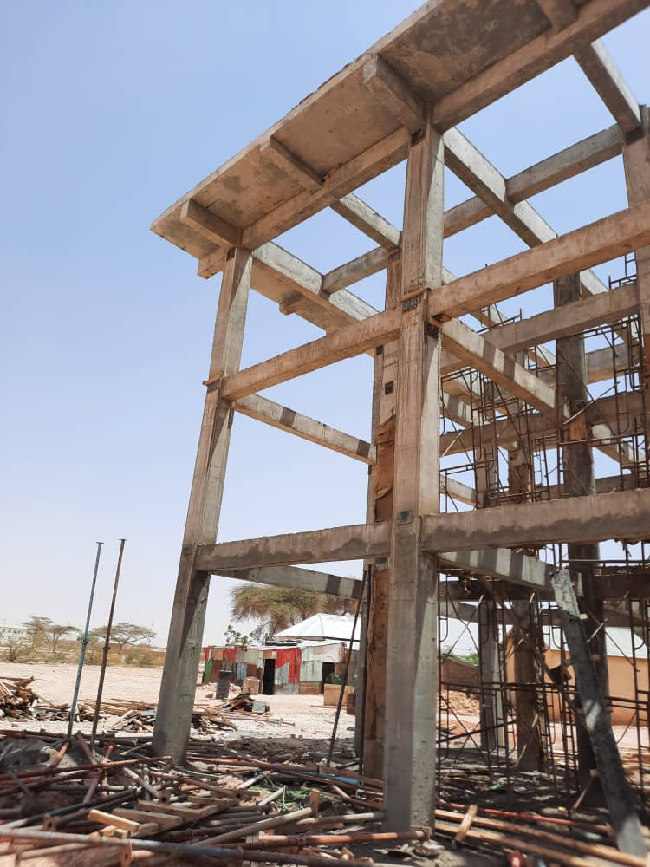
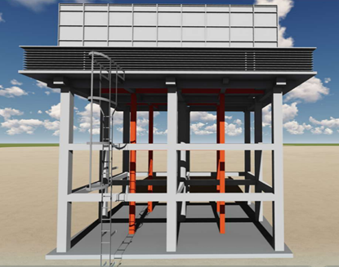
De-shutering of the top beams and slaps of Qardho water tank

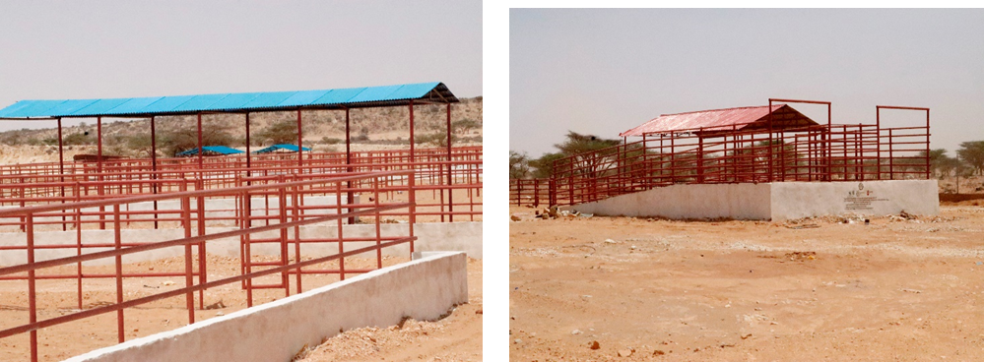
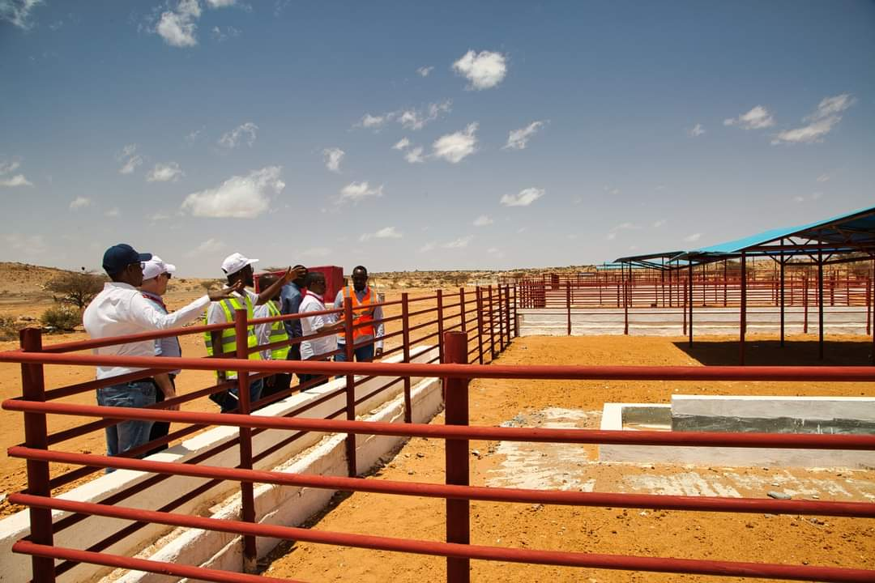
SCI officials monitoring and supervising Qardho livestock market

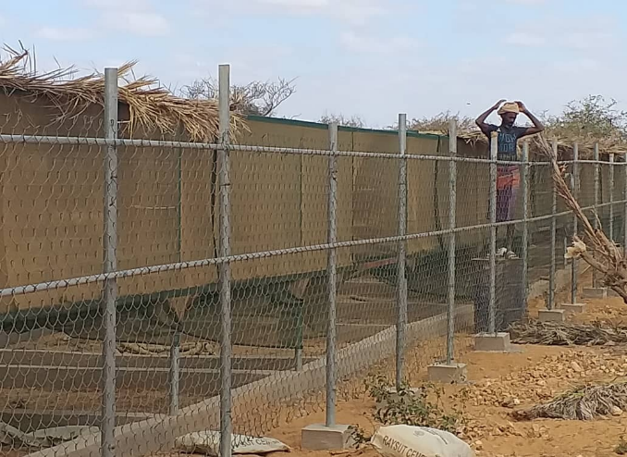
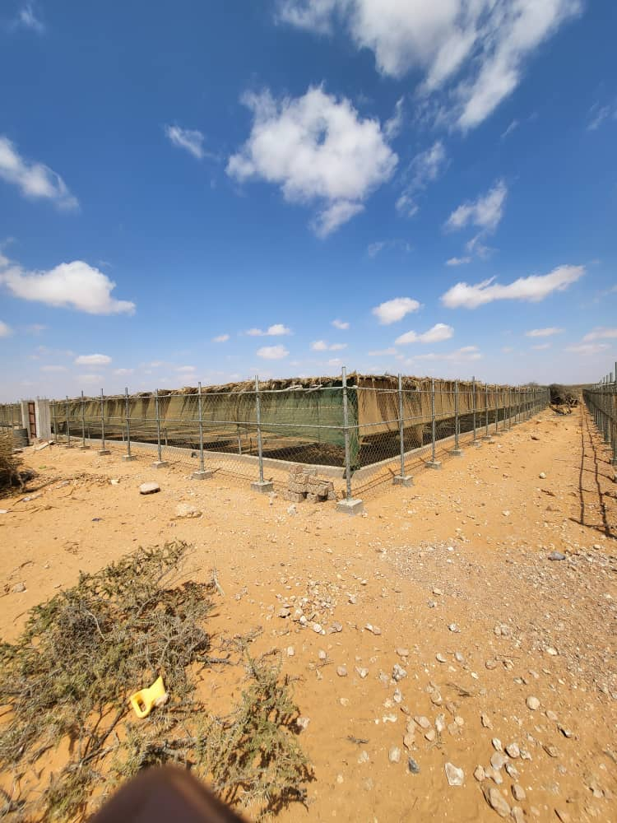
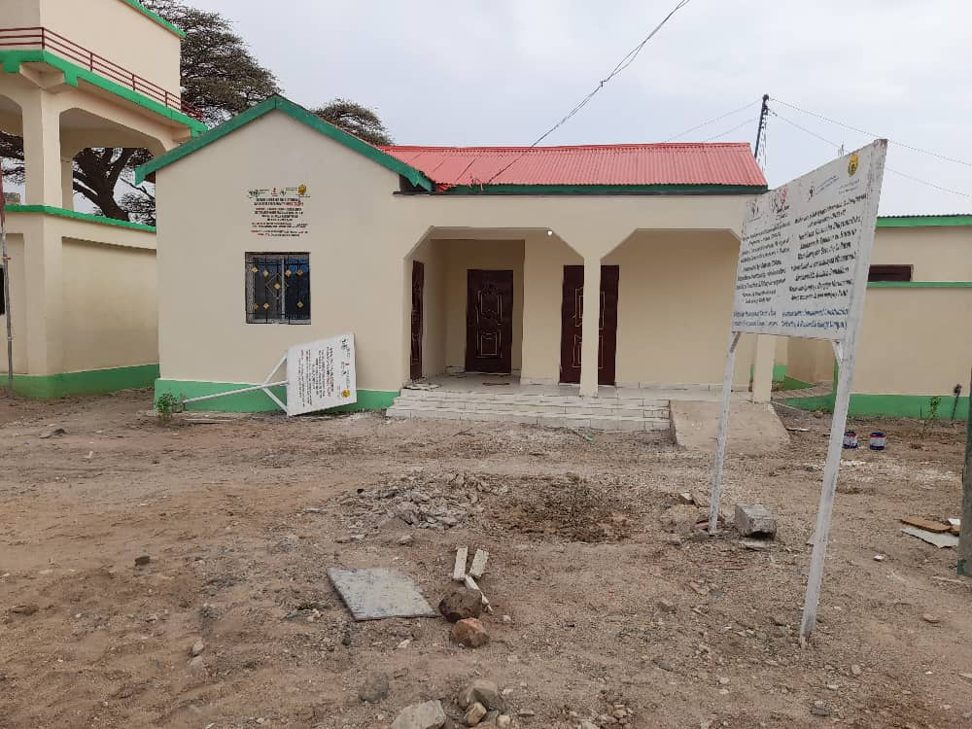C  certification office In Borama Livestock Market | 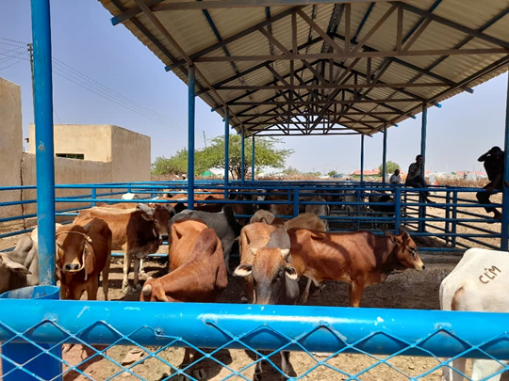  Livestock shade in action in Borama Livestock market
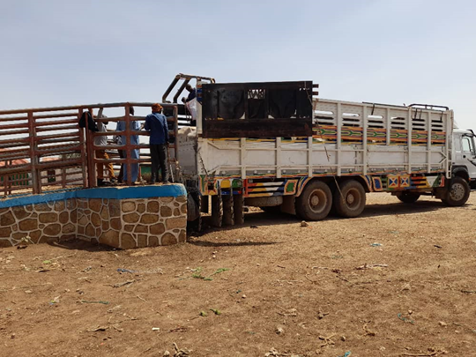  Rehabilitated Loading Ramp in Action in Wajale | 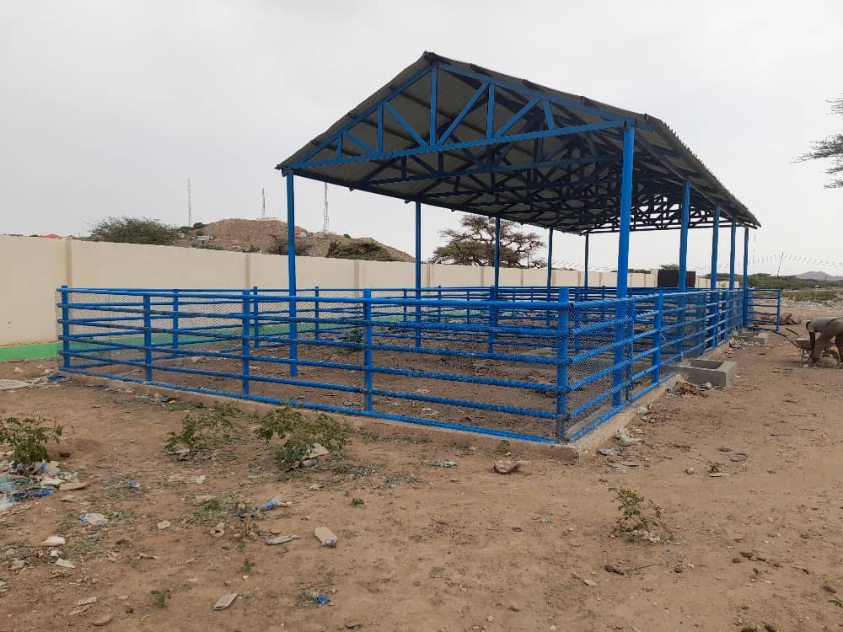
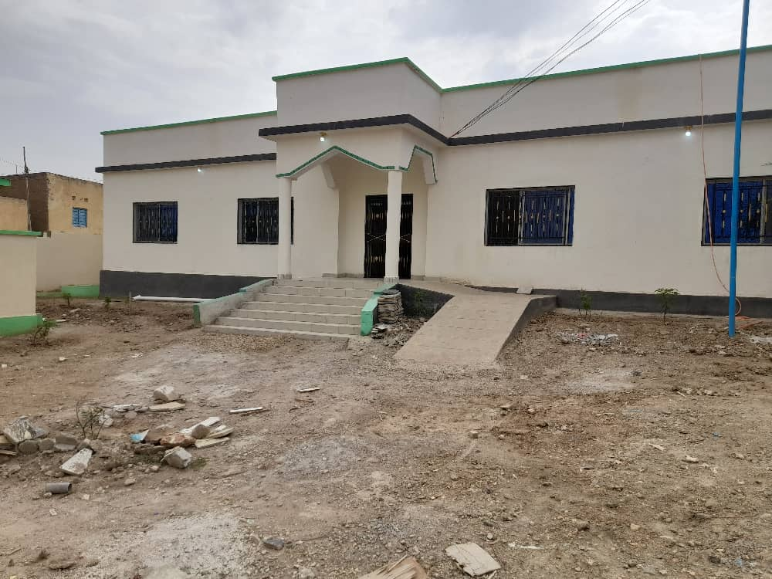 | 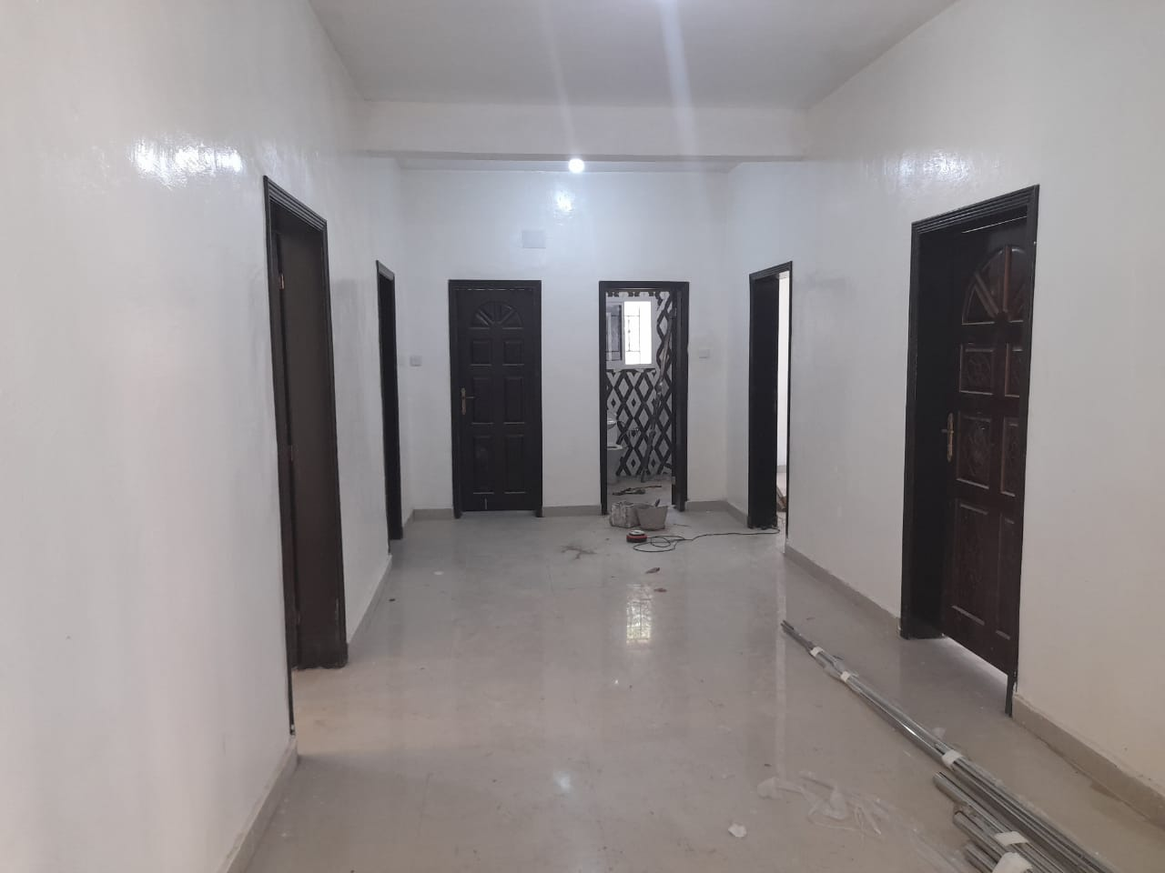
Certification Offices in Borama livestock market | Sanitation blocks in Borama
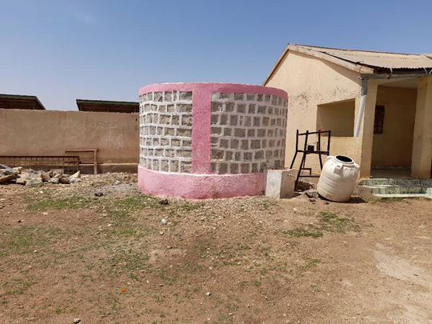  Constructed water tank in Wajale | Livestock Shade in Action in Borama

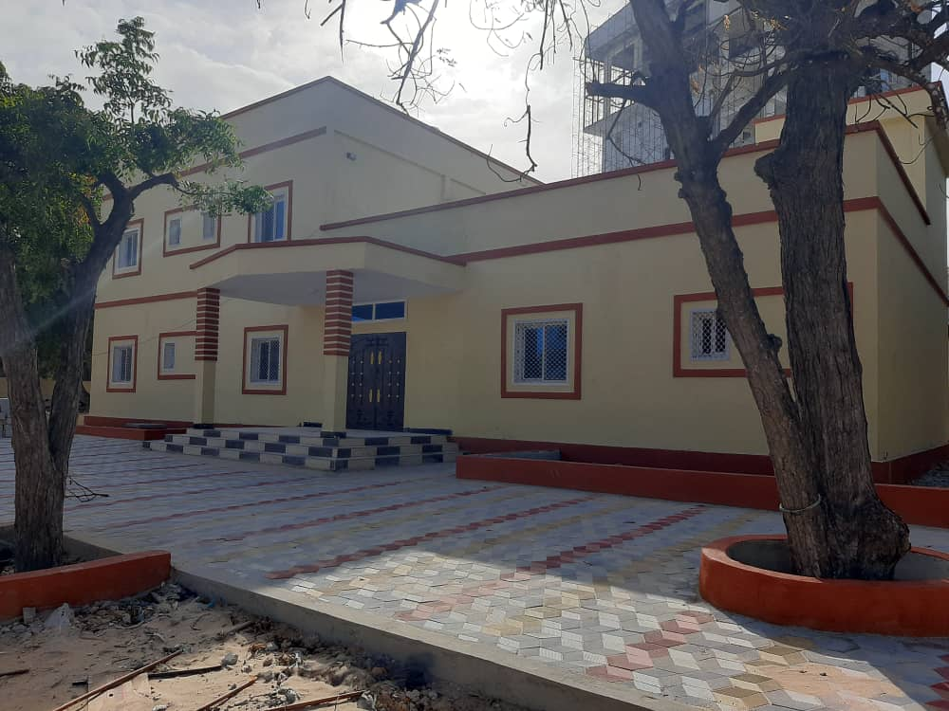
Reconstruction of Ministry of Agriculture and irrigation MOA HQ office Photos
Figure I: Completed G+1 Ministry of Agriculture and irrigation, HQ, Mogadishu
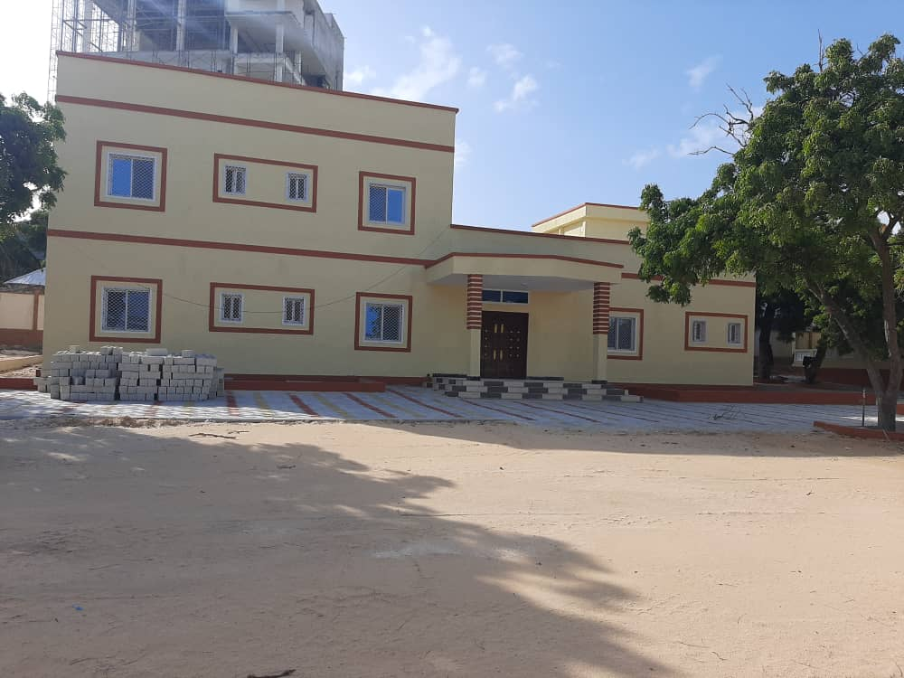

Annex 3 – Resilience/Borderland Projects

- Project title: Build Resilience for Food and Nutrition Security in the Horn of Africa (BREFONS)
Start Date: 2022
End Date: 2027
Project Location: Djibouti, Ethiopia, Kenya, Somalia, and South Sudan
Cross-border cluster: Cluster 1, Cluster 2, and Cluster 3
Priority Intervention areas (PIAs):
- PIA 1: Natural resources and environment management
- PIA 2: Market access, trade and financial services
- PIA 3 : Livelihoods support and basic social services
- PIA 4 : Disaster risk management, preparedness and effective response
- PIA 5: Research, knowledge management and technology transfer
Lead Organization: IGAD
Collaborating organizations: IGAD
Financial sources: African Development Bank (AFDB)
Project description: Program objectives: BREFONS’s principal goal is to build resilience to food and nutrition insecurity in the project intervention areas in the Horn of Africa. The program will lead to improvement in the living conditions of women, youth, and the population in general. BREFONS’s specific objective is to build resilience to food insecurity and climate change by enabling participating countries to: (i) increase agropastoral productivity and production systems in cross-border areas in the IGAD region (the regional clusters); (ii) make agropastoral value chains more competitive, thereby ultimately boosting trade and incomes; and (iii) enhance populations’ adaptive capacity so that people can better prepare for and manage climate change, climate risks, and climate variations.
Contacts: IGAD Secretariate, IGAD Drought Disaster Resilience and Sustainability Initiate (IDDRSI) Regional Programing Coordinator Dr. Tesfaye Beshah

- Project title: Building Opportunities for Resilience in the Horn of Africa (BORESHA)
Start Date: 2017
End Date: 2020
Project Location: Mandera County in Kenya, Dolo Ado region in Ethiopia, and Gedo region in Somalia.
Cross-border cluster: Cluster 2, Cluster 3
Priority Intervention areas (PIAs):
- PIA 1: Natural resources and environment management
- PIA 2: Market access, trade and financial services
- PIA 3 : Livelihoods support and basic social services
- PIA 4 : Disaster risk management, preparedness and effective response
- PIA 5: Research, knowledge management and technology transfer
- PIA 6: Conflict prevention, resolution and peace building
- PIA 7: Coordination, institutional strengthening and partnerships
Lead Organization: Danish Refugee Council
Collaborating organizations: World Vision International, Care International, WYG
Financial sources: European Union
Project description: Funded by the European Union Trust Fund for Africa, the Building Opportunities for Resilience in the Horn of Africa (BORESHA) project's overall objective is to promote economic development and greater resilience, particularly among vulnerable groups in the Mandera Triangle. The project will adopt a community-driven approach to address the shared nature of the risks and opportunities on in this border area.
It is part of the EU's programme for Collaboration in the Cross-Border areas of the Horn of Africa, providing over 60 million euros of investment to prevent and mitigate the impact of local conflict and to promote economic development and greater resilience in four different cross-border regions.
Contacts: BORESHA Consortium Danish Refugee Council - East Africa and Great Lakes P.O Box 14762 – 00800 Nairobi, Kenya Office: +254 709867000 Email: KEN-Boresha@drc.ngo | Twitter: BORESHA_HoA Website: www.boreshahoa.org

- Project title: Drought Resilience and Sustainable Livelihoods Programme in The Horn of Africa (DRSLP)
Start Date: 2012
End Date: 2018
Project Location: Djibouti, Ethiopia Kenya, IGAD Secretariat
Cross-border cluster: Cluster 1 Cluster 1, Cluster 2, and Cluster 3
Priority Intervention areas (PIAs):
- PIA 1: Natural resources and environment management
- PIA 2: Market access, trade and financial services
- PIA 3 : Livelihoods support and basic social services
- PIA 4 : Disaster risk management, preparedness and effective response
- PIA 7: Institutional Strengthening, Coordination and Partnerships
- Lead Organization: Intergovernmental Authority on Development (IGAD)
Collaborating organizations: Ministry of Livestock, Forestry and Range – Somalia; Ministry of Agriculture and Livestock – Kenya; Ministry of Agriculture - Ethiopia ; Ministry of Agriculture, Water, Fisheries, Livestock and Marine Resources – Djibouti,
Financial sources: Africa Development Bank
Project description: The Drought Resilience and Sustainable Livelihoods Program (DRSLP) is a long-term program developed by the African Development Bank and the IGAD Member States to build communities’ resilience to drought and climate change shocks improve their livelihood and promote regional integration in the Horn of Africa. Designed to be implemented in a series of 5-year projects, the program is expected to develop infrastructure for water mobilization and management; and agriculture and livestock production, health and marketing.
The Drought Resilience and Sustainable Livelihoods Program (DRSLP) is a long-term program developed by the African Development Bank and the IGAD Member States to build communities’ resilience to drought and climate change shocks improve their livelihood and promote regional integration in the Horn of Africa. Designed to be implemented in a series of 5-year projects, the program is expected to develop infrastructure for water mobilization and management; and agriculture and livestock production, health and marketing. The first project, DRSLP I, which includes support to the IGAD Secretariat in its coordination role, was approved on 12 December 2012 for a total amount of UA 91.2 million in loans and grants. DRSLP II for a total amount of UA 81.667 million was approved on 26 November 2014. DRSLP III, approved in December 2015, for a total amount of UA 31.176 million, was aimed at scaling up program interventions in Djibouti and Sudan. Implementation of the three projects is now underway in Djibouti, Ethiopia, Kenya, Somalia, and Sudan. Sudan and Somalia each appointed the IGAD Secretariat to act as its Third Party to receive and administer resources from the African Development Bank as provided for in the second and third projects of DRSLP. A Fund Management Unit was subsequently established at the IGAD Secretariat.
The first project, DRSLP I, which includes support to the IGAD Secretariat in its coordination role, was approved on 12 December 2012 for a total amount of UA 91.2 million in loans and grants. DRSLP II for a total amount of UA 81.667 million was approved on 26 November 2014. DRSLP III, approved in December 2015, for a total amount of UA 31.176 million, was aimed at scaling up program interventions in Djibouti and Sudan. Implementation of the three projects is now underway in Djibouti, Ethiopia, Kenya, Somalia, and Sudan. Sudan and Somalia each appointed the IGAD Secretariat to act as its Third Party to receive and administer resources from the African Development Bank as provided for in the second and third projects of DRSLP. A Fund Management Unit was subsequently established at the IGAD Secretariat.

The project interventions support activities to rebuild existing livelihoods through investment in natural resources (water, pasture) management, integrated land management and ecosystem restoration and protection and also investment in agricultural and livestock infrastructure, while improving storage, market and transport infrastructure, such as rural roads. The project aims at addressing the root causes of the region’s vulnerability in order to build a medium to long-term resilience against drought, enhance peace building and conflict resolution and equitable utilization of the limited natural resources.

Technical and Human Resource Support was provided to IGAD Secretariat with the technical assistance required to implement the drought resilience initiatives by: (i)Recruitment of technical Staff for Regional Coordination Unit: (ii)Financing studies and the development of supportive policy and legal frameworks at member state and regional levels (iii)Recruitment of additional staff for the relevant divisions and units of IGAD. Institutional Support Support to IGAD Secretariat in terms of logistics: (i)Installation of ICT Infrastructure and enhancing the (water, agriculture ,livestock and NRM) information management systems (ii)Equipment for Regional Coordination Unit, IGAD Secretariat, IGAD divisions and specialized institutions (iii)Regional Coordination Meetings and enhancing linkages with member states and NSAs Read More: Djibouti: ; Ethiopia: Kenya: IGAD Secretariat:

Contacts: then, Dr. John P. Kabayo - john.kabayo@igad.int : replaced contact is Dr. Tesfaye Beshah.

- Project title :Horn of Africa: Strengthening IGAD’s capacity to enhance drought resilience in the Horn of Africa
Start Date: 2016
End Date: 2020
Project Location: IGAD Member States: Djibouti (HQ), Eritrea (currently suspended), Ethiopia, Kenya, Sudan, Somalia, South Sudan, Uganda
Cross-border cluster: Cluster 1
Priority Intervention areas (PIAs):
PIA 1: Natural resources and environment management
PIA 3 : Livelihoods support and basic social services
PIA 7: Institutional Strengthening, Coordination and Partnerships
PIA 8: Human Capital, Gender and Social Development
Lead Organization: Intergovernmental Authority on Development (IGAD)
Collaborating organizations: Deutsche Gesellschaft für Internationale Zusammenarbeit (GIZ) GmbH
Financial sources: German Federal Ministry for Economic Cooperation and Development (BMZ); European Union Trust Fund for Africa (EUTF)
Project description: The German International Zussamenarbeit (GIZ) supports this approach by strengthening the capacity of IGAD and its Member States to develop adequate, pro-active policies and interventions to build drought disaster resilience. The project works closely with IGAD, its specialised offices, Member States and local authorities throughout the IGAD region in five key intervention areas: 1. Improve internal capacity for IDDRSI support at the IGAD Secretariat and within its institutions 2. Boost IGAD’s capacity to deliver IDDRSI support services and to facilitate Member State implementation of cross-border IDDRSI activities 3. Strengthen specific IGAD capacities for managing natural resources within selected IDDRSI clusters 4. Strengthen peace and security as an integral part of cross-border IDDRSI measures 5. Assist IGAD to build up the basic capacity it needs to deal with the drought resilience-migration nexus.
Contacts: Bedru Muzein bedru.muzein@giz.de

- Project title: IGAD-FAO Partnership Program (PP)
Start Date: June 2016
End Date: May 2021
Project Location: Ethiopia, Kenya, Somalia Border including selected cross-border locations of Ethiopia (Liben) Kenya (Mandera) and Somalia (Gedo) among ethnic Somalis. The target areas also encompass the Watershed of the Dawa River, which forms part of the Ethiopia- Somalia and Ethiopia- Kenya border.
Cross-border cluster: IGAD Cluster 3
Priority Intervention areas (PIAs):
- PIA 1: Natural resources and environment management
- PIA 2: Market access, trade and financial services
- PIA 3 : Livelihoods support and basic social services
- PIA 6: Conflict prevention, resolution and peace building
- PIA 7: Coordination, institutional strengthening and partnerships
- Lead Organization:Inter-Governmental Authority on Development (IGAD)
Collaborating organizations: Food And Agriculture Organization Of The United Nations (FAO)
Financial sources: Swiss Agency For Development And Cooperation (SDC)
Project description: IGAD-FAO Partnership Program is designed by IGAD and FAO to bring communities at the center of the cross-border policy and investment discourse and actions, not only as beneficiaries but as key stakeholders defining the agenda of their future. It seeks to enhance the resilience of communities in selected cross border areas coupled with the strengthening of IGAD’s capacity (particularly the specialized institutions) to effectively lead and facilitate interaction among its member states on policy and investments thereby fostering the delivery of cross border resilience. Four key components identified through interaction with various key stakeholders frame the program; Outcome 1: Cross-border communities have enhanced trade opportunities, improved access to natural resources and increased productive capacity, Outcome 2: The regional thematic resilience related policy framework has improved, Outcome 3: Improved evidence-based analysis and information feed into investment decisions, Outcome 4: IGAD specialized institutions are able to more effectively deliver its mandate. IGAD FAO PP Objective is to enhance resilience to drought resulting in improved food and nutrition security of communities and households in ASAL.
Contacts: Caroline Agosa Kirungu Project Coordinator/ Agroclimatologist IGAD Centre For Pastoral Areas and Livestock Development Kabete Vetlab, Kapenguria road, off Waiyaki way P.O.Box 47824- 00100 caroline.kirungu@igad.int / Paul Opio
FAO Livestock Officer – Resilience Team for East Africa
UN Avenue, Gigiri, Nairobi
United Nations Complex
Block P, Level 3
PO Box: 30470, 00100, GPO
Paul.Opio@fao.org

- Project title: Regional Approaches for Sustainable Conflict Management and Integration (RASMI)
Start Date: 2017
End Date: 2020
Project Location: Mandera country, Kenya, Gedo region in Somalia and Dolo in the Somali region of Ethiopia
Cross-border cluster: Mandera cluster
Priority Intervention areas (PIAs):
- PIA 1: Natural resources and environment management
- PIA 2: Market access, trade, and financial services
- PIA 3: Livelihoods support and basic social services
- PIA 4: Disaster risk management, preparedness, and effective response
- PIA 5: Research, knowledge management, and technology transfer
- PIA 6: Conflict prevention, resolution and peace-building
- PIA 7: Coordination, institutional strengthening, and partnerships
Lead Organization: PACT
Collaborating organizations:
- Inter-Africa Group (IAG)
- Integrated Development Focus (IDF)
- Mandera Women for Peace and Development (MWFPD)
- Network for Peace and Development (NEPED)
Financial sources: European Union Emergency Trust Fund for Africa (EUTF)

Project description: The Regional Approaches for Sustainable Conflict Management and Integration (RASMI) project adopts a conflict systems-based approach to promote peace-building, conflict management, and conflict resolution capacity at the community and cross-border levels. It is part of the EU’s program for Collaboration in the Cross-Border areas of the Horn of Africa, providing over 60 million euros of investment to prevent and mitigate the impact of local conflict and to promote economic development and greater resilience in four different cross-border regions.RASMI, which means “reliable” in Somali, targets stakeholders in the Mandera Triangle who are most vulnerable to engaging in conflict, irregular migration, and recruitment into militias and terror groups. These stakeholders include youth, internally displaced people, and pastoralist dropouts and marginalized ethnic groups. At the same time, RASMI engages local government agencies, women, religious leaders, security forces and the private sector – those who have the greatest capacity for managing conflicts and promoting peace.
Contacts: Regional Team Lead: Yussuf Mohammed Abdullahi ymabdullahi@pactworld.org
Project Manager: Issack Abdirahman IMAbdirahman@pactworld.org

- Project title: Strengthening Coordination and Implementation of IDDRSI (SCII)
Start Date:2019
End Date: 2022
Project Location: IGAD region, Mandera
Cross-border cluster: Mandera
Priority Intervention areas (PIAs):
- PIA 1: Natural resources and environment management
- PIA 2: Market access, trade and financial services
- PIA 3 : Livelihoods support and basic social services
- PIA 4 : Disaster risk management, preparedness and effective response
- PIA 5: Research, knowledge management and technology transfer
- PIA 6: Conflict prevention, resolution and peace building
- PIA 7: Coordination, institutional strengthening and partnership
- PIA 8: Human capital, gender and social development
Lead Organization: Inter-Governmental Authority on Development (IGAD)
Collaborating organizations: (IDDRSI at national levels, and other institution to be confirmed
Financial sources: Government of Sweden
Project description: Building on the on-going support from Sweden and other development partners; and with the benefit of the experiences and lessons learnt from implementation of the first phase of the IDDRSI Strategy (2013 – 2018), the IGAD Secretariat will use the proposed project to consolidate its work in the promotion and coordination of resilience-building activities in the IGAD region by focusing on the following areas: (a) Optimising the implementation of IDDRSI: This aims at mainstreaming CPP elements in the National Development Plan, improved coordination of regional platform, and improved governance of CPPs at national and sub-national levels. (b) Scaling up resilience-enhancing technologies and innovations in cross-border areas: This will be achieved through multi-stakeholders and policy dialogues. (c) Gender mainstreaming, capacity development and partnership needed to achieve the objectives of IDDRSI: A Gender and Resilience Working Group will be established to facilitate mainstreaming of gender across IDDRSI PIAs, basing on findings from gender analysis of RPP and CPPs conducted in 2016. Capacity development will focus on Member States M&E strengthening and staff support to IGAD. Furthermore, inclusive partnerships with regional, continental and global resilience actors will be established. d) Improving the IGAD’s capacity to monitor, analyse and evaluate the process of attaining resilience-enhancement. This refers to capacities relating to food security, nutrition and resilience information systems and institutional framework at regional and national level improved. Furthermore, climate information on rainfall seasons disseminated at Regional Climate Outlook Forums.

Contacts: Tesfaye Beshah Regional Programming Coordinator IGAD Drought Disaster Resilience and Sustainability Initiative (IDDRSI) Djibouti tesfaye.beshah(at)igad.int

Annex 4 –Status of HoA Initiative Priority Project List (For Somalia) As on May 4, 2023

Projects | Development Partner | Status | Total  ($m in USD) | Partner countries
Pillar 1: Regional Infrastructure Networks
1 Economic Corridors
Somalia HoA Infrastructure Integration Project (Under SHIIP) | World Bank | Active | 63 | Somalia
Pre-feasibility study (Economic Corridors) | EU | Active | 0.32 | Regional
Horn of Africa Kismayo, Lamu and  Mogadishu Corridor: (Kenya) Elwak-Rhamu- Mandera Road Upgrading Project | AfDB | Active | 206.55 | Kenya, Ethiopia, Somalia
Horn of Africa Djibouti - Somalia  Regional Transport Project Phase I | AfDB | Active | 64 | Somalia
pre-feasibility study for the Somalia Kub-Kab Road corridor (Somalia) | AfDB | Active | 0.063 | Somalia
Road Infrastructure Programme Phase II (several roads) | AfDB | Pipeline | TBC | Somalia
2 Regional Energy Trade
Pre-feasibility study (Regional Energy Trade) | EU | Active | 0.32 | Regional
3 Single Regional and Interconnected Digital Market

The Eastern Africa Regional Digital Integration operation (EA-RDIP) | WB | Active | 80 | Somalia
D4D Collaboration for the Horn of  Africa Initiative  on Digital Government - Now IDGC - Initiative on Digital Government and Cybersecurity | EU | Active | 10.6 | Regional
Pre-feasability study (Single Digital Market) | EU | Active | 0.32 | Regional
HoA Digital market integration phase I project | AfDB | Active | 8.3 | Regional
Pillar 2: Trade and Economic Integration
De-Risking, Inclusion and Value Enhancement of Rural Economies Project | World Bank | Active | 333 | Regional
COMESA Trade Facilitation Program | EU | Active | 5.94 | Regional
Pillar 3: Building Resilience
Groundwater for Resilience | World Bank | Active | 385 | Regional
Food Systems Resilience Program for Eastern and Southern Africa | World Bank | Active | 600 | Regional
Locust Response (Djibouti, Kenya, Ethiopia, Somalia) | World Bank | Active | 210 | Regional
Development Response to Displacement Impacts Project in the HoA | World Bank | Active | 130 | Regional
Africa Environmental  Health and | World Bank | Active | 8 | Regional

Pollution Management Program
Locust Response | EU | Active | 81.62 | Regional
Collaboration in Cross-  Border Areas of the Horn of Africa Region –top up | EU | Active | 5.30 | Regional
RESTORE Building Resilience in Northern Somalia | EU | Active | 3.18  (EUR€  11.8  m total proj.) | Somalia
RESTORE II Building Resilience in Northern Somalia | EU | Active | 8.48 | Somalia
Peaceful and resilient borderlands in the Horn of Africa | EU | Approved | 42.40 | Regional
BREACH - Boosting Resilience and Adaptation to Climate Change | EU | Approved | 37.10 | Somalia
MULTINATIONAL - East and  Horn of Africa Desert Locust Crisis: Emergency assistance to fight the desert locust invasion in 9 regional member countries  - Special Relief Fund (SRF) | AfDB | Active | 1.49 | Regional
Program to build resilience for food and nutrition security in in the Horn of Africa | AfDB | Active | 176.85 | Regional

