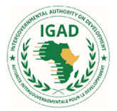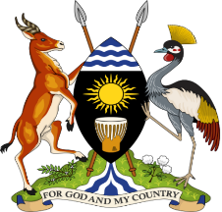
THE REPUBLIC OF UGANDA

Progress Report of Resilience Projects from January 2014 to October 2023
Tenth Anniversary of IDDRSI

16th IDDRSI Platform Steering Committee and 9th General Assembly Meetings
22-24 November 2023
Entebbe, Uganda

Progress Report of Resilience Projects from January 2014 to October 2023
Tenth Anniversary of IDDRSI

16th IDDRSI Platform Steering Committee and 9th General Assembly Meetings
22-24 November 2023
Entebbe, Uganda

Table of Contents

Table of Contents i
1.0 Introduction 1
2.0 Progress on the Implementation of Recommendations of 15th PSC 2
3.0 Updates on the Implementation of the Resilience Projects: January 2014 to October 2023 3
3.1 PIA 1: Natural Resources and Environment Management 3
3.1.5 Development of Renewable Energy Access to affordable, reliable, sustainable and renewable energy ensured 7
3.1.6 Land Governance 8
3.2 PIA 2: Market Access, Trade and Financial Services 8
3.2.1 Transport and Market Development 8
3.2.3 Access to Secure and Affordable Financial Services 10
3.2.4. Strengthening Regional and Cross-Border Trade 10
3.3 PIA 3: Enhance Production and Livelihood Diversification 11
3.3.1 Livestock Production and Productivity 11
3.3.2 Crop production and Productivity 12
3.3.3 Fisheries and Apiculture development 12
3.4 PIA 4: Disaster Risk Management, Preparedness and Effective Response 12
3.4.1 Early Warning Systems and Response 13
3.4.2 Contingency Planning 13
3.4.3 DRR (Prevention, Mitigation & Preparedness) and Climate Change Adaptation. 14
3.4.4 Hazard, Risk and Vulnerability Mapping 15
3.5 PIA 5: Research, Knowledge Management and Technology Transfer 15
3.5.2 Advisory and Extension Systems 15
3.6 PIA 6: Conflict Prevention, Resolution and Peace Building 15
6.1 Peace Building and Mediation Mechanisms 15
6.2 Conflict Resolution 17
3.7 PIA 7: Institutional Strengthening, Coordination and Partnerships 17
3.7.1 Coordination and Platform Management 17
3.7.2 Institutional Strengthening and Capacity Building 19
3.7.3 Enhancing Partnerships 20
3.7.4 Resource Mobilization 20
3.7.5 Monitoring, Evaluation and Learning (MEL) 20
3.8 PIA 8: Human Capital, Gender and Social Developments 21
8.1 Access to Health and Nutrition 21
8.4 Social Safety Nets 23
8.5 Migration, Displacement and Social Inclusion 24
4.0 Challenges and Lessons Learnt during the Last Ten Years 25
4.1 Challenges 25
4.2 Lessons Learnt 26
5.0 Recommendations for the Implementation of IDDRSI from 2024 to 2027 28
6.0 Partnerships 29

Introduction
IGAD Drought Disaster Resilience and Sustainability Initiative (IDDRSI) is a15-year regional strategy to end drought emergencies with an objective to increase investments in the drylands, improve livelihoods and enhance resilience of communities to drought. Uganda like the other member stated is implementing its second 5-year Country’s Programming Paper, 2019 – 2024 whose focus is Consolidating the Path to Resilience and Sustainability. The plan builds on the foundation laid in the 1st CPP and particularly in addressing the key constraints in drought emergencies.
Uganda Country Programming Paper (CPP) is the domestication of the IGAD Drought Disaster Resilience and Sustainability Initiative (IDDRSI). It therefore identifies Uganda’s priority interventions to end drought related emergencies and build resilience in the drylands. The overall objective of the CPP is to improve livelihoods and enhance resilience of communities to drought by transforming the agro-pastoralist and pastoralist sector into a more profitable, integrated and resilient economic system thereby improving food and nutrition security.
This CPP contributes to the realization of Uganda Vision 2040 aspirations, which aims at transforming Uganda from a predominantly peasant and low-income country to a competitive upper middle-income country with a per capita income of USD 9,500. The Vision 2040 is premised around strengthening the fundamentals of the economy to harness the abundant opportunities around the country. It is also aligned to the Third National Development Plan whose goal is to increase household incomes and the quality of life of Ugandans.
Uganda since 2015 implemented the Regional Pastoral Livelihoods Resilience Project (RPLRP) together with the other two project countries of Ethiopia and Kenya and IGAD levels. The overall Project Development Objective (PDO) was: To enhance livelihood resilience of pastoral and agro-pastoral communities in cross-border drought prone areas of selected countries and improve the capacity of the countries’ governments to respond promptly and effectively to an eligible crisis or emergency.
This report therefore presents summary findings on implementation of the country’s Proramming Paper interventions for a decade along the 8 Priority Intervention Areas (PIAs) of i) Natural Resources and Environment Management; ii) Market Access, Trade and Financial Services; iii) Enhanced Production and Livelihood Diversification; iv) Disaster Risk Management; v) Research, Knowledge Management and Technology Transfer; vi) Peace Building, Conflict Prevention and Resolution; vii) Coordination, Institutional Strengthening and Partnerships; and Human Capital, Gender and Social Development.

Progress on the Implementation of Recommendations of 15th PSC
SN | Recommendation | Progress
15.3 | Recognizing resilience as a multi-sectoral and multi-agency undertaking urges the Member States to step up their coordination efforts to cover projects implemented by various ministries and agencies to represent the status of resilience at the country level. Further urges the Member States to set up relevant stakeholder coordination mechanisms for proper planning, implementation, monitoring, evaluation and learning of resilience projects to improve resilience programming for optimum prioritisation and synergy | In Uganda, the Office of the Prime Minister (OPM) is mandated to coordinate all government programmes, policies and plans in the country.  OPM annually develops the Government Annual Performance report that is encompasses resilience initiatives implemented by government
15.5 | Noting that the arid and semi-arid lands in the region are facing water scarcity for human beings, livestock and agriculture and recalling recommendation 14.4, call upon all stakeholders to intensify investment in water development to ensure that communities in the ASALs have sustainable access to safe water through bringing “water to the people” approach that would also address their needs for water for livestock, crop and fruit production | During FY 2022/23, access to safe water in urban areas increased from 72.1% in FY2021/22 to 72.8%. The rate of investment in urban water supply infrastructure is lower than the rate of population growth rate in urban areas, estimated at 5% per year.
15.11 | Pursuant to the IGAD policy framework on informal cross-border trade aimed at boosting cross-border security governance, calls for the IGAD Member States to remove barriers and strengthen trade between member states to facilitate the movement of foodstuff from the food surplus to deficit regions. | According to the EAC Time Bound Program (TBP), there were 256 NTBs reported between 2004 and 2022, of which 234 were resolved. Over the last 7 years the rate of resolution has improved, increasing from 76%, from 2004 to 2015, to 94.9% in the years since then. The EAC Time Bound Programme reported that there were nine NTBs in 2015, and the average time of resolution was 535.3 days (about 1 and a half years) per NTB. In the years leading from this, the time to resolve NTBs improved, dropping from 328.4 days (about 11 months) in 2016, to 126.6 days in 2018. This illustrates a significant decrease in time taken to resolve an NTB. There was a slight increase in 2019 to 221.7 days as a result of COVID-19, however, the trend continues to fall, hitting 131.4 days in 2020 and 76.6 days in 2021.

Updates on the Implementation of the Resilience Projects: January 2014 to October 2023

PIA 1: Natural Resources and Environment Management
Major Projects implemented with budget utilisation
No | Title of Project | Duration of the Project | Utilised Budget (UGX Billion)
1 | Water for Production Project | 7/1/2004 - 6/30/2017 | 712.00
2 | Water for Production Phase II | 7/1/2019- 6/30/2024 | 530.155
3 | Irrigation for Climate Resilience Project | 7/1/2020 - 6/30/2025 | 429,407
4 | Development of Solar Powered Irrigation and Water Supply Systems | 7/1/2020- 6/30/2025 | 476.730
5 | Farm Income Enhancement and Forestry Conservation Project II | 7/1/2016 – June 2021 | 400
6 | Drought Resilience Project in Karamoja Sub-region | 7/1/2019 - 6/30/2024 | 113.560
7 | Enhancing Resilience of Communities to Climate Change | 7/1/2017- 6/30/2022 | 31.920

Develop water reservoir systems for irrigation, livestock production and human consumption
Globally Water for Production accounts to over 80% of water withdrawn for use. However, in Uganda, less than 2% of water is used in production but there is a sharp increase in demand primarily due to climate change and degradation of natural resources. The water sector has undertaken significant investments in water for production since the early 1990s in the cattle corridor districts that stretches from Isingiro in South Western Uganda to Karamoja in North Eastern. Bringing service coverage to 65% to-date, a sharp increase in demand is being experienced, primarily because of the high population growth, new approaches (force on account) to service delivery and the effects of climatic change resulting in water stress in most parts of the Country.
In response to the increasing demand for Water for Production from Districts and the general public, the MWE established Water for Production Regional centres (Northern, Eastern and Western) and has currently established Central and Karamoja Regional offices with a responsibility of improving the quality of life of the population through the provision of water for productive use in Livestock, aquaculture and mitigate effects of climate change through modern irrigation technology through; construction of valley tanks, earth dams and modern irrigation systems. Through this approach, service delivery has been brought closer to the grassroots through the staff deployed at the regions who work very closely with the districts and the communities.
Key medium-term targets for the water for production
- Develop water storage capacity to address water scarcity; Increase the cumulative water storage capacity from 39.3 Mcm³ to 163.37 Mcm³ by 2040.
- Develop bulk water transfer Infrastructure to water stressed areas.
- Increase area under formal irrigation (hectares) targeting medium to large scale Irrigation from 15,000 hectares (0.5%) to 1,515,000 hectares (50%) by 2040 against the irrigation potential of 3,030,000 hectares.
- Restore, improve and sustain functionality to 100% for all water for production facilities currently comprising of; (10 medium scale irrigation schemes, 35 earth dams and 381 Communal Valley tanks.
Water for Production (WfP) Performance since 2014 to date
In order to address the challenges of climate change and food insecurity across the country, the Ministry of Water and Environment constructed to completion medium and large-scale irrigation schemes across the country thereby increasing the land area under formal irrigation. The area under irrigation has increased from 14, 418 hectares in FY2014/15 to 22,976 hectares in FY2022/23 against an irrigation potential estimated at 3.03 million hectares country wide (Figure 3.1). This increase was higher than the NDP III target for the FY 2022/23 of 20,200 Ha. At the current rate of implementation, it is likely that the NDPIII target of 27,424 Ha will be achieved by 2025.
Figure 3. 1: Area under Irrigation (hectares)

The cumulative water for production storage capacity increased from 31.7 million cubic meters in FY2014/15 to 52.6 million cubic meters in FY2022/23 against the NDP III target of 57.52 million cubic meters in the same period (Figure 3.2). Additionally, functionality of Water for Production facilities is at 88.3%.
Figure 3. 2: Cumulative Water for Production Storage Capacity, FY2024/25 – FY2022/23

Irrigation schemes constructed. The Ministry has been able to fully complete the construction of the following irrigation schemes: Ngenge (880ha), Rwengaaju (116ha), Tochi (500ha), Mubuku II (480ha), Doho II (1,000ha), Olweny (600ha) and Agoro (650ha) in the Districts of Kween, Kabarole, Oyam, Kasese, Butaleja, Lira and Lamwo respectively with a total of 4,226 hectares.
Dams constructed. In order to increase storage, control floods, and provide for strategic multi-purpose water, the Ministry constructed Kagango dam (0.165 million cubic meters) in Isingiro District, Andibo earth dam (3.2 million cubic meters) in Nebbi District, Ongole dam (1.0 million cubic meters) in Katakwi district, Mabira earth dam (1.2 million cubic meters) in Mbarara District, Tochi (4.8 million cubic meters) in Oyam District, Ngenge (0.250 million cubic meters) in Kween District, Wadelai (8 million cubic meters) in Nebbi District and Mubuku II (0.140 million cubic meters) in Kasese District. This has created a water storage capacity of 13.190 million cubic meters for multi-purpose use with main focus on irrigation development. Construction of Kyenshama earth dam in Mbarara District is in the final stages of completion. These have increased on water for multi-purpose uses. Undertook feasibility studies and designed of One (1) multipurpose storage facility of Geregere earth dam and water facilities in Agago District.
Furthermore, the Ministry has intervened at community and individual level by constructing 169 valley tanks across the country.
Medium term plans
The Ministry in conjunction with other players plans to increase water for production storage capacity to 76.8 MCM from the current 52.6 MCM. The key interventions shall include:
- Construction of three (03) multi-purpose bulk water storage dams and watering facilities of Kyenshama in Mbarara (30%), Geregere in Agago (20%) and Lodoon in Napak (20%) including water abstraction systems, transmission mains, water pumping systems, storage tanks and water distribution networks.
- Construction of new medium to large scale irrigation schemes in Acomai, Atari, Amagoro, Nabigaga, Rwimi, Nyimur, Musambya, Kibimba, Kabuyanda, Matanda/Enengo, Igogero, Angololo, Kagera, Namatala, Namulu, Sipi, Unyama, Lumbuye, Nyabanja, Palyec, Porongo, Lopei and Imvepi.
- Rehabilitate and /or expand existing irrigation schemes namely Kiige, Odina, Ongom, Agwata and Atera irrigation schemes.
- Construct new multi-purpose water development schemes of; Kyenshama Geregere, Ojama Makokwa, Kyahi, Kakingole, Kokonyuko, Korisae Lothar, Girik, Komothing, Achorichori, Katabok, Kulodwongo, Katabok, Kaputh, Longore, Naoyamuwe, and Kokyeyo. Lemsui, Nakonyen and Nangololapolon
- Preparations to complete designs for 7 Multipurpose dams at Lemsui, Nakonyen and Nangololapolon, Makokwa, Kyahi, Ojama and 8 large scale Irrigation schemes of Rwimi, Kagera, Lumbuye, Kaliro, Nyabanja, Palyec, Purongo, Namalu, Sipi, Unyama, Amuru and Imvepi are underway.
- Additional works are considered in Karamoja area; therefore, another set of detailed designs will be completed for seven strategic multi-purpose bulk water storage facilities and irrigation schemes in Karamoja Sub-region; Korisae in Napak, Girik in Nakapiripirit, Komothing in Nabilatuk, Kulodwong in Abim, Kaputh in Kotido and Kokyeyo in Karenga.
- Develop 376 Solar powered water supply and small-scale irrigation systems under the Development of Solar Powered Water Supply and Irrigation Systems Project.
- Procure of six (6) Sets of earth moving equipment for construction of WFP interventions.

Figure 3. 3: Water for Production (WfP) facilities constructed
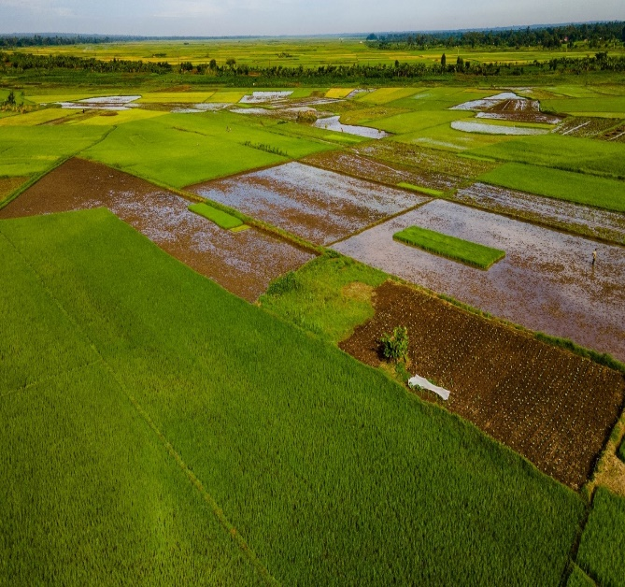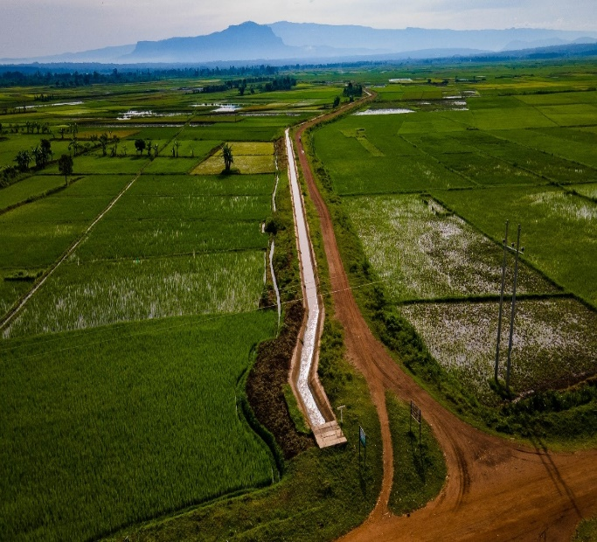
Aerial view of Doho II Irrigation scheme in Butaleja District Aerial view of Tochi Irrigation scheme in Oyam District
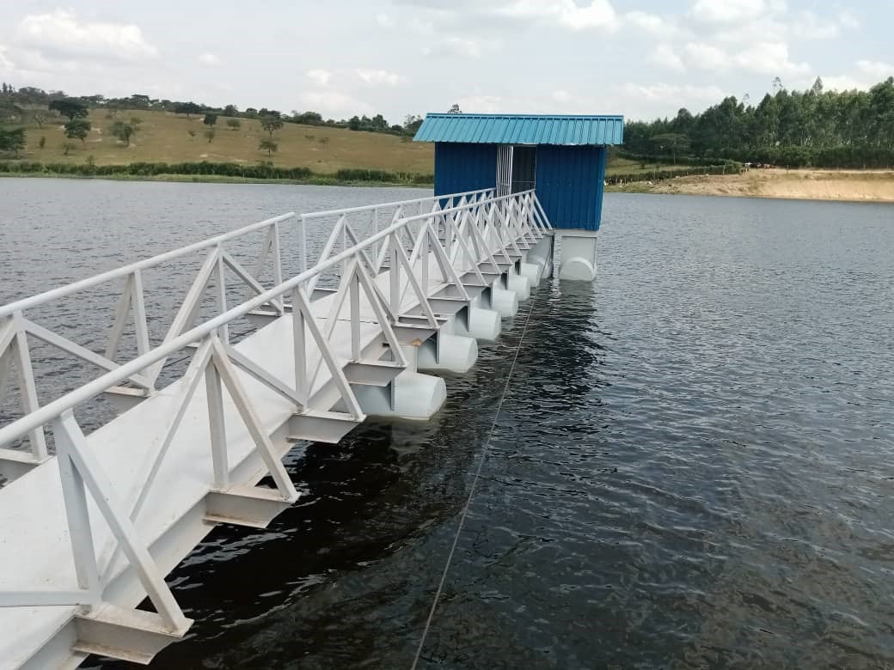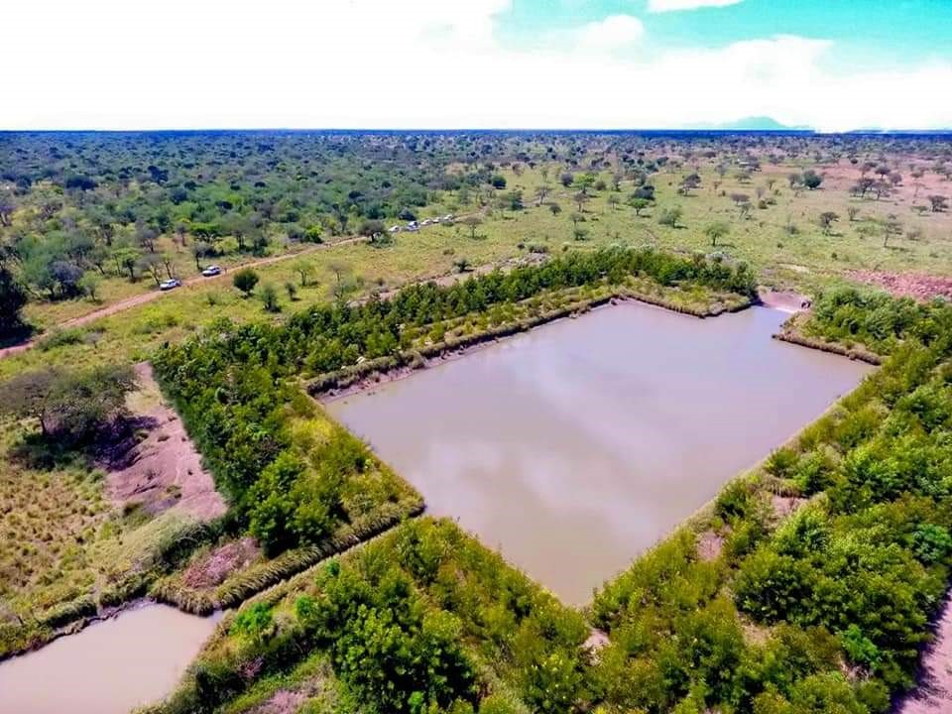
Kyenshama earth dam in Mbarara District Loho Valley Tank in Kotido District

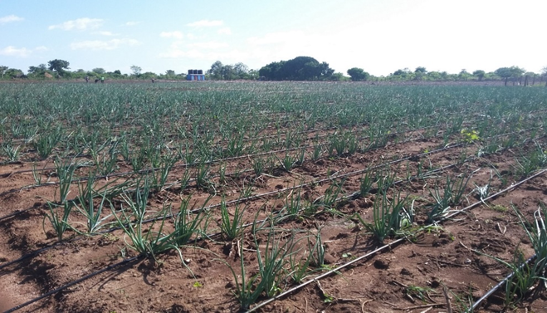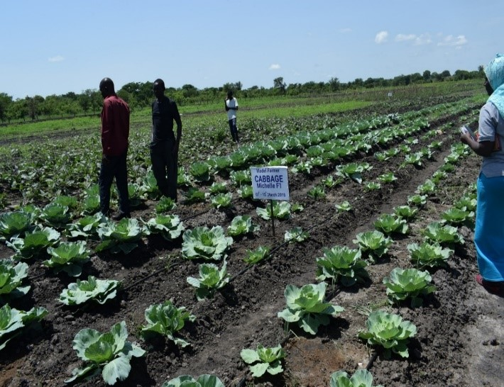
Ojikai Solar Powered Irrigation Scheme in Soroti District Lotuke Solar Powered Irrigation Scheme in Abim District

In order to ensure the protection of forests, rangelands, and mountain ecosystems, 998.3km of forest reserve boundaries were re-surveyed and marked in all 16 management areas of the Central Forest Reserves (CFRs) across the country (9 Ranges and 7 Plantation areas) and this constituted 45% (4,379.7km) of the total 9,755km of the 506 CFRs.
The unsustainable use of natural resources, including deforestation and land-use changes, has led to a reduction in forest cover, resulting in less absorption of carbon dioxide (CO₂) and increased release of greenhouse gases (GHGs), and incidence of floods and drought. Forests, acting as carbon sinks, play a vital role in mitigating climate change by sequestering CO₂. Similarly, wetlands, which act as natural carbon sinks, are facing modification and loss of functionality due to human activities. This disrupts their ability to absorb and sequester greenhouse gases, contributing to the accumulation of GHGs in the atmosphere. Preserving and restoring both forests and wetlands are crucial for mitigating climate change and preserving biodiversity and ecosystem services.
Forest cover increased from 10.7 percent of the total land area in the FY2010/11 to 13.3 percent of the total land area in the FY2022/23. Assure a significant survival rate of planted tree seedlings The average survival of tree seedlings established in the plantation management area was 75%. Survival of tree seedlings supplied to the farmers is compromised by a number of factors, including lack of sufficient technical advice provided by the forestry staff to the farmers and limited financing to facilitate the staff to engage with the farmers. For the tree seedlings supplied, the survival rate was about 65%.
Wetland coverage. Wetlands in Uganda today cover a total surface area of 33,762.6 sq. km (13.9%), with a notable increase of 0.9% from 13% in 2015 to 13.9% in 2022. Although the wetland coverage was estimated at 13% in 2015 of Uganda’s surface area, only 8.9% (21,526 km²) was intact, while 4.1% (9,885km²) was under some form of degradation.

3.1.5 Development of Renewable Energy Access to affordable, reliable, sustainable and renewable energy ensured
Uganda has many renewable energy resources that can be used for energy production and the provision of energy services. Many of the resources are not fully tapped. Renewable energy sources, such as biomass, geothermal resources, sunlight, water, and wind, are natural resources that can be converted into clean, usable energy. To add to existing solar energy in Uganda, the government of Uganda is implementing the development of solar-powered water supply and irrigation systems

3.1.6 Land Governance
Although eighty percent of Uganda's land is arable, only 35% is being cultivated. This is due to; varied and complicated land tenure system, low utilization of mechanization, high dependence on rain fed agriculture, pest and disease infestations, and limited access to affordable financing.
The total land titled/registered increased from 22.4% in 2021/22 to 30% in FY2022/23. The total number of land conflicts including backlog was 52,068, out of which 30,242 were mediated/resolved. This reduces the unresolved land conflicts from 45.84% in FY 2021/22 to 41.9% in FY 2022/23.
The percentage change in land conflicts increased from 2% in FY 2021/22 to 10% in FY2022/23. The total number of land conflicts including backlog was 52,068, out of which 30,242 were mediated/ resolved. This reduces the unresolved land conflicts from 45.84% in FY 2021/22 to 41.9% in FY 2022/23.

PIA 2: Market Access, Trade and Financial Services
Major Projects implemented with budget utilisation
No | Title of Project | Project Duration | Utilised Budget (UGX) - Billion
1 | Regional Pastoral Livelihood Improvement Project | July 2015 - June 2021 | 120
2 | Markets and Agricultural Trade Improvements Programme (MATIP 2) | 7/1/2015 - 6/30/2022 | 320
The Regional Pastoral Livelihood Improvement Project (RPLRP) was a five-year project executed by Ministry of Agriculture, Animal Industry and Fisheries (MAAIF) through Credit from IDA. The Project Development Objective was to enhance livelihood resilience of pastoral and agro-pastoral communities in cross-border drought prone areas of Uganda and improve the capacity of the government to respond promptly and effectively to an eligible crisis or emergency. Investment areas are natural resources, market infrastructure livelihoods and drought and conflicts risks reduction.
The technical components are: Natural Resource Management, Market Access and Trade, Livelihood Support, Pastoral Risk Management and Project Management and Institutional Support. key activities are; water resources development, pasture and land development, access to natural resources, market infrastructure and information, livestock mobility and trade, production and health, food and feed production, livelihood diversification, early warning, project management.
Project achievements. Construction of 12 markets, 12 slaughter sheds, 4 Quarantine stations (QS), 4 HG and 72 community crushes.
Markets and Agriculture Trade Improvement Programme Project 2 (MATIP 2) is one of the government interventions aimed at attaining prosperity for all, and improved market access and infrastructure development and also as a key function for the transformation of the agricultural sector from subsistence to commercial production.
Project achievements - Nine (9) Urban markets redeveloped, handed over and operationalized; Two (2) first and high levels value addition equipment installed in Arua and Busia; 16,951 vendors using market facilities (women) resettled in new Markets.

3.2.1 Transport and Market Development
Border infrastructure. Over the years, a number of border infrastructure has been improved and equipped to facilitate market access and ensure bee equitable access to markets, trade and basic services. In FY2022/23, a communication booster was installed in Mpondwe Market, for easy communication within the market and among traders.
Non-Tarif Barriers (NTBs) eliminated. There were 256 NTBs reported between 2004 and 2022, of which 234 were resolved. The EAC Time Bound Programme reported that there were nine NTBs in 2015, and the average time of resolution was 535.3 days per NTB. In the years leading from this, the time to resolve NTBs improved, dropping from 328.4 days in 2016, to 126.6 days in 2018. This illustrates a significant decrease in time taken to resolve an NTB. There was a slight increase in 2019 to 221.7 days as a result of COVID-19, however, the trend continues to fall, hitting 131.4 days in 2020 and 76.6 days in 2021, as seen in the figure below

Figure 3. 4: Average Time (days) Taken to Resolve NTBs
600
500
400
300
200
10 0
0
 | 2015 |  | 2016 |  | 2017 |  | 2018 |  | 2019 |  | 202 |  | 2021
Year
Source: Data from EAC Time Bound Programme
NTBs reported NTBs rose between 2015 and their peak in 2017. Since 2017 there has been a decline in NTB reports each year. In most years more NTBs were resolved than reported thus indicating longer term NTBs being removed. 50 NTBs were reported in 2017, while only 11 NTBs were removed. However, much of this backlog was resolved in 2018, which was the best year for removal (56).

Figure 3. 5: NTBs reported and resolved
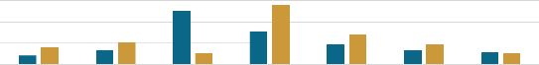
2015 2016 2017 2018 2019 2020 2021

Markets negotiated. These are: East African Community (EAC); Common Market for Eastern and Southern Africa (COMESA); African Continent Free Trade Area (ACFTA) including Specific Bilateral engagements such as Algeria, Serbia, Iran, Democratic Republic of the Congo (DRC) as strategy to expand market development and expansion opportunities aimed at achieving resilience and sustainability of the citizens of Uganda.
Trade Information Desks established. With Support from the World Bank, 3 TIDOs have been established in Goli- Nebbi district, Bunagana- Kisoro district and Mpondwe-kasese district over the period under review. TIDOs operate under the auspices of CBTAs at border stations bridging the gap in information access to CBTs. They too have also helped to fast-track implementation of the Simplified Trade Regime (STR) initiated by COMESA in 2010. However, the TIDOs lack a retainer salary to enable them to offer efficient services to the traders. The lack of TIDO retainer salaries has resulted in some Cross Border Trade Associations (CBTAs) at border stations having very weak in-service delivery.

3.2.3 Access to Secure and Affordable Financial Services
Over the period under consideration, so far three hundred and seventy (370) SACCOs have been formed and strengthened compared to about seventeen (017) SACCOs in 2014 in the entire Kalamoja sub region. The outcome of this is that there has been enhanced Access to secure and affordable financial services (relatively lower interest rates). This intervention mainly accelerated by implementation of the Parish Development Model (PDM) has enabled about 370,000 people to access critical financial services which enables the participating members and target households, to build resilience and self-sustenance in times of drought emergencies and other climate induced crisis and shocks.
Figure 3. 6: Growth of SACCOs in Karamoja Sub region, 2014 - 2023

3.2.4. Strengthening Regional and Cross-Border Trade
Regional and cross-border trade has increased over the years. Uganda has continued to register trade surplus mainly food stuffs – grain (sorghum, cereals, maize), milk and cream, and manufactured products such as soap, cooking oil, assorted steel products among others. This is attributed to increased cross border trade and several markets that have been negotiated over the period and relentless and continuous effort towards elimination of NTBs within the EAC region. In addition, several markets have been negotiated over the period under review and they include; East African Community, Common Market for Eastern and Southern Africa, African Continent Free Trade Area and World Trade Organization; Specific Bilateral engagements -Algeria, Serbia, Iran, Democratic Republic of the Congo (DRC).
Table 2: Uganda Merchandise Trade Balance with EAC Partner States (USD Millions)
Financial Year | 2013/14 | 2014/15 | 2015/16 | 2016/17 | 2017/18 | 2018/19
Exports | 907 | 1,035 | 959 | 1,063 | 1,271 | 1,165
Imports | 671 | 677 | 678 | 747 | 800 | 11
Merchandise Trade Balance | 236 | 358 | 281 | 316 | 471 | 1,154
Source; Bank of Uganda; Report on the State of the Economy December 2019

Cross Border Trade Associations (CBTAs) formed and strengthened. Coupled with the above, in total, 18 of Cross Border Trade Associations (CBTAs) have been formed and strengthened in Mpondwe, Goli and Bunagana under the Great Lakes Trade Facilitation Project and Busia, Goli and Elegu under RIIP project by EU. In particular, the CBTAs formed and strengthened in arid and semi-arid areas include: Swam-Buko District, Madiope Lamwo, Oraba in koboko and okuthi in Kabong district. These have played acritical role in ensuring that small scale traders- including women and the youth have effectively participated in trade to enhance their household incomes.
The table3: Cross border trade performance across EAC region
TRADE BALANCE WITH EAC STATES (USD Millions)
Countries | Exports  FY2017/18 | Imports FY2017/18 | Trade Balance FY2017/18 | Exports FY2018/19 | Imports FY2018/19 | Trade Balance FY2018/19
Kenya | 842 | 469 | 373 | 487 | 694 | 207
Tanzania | 85 | 126 | -41 | 77 | 433 | -356
Rwanda | 253 | 20 | 233 | 167 | 15 | 152
Burundi | 37 | 1 | 36 | 45 | 6 | 39
Southern Sudan | 338 | 7 | 331 | 389 | 6 | 383
Total | 1,555 | 623 | 932 | 1,165 | 1,154 | 11
Source: Bank of Uganda: Report on the State of the Economy, December 2018
Trade facilities constructed. A of trade support facilities were constructed (warehouse, market & commercial buildings) over the period to to enhance compliance with product standards and SPS measures, and enhanced access to financial and other business support services for increased and equitable trade at the borders. Over the period under review five have been constructed at Katuna, Mpondwe, Busia, Rwakaka and Oraba.

PIA 3: Enhance Production and Livelihood Diversification
Major Projects implemented with budget utilisation
No | Title of Project | Project Duration | Budget UGX – (Bns)
1 | Regional Pastoral Livelihood Improvement Project | July 2015 – June 2021 | 120
2 | Support to Sustainable Fisheries Development Project | July 2015 – June 2022 | 49.70

3.3.1 Livestock Production and Productivity
The National Agriculture Research organisation (NARO) continued research on anti-tick vaccine development and has already launched. Efficacy evaluation trials have started at Kiburara prisons farms, Isimba prisons farms, Maruzi, Nabuin and Mbarara and this will be completed by the end of December 2023.
The National Agriculture Research organisation (NARO) is in advanced stages of establishing a local animal vaccine manufacturing infrastructure at Nakyesasa in Wakiso District to produce vaccines for ticks, foot and mouth disease. The facility has a capacity to produce over 50,000,000 doses of anti-tick vaccine. The quantities are sufficient to cover the demand of both the country and region in control of tick resistance. Once the facility is completed, it will enhance foreign exchange earnings for the country due to sale of vaccine in the region and save the country USD. 1.1bn which the country loses annually due to ticks and tick bone diseases. It will further help the country tap into the UGX. 3trillion Regional Market for Meat and Milk.
The National Agriculture Research organisation (NARO) is also setting up an aflaSafe facility at Namulonge to help in management of aflatoxin in cereals which has become a threat to food safety and trade in the region. The facility will have productions line with capacity to produce 5tons of aflasafe per hour). Once this facility is functional, Uganda will save an estimated US$38 million lost annually in export opportunities due to aflatoxin. This will also greatly impact on the economy in terms of prevention of diseases in human beings (mainly cancer) and increasing the production of quality milk and eggs.
The ministry continues to facilitate research in disease resistant varieties and building capacity of farming households on the best agriculture practices (Agronomy) on integrated pest, vector and disease management. All those initiatives have been supported by NARO and the project on livestock disease control (LDC).

3.3.2 Crop production and Productivity
Agriculture in Uganda is largely rain-fed and should you fail to plant within the season or drought sets in before harvest, then you lose the entire crop. Timing is important when providing farm production support. The distribution of farm inputs in the country is frequently delayed; leading to crop failures or animal diseases.
Government through NARO has developed, released and promoted high yielding disease and drought resistant varieties of various selected commodities including coffee, maize, ground nuts, sorghum and beans which have since increased productivity and production as well as household income.
Government has since continued to generate new varieties that suit the changing climate conditions. In FY2022/23, NARO generated 30 crop varieties which include; 3 for cassava, 2 for sweet potato, 2 for Irish potatoes, 11 for sorghum and 4 for Groundnuts, 3 for wheat and 4 for Rice. Most of these varieties are drought tolerant, early maturing and high yielding which are key aspects for food and nutrition security in the country.

3.3.3 Fisheries and Apiculture development
Government through the Fisheries Protection Unit continues to enforce sustainable fisheries rules and regulations along the major water bodies through registration and licensing of all fisher folks and fish input dealers on all water bodies with a view of eliminating illegal dealers and fake in-puts. Construction of model communal aquaculture parks in Kalangala and in Apac has commenced. These are pilot model parks which if successful will be rolled on into other parts of the country, targeting women and youths.
The Ministry is promoting aquaculture as an alternative livelihood for farmers cultivating in wetlands and also fishing communities through construction of ponds, provision of starter feeds and seed to youth and women groups. All those efforts have been supported by the project promoting environmentally sustainable commercial aquaculture (PESCA).

PIA 4: Disaster Risk Management, Preparedness and Effective Response
Major Projects implemented with budget utilisation
No | Title of Project | Project duration | Budget UGX (Bn)
1 | Strengthening Community Resilience to Climate Change and Disaster Risk | July 2016 – June 2020 | 12.129
2 | Humanitarian Assistance | July 2008 – June 2015 | 11.206
3 | Resettlement of Landless Persons and Disaster Victims | July 2006 – June 2015 | 1.429
4 | Support to Refugee Settlement | July 2014 – June 2021 | 0.915

3.4.1 Early Warning Systems and Response
Uganda National Integrated Early Warning System (UNIEWS).
Early warning (EW) is considered a key enabler of disaster preparedness in Uganda, especially at the community level. Early warning information is generated across different sectors and compiled to produce a monthly Early warning Bulletin called the Uganda National Intergrated Early Warning System (UNIEWS) Bulletin. The bulletin is multi-sectoral and provides information on all key sectors of health, agriculture, food security, nutrition, water, displacement, etc. The Bulletin is published by the National Emergency Coordination and Operations Centre (NECOC) at the Office of the Prime Minister. The UNIEWS was started in 2017 and is now in its 83rd issue as of October-November 2023.
Despite its benefits and very well appreciated benefits at national level, magnitudes of local impacts of disasters gave rise to the production of regional and district specific bulletins under different projects coordinated by OPM. One such project supported by Food and Agriculture Organization (FAO) and World Food Program (WFP) is the “Pro resilience for action” or PRO-ACT. Under PRO-ACt, 252 district specific and 28 regional bulletins have been produced and shared with Disaster Reduction Management stakeholders across the region of Karamoja.
The project began with drought as the major focus but later included livestock and crop pests and diseases in addition to flooding hence shifting to multi hazard. The bulletins can be found on the NECOC website https://necoc.opm.go.ug/bulletins.php.
Elements of capacity building as a strategy for sustainability were also incorporated at various time periods to empower district local governments in acquisitioning, processing and dissemination of EW information in Karamoja sub region jointly with the Ministry of Agriculture Animal Industries and Fisheries (MAAIF), FAO, WFP and United Nations Institute for Training and Research (UNITAR). The efforts targeted Anticipatory or Early Actions (AA/EA), for crop and livestock activities like plant clinics and vaccination campaigns, determination of triggers and thresholds for drought and floods within Karamoja as well as basic to mid-level spatial information management and usage.
Statistics in form of infographics are shared with Response/DRR Platform members monthly with support from International Organization for Migration (IOM) since October 2020.

3.4.2 Contingency Planning
District Contingency Planning Methodology.
In 2016, Uganda through the Office of the Prime Minister developed a standard methodology for Contingency Planning, both for districts. This was to facilitate districts to utilize their respective district risk, hazard and vulnerability profiles to develop preparedness and contingency plans.
As of September 2023, a total of 47 districts have District Disaster Contingency Plans (DCP) and 15 out of the 47 developed their DCPs in the year 2023.
Office of the Prime Minister has also developed a Preparedness and Contingency Plan for El Nino rains following the confirmation of El Nino conditions over the country in the rainfall period of September to December 2023.
The Health Sector also has Sector multi-hazard Contingency and preparedness Plans for various hazards which have potential to become public health emergencies, namely; cholera, malaria, anthrax, and yellow fever.

3.4.3 DRR (Prevention, Mitigation & Preparedness) and Climate Change Adaptation.
Disaster Risk Management Plan, 2022
Uganda developed a National Disaster Risk Management Plan, 2022, whose vision is “a disaster-resilient Uganda capable to anticipate, prepare for and coping with all disaster risks”. The National DRM Plan has objectives that are in line with the provisions of the National Disaster Preparedness and Management Policy, 2011 and Sendai Framework for DRR, 2015-2030 priorities. The DRM Plan objectives are:
- Improve the understanding of disaster risk, hazard and vulnerabilities at all levels.
- Strengthen disaster risk coordination and governance at all levels of government with clarity in roles and responsibilities of all actors, communities and individuals.
- Propose the inclusion of levels of disasters to trigger various levels of responses at national and district levels.
- Advocate for investments in disaster risk reduction for resilience through structural and non-structural measures, capacity building and research.
- Enhancing disaster preparedness for effective response and to “Build Back Better” in recovery, rehabilitation and reconstruction.
- Increase resilience to emerging disaster risks i.e. Covid-19 and other pandemics.
- Strengthen scientific and technical capabilities by collaboration with the private sector, media and academia.
- Promote mainstreaming of disaster risk management into national development planning processes.
- Promote a multisector risk management planning by MDAs and other stakeholders.
- Guide in the development of multisector knowledge management related to information transfer/data sharing.
Implementation of the DRM Plan is multi-sectoral and interventions therein will directly contribute to the prevention, mitigation and preparedness efforts for Uganda.
National Development Plan III
The 3rd National Devlopment Plan (NDPIII) acknowledges the retrogressive role of disasters to Uganda’s development gains and aspirations. During its formulation therefore, effort was made to mainstream disaster risk reduction measures across the various Programme areas, and to enhance coherence in policy and implantation, the sectors of Disaster Risk Reduction and Climate Change were situated in the same Programme under Chapter 9; Natural Resources, Environment, Climate Change, Land and Water Management. The DRR and CC sectors therefore report under the same programme and this helps to identify areas of convergence as well as operational gaps.
The National Planning Policy is also spearheading the process of developing Guidelines for mainstreaming climate change and disaster risk reduction in the various plans of Ministries, Departments and Agencies, to ensure that prevention and mitigation interventions are incorporated into the regular sectoral plans and programmes

3.4.4 Hazard, Risk and Vulnerability Mapping

National Risk Atlas, 2021
From the year 2015, Office of the Prime Minister with support from the UNDP embarked on a national hazard, risk and vulnerability mapping exercise. Primary data collection was undertaken at the lowest administrative Unit i.e. Sub County level in all districts the data used to compile District hazard, risk and vulnerability profiles. A total of 136 districts were mapped. The district risk profiles were further analysed to develop the National Risk Atlas.
In 2021, Uganda’s first National Risk Atlas was launched, and identifies seven priority hazards namely; drought, flood, landslides, lightning, hailstorm, windstorm and earthquake. The Atlas is reviewed and updated every five years, so the first review is scheduled for 2026. As part of the review process, several districts area already being supported to review their district hazard, risk and vulnerability profiles, starting with the 9 districts of Karamoja sub region.

PIA 5: Research, Knowledge Management and Technology Transfer

3.5.2 Advisory and Extension Systems
Capacity has been developed for extension workers to deliver extension services which include educating farming households on the best agriculture practices that is spacing of plants, excavating of water harvesting trenches and other sustainable land practices.
The Ministry also developed the e-extension system which is currently being piloted in about 30 districts across the country. This system is efficient in supporting knowledge transfer to farmers and also monitoring performance of extension works at the district local government. This will improve extension service delivery through timely feedback and tracking of the performance of the recruited extension workers.
The Ministry also developed the National Food and Agricultural Statistics System to support the Parish Development Model in obtaining real time data for planning and decision making
All those initiatives have been supported by the agriculture cluster development project (ACDP)

PIA 6: Conflict Prevention, Resolution and Peace Building
Major Projects implemented with budget utilisation
No | Title of Project | Duration of the Project | Utilised Budget (UGX) - Bns
1 | UPDF Peace Keeping Mission in Somalia (AMISOM) | 7/1/2015 - 6/30/2025 | 406.940

6.1 Peace Building and Mediation Mechanisms

National Peace Building and Conflict Transformation policy developed. During the period under review, the Ministry of Internal Affairs engaged Office of the Prime Minister on the status of the Peace Policy and the need to finalize it for Cabinet Approval. Realizing the mandate of ensuring peace and security lies with MIA, OPM transferred the Draft National Policy to the Ministry of Internal Affairs to lead the process of reviewing the policy and finalize for Cabinet Approval. Since then, the Ministry is working on a road map to undertake a Regulatory Impact Assessment & update the Policy as well as harmonize it with the already existing policies such as the National Transitional Justice Policy.
Peace Committees Established. Established & trained 5 district peace committees of; Abim, Napak, Napiripirit, Lwengo and Kapelebyong in Conflict Prevention and Management Resolution skills. Also Revitalised 2 District Peace Committee of Moroto and Otuke districts. Both efforts were aimed at strengthening local institutional capacities for reconciliation at community levels.
During the period under review, the Conflict Early Warning and Early Response Unit (CEWERU) implemented 4 Rapid Response Fund projects funded by IGAD/CEWARN intended to support conflict prevention, management and resolution (CPMR) measures emanating at local levels and supports to build the required capacities of actors (government and civil society actors).
A total of four (4) projects were implemented including; 2 projects implemented in the pastoral region of Karamoja covering the districts of Abim, Kaabong, Kotido (Karamoja North) and Moroto, Napak, Nabilatuk (Karamoja South) synonymous with Livestock raiding and competition for water and pasture that lead to cycles of reciprocal violence among the pastoral communities.
The activities implemented included:
- Community Peace dialogues among the conflicting communities including interface peace dialogue and intra-community camp fire among the inter- ethnic groups of elders, kraal leaders, youth, women and religious leaders4 projects implemented were addressing issues of social cohesion among the different ethnic groups
- Advocacy campaigns on Peace Caravans and awareness campaign on conflict early warning and peace messaging through radio talk shows
- Training of Peace Committee members and women mediators
- Coordination meetings with District Committee Security Committee Leaders among others.
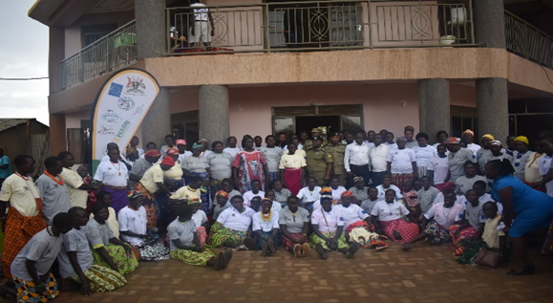
Participants during the interface meeting between District Security Committee and women peace mediators on the persistent conflict in Kotido district. All the projects were aimed addressing issues of social cohesion and curb conflicts among the pastoral ethnic groups.
Transitional Justice Act enacted and operationalized:
The principles for the development of the Transitional Justice Act were recalled based on guidance-received form the Attorney General to consult further institutions/ stakeholders to agree on the roles and avoid duplication of effort and over lapping mandates.

6.2 Conflict Resolution
2.1 Strengthen Conflict Early Warning and Early Response Mechanism in ASALs and its linkage with the National Early Warning System and National Emergency Coordination and Operations Centre (NECOC)
A modern situation room established and operationalized. A modern situation room established and operationalized. Several initiatives to strengthen the situation room to be able to produce high quality conflict early warning reports through provision of equipment (Computers), procurement of smart phones to Field Monitors and Data for information collection. Analysis and reporting. (2) secondment of GIS officer to Situation Room for effective supervision of and production of monthly early warning reports. Production of monthly, quarterly and Annual conflict early warning reports by the early warning reports During the reporting period 12 conflict early warning reports were prepared and submitted to relevant MDAs for appropriate action.
2.2 Build capacity of the Conflict Early Warning and Early Response Unit (CEWERU) to fulfil its mandate
The Conflict Early Warning and Early Response Unit (CEWERU) organizational structure reviewed and implemented. There is on-going rationalization process to review the structures of MDAs but besides that, the Unit reviewed and developed a 5-year CEWERU Strategic Plan (2023-2028) that addresses the new and emerging conflict trends.

PIA 7: Institutional Strengthening, Coordination and Partnerships
Major Projects implemented with budget utilisation in USD
No | Title of Project | Project duration | Utilised Budget (USD)
1 | RIMA analysis in Uganda | 6 years | 2.6 million
2 | GCCA+ |  | 6 million
3 | Food security response project in Teso | 2022-2025 | 5 million
4 | Water for production and rural feeder roads projects |  | 12 million euros
5 | ProACT | 4 years | 8 million Euros
6 | Agriculture Climate Change Resilience Initiative | 3 years | 1.9 million
7 | Pastoral resilience and Livelihoods project | 5 years | 45 million

3.7.1 Coordination and Platform Management
IDDRSI country platform was able to successfully establish two coordination platforms namely: i) National Expert Pannel (NEP); and the National IDDRSI Steering Committee to foster the IDDRSI agenda in Uganda. Since establishment, 14 NEP meeting have been held in Uganda with major purpose of strengthening coordination and reporting on progress of the country towards achievement of IDDRSI objectives in various PIAs.
NEP has also been able to coordinate and carry out joint monitoring and review of the resilience project implemented in the country. In particular, monitoring the outputs of the Regional Pastoral Livelihoods Resilience Project (RPLRP) in Eastern and Norther Uganda. Figure 7. Katakwi Cattle slaughter shade

Figure 3. 8: Katakwi Cattle slaughter shade in Katakwi town constructed under the PLRP project
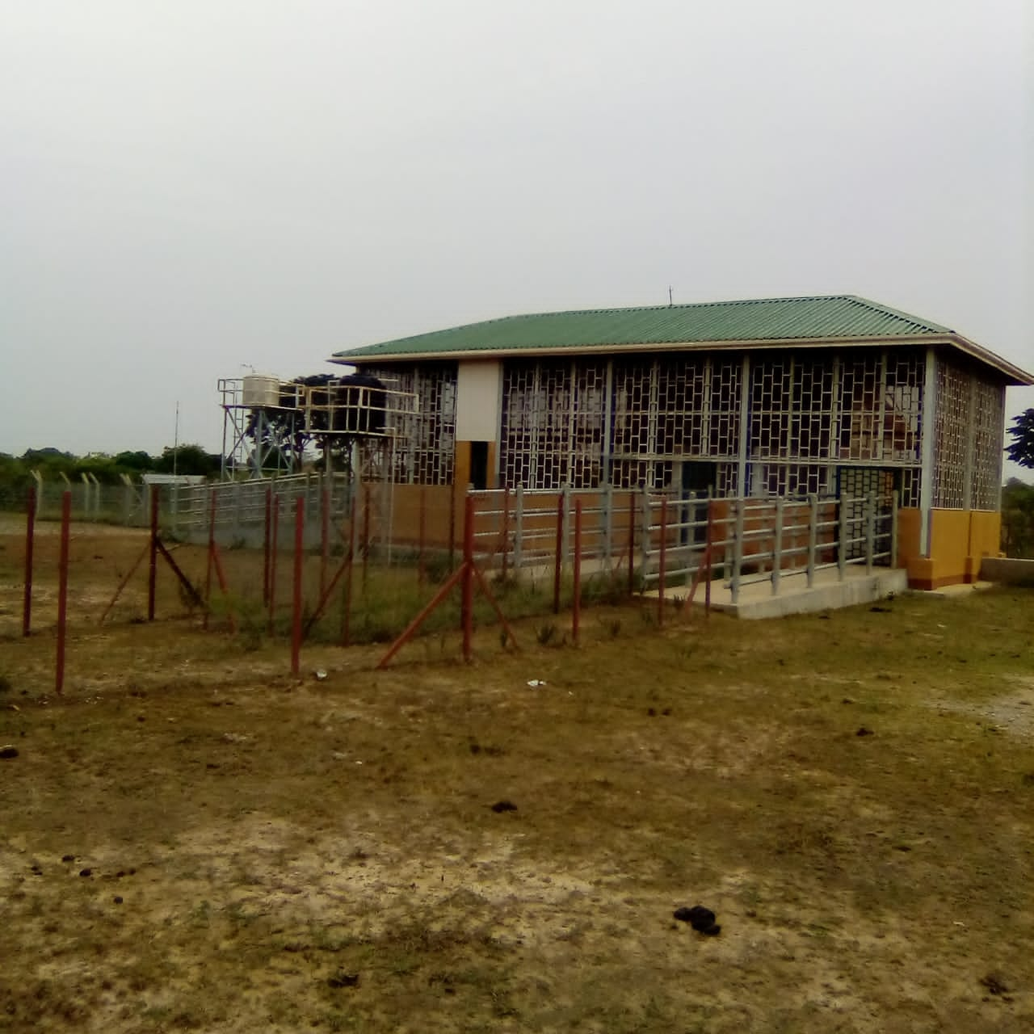

IDDRSI NEP platform, Uganda has been able to train and establish 19 out of the 28 ASAL districts sub national coordination platforms for planning and budgeting and reporting using IDDRSI M&E frameworks.

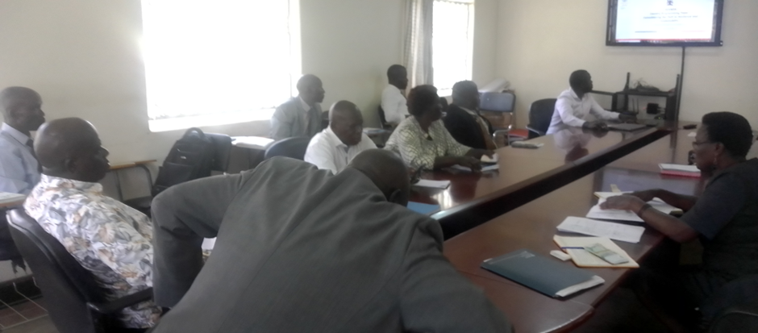
Photos in one of the Subnational joint capacity buildingfolllow-up training organized by NEP memebrs coordination meetings in Central cattle corrdor districts (Nakasongola and Luwero)
National steering committee that plays critical coordination and general oversight role on IDDRSI operations in Uganda was established. The steering committee established with membership from the 8PIA implementing agencies is functional and holds bi-annual meetings to discuss progress of the country towards the achievement of IDDRSI objectives and collectively work with different MDAs implementing different interventions.
IDDRSI was able to initiate and coordinate the formation and establishment of the greater Karamoja Development Partners working group and the special resilience working to coordinate joint resilience programming for Karamoja. The first Joint resilience programming involved UN partners (FAO, WFP, UNICEF and OPM). 2015 to 2018 joint resilience programming for Karamoja (6-million-dollar initiative supported by the EU).
IDDRSI coordination in Uganda has also been able to participate and support coordination for joint data collection, analysis, validation, and publication of IPC reports for Karamoja and refugee hosting districts in Uganda. Eight (8) reports have since been published since formation of IDDRSI.
IDDRSI under the stewardship of the Resilience Measurement unit was able to support the implementation of joint resilience analysis for Karamoja and refugee hosting districts for informed decision making and guide on policy directions for the regions. Five (5) analysis reports have been published in the international journal for food security with support from FAO, WFP, UNICEF and OPM.

3.7.2 Institutional Strengthening and Capacity Building
Through the IDDRSI platform, a need assessment was conducted by IGAD across all the PIAs in the country. Based on the assessment report, support was received in form operational tools where eight (8) laptops and licences for data management and analysis were provided to the National Expert Panel (NEP) Members.
14 district cattle disease surveillance and holding grounds were established in the 11 project implementation districts in all the Karamoja districts and Teso and Sebei selected districts.
14 district modern satellite cattle markets with mini processing facilities were constructed to boost local revenue capacities for better service delivery. See some examples of the cattlemen markets operational like Ocori Imongin cattle market in Katakwi District.
Further capacity building and institutional strengthening has been in areas of training on IDDRSI M&E results framework and indicator identifications and tracking, monitoring and evaluation. These have been organized in various levels. Three training have been organized including: M&E indicator mapping; GIS remote sensing; and Monitoring and evaluation support to technical officers across the 8 PIAs.
Through this support IDDRSI has been able to establish some working indicators that guide on progress from baseline and MTR reporting.
Further capacity has been strengthened at sub national levels with DLGs supported in identifying, and aligning their development plans and budgets to IDDRSI objectives. 21 out of 40 ASAL cattle corridor districts have been trained and sensitized on IDDRSI CPP, results frame work and strategic programming for government and partner financing. This represents nearly 49 percent achievement.
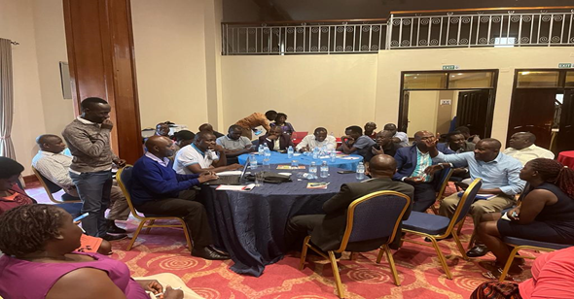
Participating DLG technical officers during plenary sessions during one of the training organizing the south western cattle corridor districts.

3.7.3 Enhancing Partnerships
Additional partnership established between government (OPM, MAAIF and UN partners (WFP and FAO) in resource mobilization and joint implementation of food security project in Teso districts (5 million dollars for 3 years.
IDDRSI has also supported current project funding for water resources and rural road projects implemented by MoWE with support from the German KFW bank (12 Million Euros).

3.7.4 Resource Mobilization
Joint resource mobilization partnership has been enhanced through the IDDRSI joint coordination and partnership mechanism for resource mobilization and programming. This has yielded in to 8 million Euros funding for Pro resilience Actions project (Pro-ACT project) being implemented in Karamoja in partnership with MAAIF, MoWE, UNMA, OPM, WFP, FAO, MoLG. Joint implementation of food security project in Teso districts (5 Million dollars) for 3 years
IDDRSI also helped mobilize over 2.6 million dollars (since 2016 to 2021 (6 years) through partnership with FAO and WFP RIMA food security and livelihoods data collections, analysis and dissemination to for Karamoja and refugee hosting district.
5 million Dollars has recently been mobilized for food security and climate change response in Teso with funding from the Norwegian government.

3.7.5 Monitoring, Evaluation and Learning (MEL)
Through the IDDRSI NEP and M&E platform, one training on IDDRI baseline indicator mapping was organized to enhance capacity of the members to identify track and report on progress `based on the IDDRSI M&E frameworks.
After the initial training one joint monitoring mission between the NEP members and project implementation team for the Pastoral Resilience and livelihoods project both at MAAIF and DLGs of Karamoja and Teso where the project was being implemented was undertaken.
Photo: Technical members of the RMU on IDDRSI monitoring activities March 2022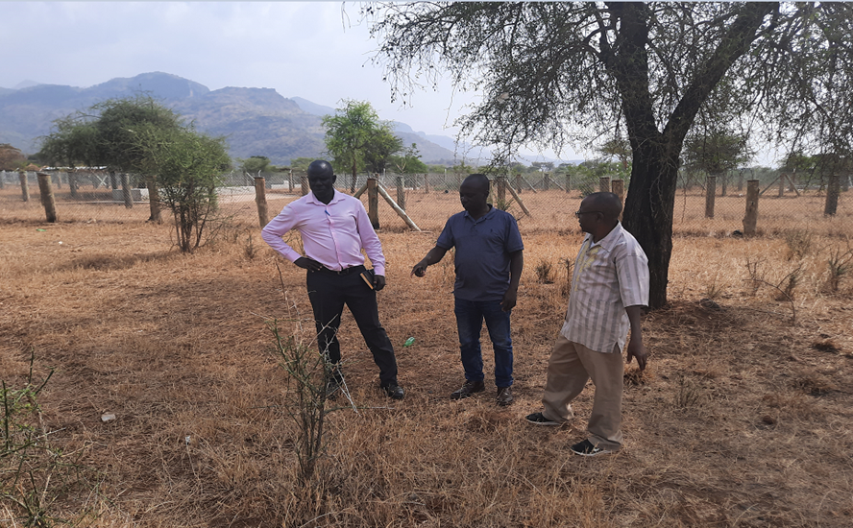
Photo: NEP and members of the Resilience Measurement Unit on IDDRSI monitoring activities March 2022 at Nakiloro cattle market – Moroto DLG affected by cattle raids and insecurity in the region. The market had been reported nonfunctional due to insecurity in the area

PIA 8: Human Capital, Gender and Social Developments
Major Projects implemented with budget utilisation
No | Title of Project | Project duration | Budget (UGX)- Bns
1 | Global Fund for AIDS, TB and Malaria | July 2015 – June 2020 | 1,103.790
2 | Italian Support to HSSP and PRDP | July 2015 – June 2019 | 20.00
3 | Italian support to Health Sector Development Plan- Karamoja Infrastructure Development Project Phase II | July 2019 – June 2023 | 86.444
4 | Emergency Construction of Primary Schools Phase II | July 2015 – June 2020 | 3.736
5 | Youth Livelihood Programme (YLP) | July 2013 – June 2018 | 265
6 | Youth Livelihood Project Phase II | July 2020 – June 2025 | 528.970
7 | Uganda Women Entrepreneurs Fund (UWEP) | July 2015 – June 2020 | 585
8 | Social Assistance Grants for Empowerment (SAGE) | July 2015 – June 2020 | 181.319

Italian support to Health Sector Development Plan. The project is located in Karamoja region covering districts of Kaabong, Abim, Kotido, Moroto, Amudat, Napak, and Nakapiripirit. The key outputs of the project include: construction of a total of 34 2-in-1 staff houses (total of 68 houses). This is aimed at reduction in morbidity and mortality at HC IIIs; Improvement in functionality and service utilization at HCIIIs; and reduction in congestion at HC IVs and Hospitals.

8.1 Access to Health and Nutrition
Access to health services in Uganda. Better access to healthcare services and improved infrastructure directly leads to improved health outcomes, reducing morbidity and mortality rates, and enhancing overall quality of life for the population. The fraction of individuals who access healthcare are within 5 km of a health facility walking distance is generally low across all types of health facilities implying that distance to health facilities is an impediment to healthcare access. For example, 41 percent of women of reproductive age (countrywide) reported that they have a serious problem in accessing healthcare for themselves when they are sick due to distance to health facilities. The problem is more striking in the South -western and Northern regions as well as in rural areas (compared to urban). The improvement of walking distance to the health facilities especially between 2018/19 and 2022/23 is associated with government efforts to construct HC IIIs in all Sub Counties without HC IIIs and upgrading HC IIs to HC IIIs under UGIFT and Karamoja Project.
HC IIs upgraded in sub counties without. To-date, a total of 381 HCIIs have been upgraded to HCIIIs under the projects of UgIFT (340) and URMCHIP (41) across the country. Of these, 270 are complete and functional. Works are ongoing on the rest and expected to be completed by June 2024. Government will continue to upgrade HCIIs to HCIIIs that are essential or that need to be upgraded.
Health Centre IIIs constructed in the 138 sub counties without any health facility. From FY2018/19 Government of Uganda with support from World Bank Project called Uganda Intergovernmental Fiscal transfer program started constructing HCIIIs in Sub Counties which did not have HCIIIs and upgrading some HCIIs to HCIIIs. The project has done well to the extent that all the Sub –counties have HCIIIs except for those which have been created of recent.
In health, the UGIFT program has equipped, staffed, and upgraded 380 facilities to the health centre III (HCIII) level. Up to 500 health centres will be able to access development grants to rehabilitate, expand and equip their facilities to meet minimum standards. At least 11,000 health workers have been hired for the least-staffed districts to enable them to meet minimum facility staffing levels. Results-Based Financing program will be mainstreamed, creating incentives for service delivery performance. Allocations for essential medicines have been increased, and the mechanisms for allocating those supplies and the transparency of allocations will be enhanced through digitalization.
Increased coverage of health workers accommodations. Health workers accommodation has been a problem in health facilities. Currently each HC III constructed come along with at least six housing units per each health facility to house critical staffs at the health facility like anaesthetists, midwives, doctors, laboratory staffs and other critical staffs.
Sixty-eight (68) twin staff houses built in Karamoja. Its only in Karamoja Region where the Karamoja Staff Housing project under Italian Government support to Uganda has built 68 twin staff houses in Kalenga, Kotido, Kaabong, Abim, Napak, Nakapiripirit, Amudat and Nabilatuk to reduce staff accommodation for health workers. Some other development partners have also supported the construction of staff houses.
Hospitals and Health Centre IVs. To increase health coverage in Uganda the following health facilities have been upgraded to Hospitals and HC IVs since FY2018/19. These are: Bondo HCIV in Arua, Bugaya HCIV in Buyende, Bujubuli HCIV in Kyegegwa, Kalaki HCIV in Kalaki, Kaserem HCIV in Kapchorwa, Kyangwali KCIV in Kikuube, Mpungu HCIV in Kanungu, Palabek Kal HCIV in Lamwo, Rugyeyo HCIV in Kanungu, Ruteete HCIV in Kabarole, Rwamanja HCIV in Kamwenge district, Muko HC IV to Hospital, Mitooma HC IV to General Hospital, Kalapata HC III to HC IV in Kabaramaido District.
Some of the hospitals that have been rehabilitated to improve health care services in the country are: Gombe Hospital in Butambala District, Koboko Hospital, Mukono Hospital, Luwero Hospital, Buwenge Hospital, Kotido Hospital and Kaberamaido Hospital.

Nutrition status in Uganda:
Uganda is among the countries in East Africa with high levels of undernutrition whereby about 29 percent or 3 in 10 children below 5 years of age are stunted while about 3.5% of all children below 5 years of age in Uganda are faced with body wasting.
The prevalence of acute malnutrition among children in Karamoja is at a serious level (13.1 per cent) with Moroto (21.9 per cent) and Kaabong (19.6 per cent) being the most affected. Main drivers of malnutrition are food insecurity (over the last three years, food insecurity in the sub-region has increased from 29 per cent in 2020 to 55 per cent in 2022); diarrhea and fever/malaria associated with rainy season which compounds the situation of already malnourished children. As part of the initial response to the worsening malnutrition situation, Government with Development partners are aiming at increasing coverage for outpatient and-and in-patient therapeutic care through mass community-level screening for acute wasting and integrated community out-reaches especially for the hard-to-reach communities in the region.
Government also initiated an emergency response in all nine districts by addressing lifesaving needs for about 23,000 children with severe acute malnutrition through timely therapeutic care. To increase coverage, government with the Development partners are supporting Kaabong and Moroto to carry out mass community screening for acute wasting among children 6-59 month and integrated community outreaches to hard-to-reach communities.
Government with support from Development partners delivered 11,946 cartons of RUTF, 91 cartons of F75, 15 cartons of F100 and two cartons of ReSoMal to all the nine districts of Karamoja to support the treatment of malnutrition and to ease the last mile delivery of nutrition supplies. The findings from the mass screening revealed that the acute malnutrition levels in the two districts remains critical (25 per cent in Kaabong and 14 per cent in Moroto), with a high percentage of the eligible children not being enrolled into therapeutic care.
Promote Water, Sanitation and hygiene
Water and sanitation are essential for life and health, but they are also essential for dignity, empowerment and prosperity. Water and sanitation are human rights, fundamental to every child and adult.
Diarrhoea however, one of three major childhood killers in Uganda, kills 33 children every day. In most cases, children get the disease by drinking unsafe water or encountering contaminated hands - theirs or parents or caregivers - that have not been washed with soap.
Early childhood diarrhoea is not only deadly; it also contributes to Uganda’s high levels of stunting, which in turn affects children’s cognitive development and performance at school. In school, lack of proper sanitation facilities also leads to high absenteeism and dropouts, especially for girls.
To improve access to safe drinking water, Government has rehabilitated 40 boreholes from 4 districts of Moroto, Karenga, Nabilatuk and Kaabong alongside sanitation improvement intervention.
WASH Innovations providing clean and safe water in schools:
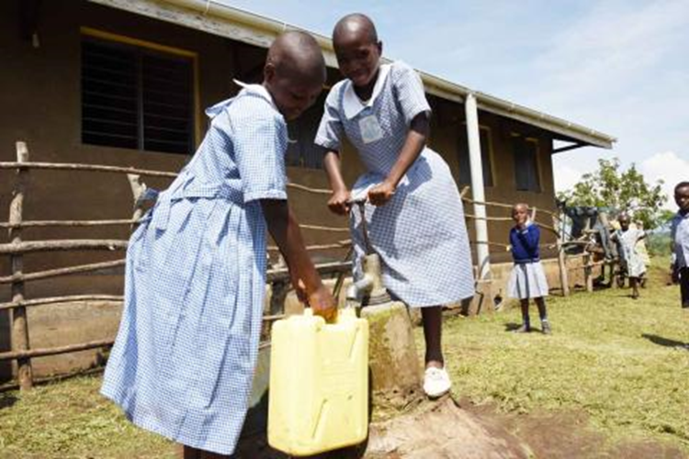

8.4 Social Safety Nets
The Expanding Social Protection (ESP) Programme was established to put in place a national social protection system in line with the National Social Protection Policy (NSPP) that benefits the most vulnerable as a core element of Uganda's national policy, planning and budgeting processes. The NSPP seeks to promote the coordination and harmonization of social protection interventions in the country. The Ministry of Gender, Labour and Social Development, through the ESP Programme, oversees the implementation of the Social Assistance Grant for Empowerment (SAGE) scheme. Under the scheme, Government provides a direct income support component of the Policy- the Senior Citizens Grant (SCG). This is a monthly cash transfer of shs.25,000 to qualifying senior citizens of 80 years and above. The Programme currently reaches 309,759 beneficiaries across the country.

Gender | Total number of SCG beneficiaries since inception | Current beneficiaries
Female | 254,304 | 188,556
Male | 174,123 | 118,203
Total | 426,430 | 306759
Programme Impacts Assessment studies and beneficiary surveys indicate vast evidence that the SCG has produced strong benefits at the individual, household and community levels. These include;
- Impacts on poverty are significant-the poverty gap has been reduced by 11% among beneficiary households and their communities.
- Increased productivity of beneficiary households-due to their advanced age (80+), SCG beneficiaries are labour incapacitated and face immobility challenges, yet they own land that has been rendered idle. The Grant has enabled them to hire labour to cultivate and put the idle land to use for subsistence farming practices.
- Improvement of the welfare of the SCG beneficiaries and their families through increased food security; improved frequency, quantity and quality of meals; improved access and uptake of health & education services among receiving households has been observed. See figures 1 for details.

8.5 Migration, Displacement and Social Inclusion
Over the years, Uganda continues to grapple with the issue of migration in form of Refugee influx from mainly the Democratic Republic of Congo and South Sudan. Other minor source countries are Somalia, Rwanda, Burundi, among others. Uganda is currently the largest Refugee hosting country on the African continent hosting over 1.5 million refugees and asylum seekers. These are mainly settled in Government gazetted Refugee Settlements in South Western Western and West Nile regions of Uganda, and a few under the Urban Refugee programme. The Refugee Programme in Uganda is largely donor funded with UNHCR as the main Government Partner, plus a host of NGOs who implemented various programmes and projects in the Refugee settlements and host communities.
Internal Displacement. The major causes of Internal displacement in Uganda are; natural disasters like land/mud slides, flooding, conflict, forced evictions for conservation, and development projects among others. At the peak of the LRA war in Northern Uganda, Uganda had almost 2 million Internally Displaced Persons (IDPs) living in camps, but with the cessation of conflict, the number of IDPs has greatly reduced to a current figure of 45,106 who are internally displaced pending relocation and resettlement. The Government has an on-going durable solution programme for Internal Displacement in Bulambuli district where Government is building houses and providing land to over 900 households for permanent resettlement.

Challenges and Lessons Learnt during the Last Ten Years

4.1 Challenges
- Absence of a law on Disaster Risk Management in Uganda. Whereas the country has a National Policy for Disaster Preparedness and Management, the provisions of the Policy are not adequately implemented and cannot be enforced in absence of an enabling law. As result, most stakeholders implement DRR interventions on an adhoc basis.
- There are land disputes in some of the areas where the water infrastructures planned could not be implemented, to some extent due to community resistance to construct WfP facilities while others demand exorbitant sums of money for land compensation and this consequently delays actual construction of the water infrastructure as planned.
- Continued degradation of water catchments and the general environment, lack of maintenance of water bodies and rivers, inadequate protection of lake shores, river banks and wetlands, and inadequate enforcement of water and environmental laws and regulations continue to be the main causes of flooding and destruction of property in the country.
- Budgetary cuts that have affected the execution of activities, while some have been postponed.
- High demand for Water for Production Infrastructure and facilities which outstrips the planned investments. Limited availability and access to earth moving equipment for excavation of Communal and Individual Valley tanks. The available few equipment sets have aged and cannot serve the existing demand.
- The limitations caused by the COVID-19 pandemic obstructed most of the planned interventions. In particular, the pandemic has been a great hindrance to construction and rehabilitation works at the target borders. Much of the resources planned for activities in the region were diverted to manage the spread of the pandemic and most institutions suffered budget cuts. Government Counterpart Funding has also been affected. On the other hand, the aftereffects of COVID 19 pandemic are still being felt by the Women groups which has affected recoveries. This is because business operations were interrupted and greatly slowed down.
- Insecurity in Karamoja Sub region. Heavy investment has been injected in the Karamoja sub region, however, implementation has been constrained by the insecurity. The persistent insecurity in the region scared away most of the actors; both state and non-state actors from undertaking activities in the region.
- Lack of local ownership of most of the interventions by state and non-state actors. Explained by the negative attitudes exhibited by the people of the region. They like depending on hand outs for their livelihoods with no sustainability plans. Sustainability arises due to uncertainty of the continuation of the Programmes in the communities which has affected the implementation and generation of projects at community level.
- Inadequate financing. There has consistently been inadequate operational funds that have compromised the implementation process and reporting at Local Level.
- Limited Markets for their Products.
- Inadequate Assistive Devices to Support Beneficiaries Mobility
- Natural Calamities such as dry spell, flooding etc.
- Inadequate mainstreaming of DRR across sectors. Whereas a progressive effort was made to integrate DRR into the National Development Plan III, no clear guidelines are already in place to ensure sectors effectively integrate disaster risk reduction measures in their programmes and plans.
- Uganda has a National Platform for Disaster Risk Reduction which serves as the central coordination mechanism for DRR in the country. The Platform has membership from government and non-government entities. However, there is still a big gap in DRR coordination at lower Government levels, and this makes DRR coordination at local government level a challenge.
- Multi-hazard Contingency Plans. In 2016, Government developed and rolled out a District mulita-hazard contingency planning methodology. This methodology has been utilized to develop District Contingency Plans but the process is still very slow with only 47 districts with approved Contingency plans out of 136 Districts.

4.2 Lessons Learnt
- Use of irrigation remains very low at only 2%. The Cumulative Water for Production (WfP) Storage Capacity (million m3) was estimated at 41.48 below the NDPIII target of 54.32 in FY20020/21. This constrains expansion of commercial agricultural thus affecting household incomes and quality of lives of many Uganda.
- For any intervention for Karamoja region should look beyond borders to minimize cross border resource sharing conflicts. There is therefore a need to design projects/ dividends that benefit cross border communities and promote peace building.
- Need to have back up funding especially counterpart funding from Government
- In future, it is important to recruit enough staff to run the project coordination unit to have timely, efficient and effective implementation of all planned project activities.
- The main challenge has been on the timely assessments and reporting to the Centre, however, this shall be addressed by the National Disaster preparedness plan that has been developed
- There is great value in pursuing risk-informed developments and this is possible with risk knowledge on hazards, risks and vulnerabilities of the population. Uganda carried out hazard, risk and vulnerability profiling of 135 districts and developed profiles that are being utilized for risk-informed planning. The District profiles were used to develop the National Disaster Risk Atlas.
- NTBs encountered during CBT for Uganda continue being serious obstacles, contrary to the aspiration of achieving an integrated EAC market as envisaged by the EAC Treaty and accompanying protocols, agreements and instruments. The NTBs obstacles have additionally hindered exploitation of the potential to grow Uganda small businesses through cross border trade. It is therefore necessary to prioritize resolution of NTBs encountered during Uganda CBT as part of measures to support growth of CBT and small businesses.

Recommendations for the Implementation of IDDRSI from 2024 to 2027
- Take stock of the poor and the vulnerable. There is need to develop a database of all the people in the Arid and semi-arid lands (ASAL) for better management of the beneficiaries from livelihood interventions. One way to start is to leverage on the National Identification database. This would help in avoiding duplication of interventions, better and inclusive targeting and guided resource allocation.
- There is need for strong policy and regulatory framework to back up most of the interventions to achieve lasting gains in the region and for sustainability.
- Continue institutional support to NTB elimination. This is key to freeing trade in the EAC and realising GDP growth and poverty reduction and sustainable resilience in arid and semi-arid communities
- Ensure strong Monitoring and Evaluation framework for interventions in the region
- Develop Resource Mobilization Strategy
- Continued sensitization of stakeholders (LGs, beneficiaries) on their roles and responsibilities especially on the projects completed.
- Strengthen Partnerships and Advocacy.
- Continuously document success stories to inform the future and effective programme implementation.
- Strengthen collaboration with other organizations for effective implementation.
- Align UWEP with Parish Development Model.
- Benchmarking with other regional implementing Countries or Member state
- Promote Risk identification and knowledge should through systematic hazard, risk and vulnerability mapping and review and update of such profiles to ensure the country is informed of all potential risk at all times.
- GOU should prioritise and implement support measures to eliminate the most serious NTBS faced by CBTs in order to reduce the time and cost for clearing imports/ exports and to eliminate demands for bribes which arise due to difficulties experienced by traders during compliance with trade procedures.

Partnerships
Logos of Development Partners that supported resilience projects implemented during the last ten years (UN Agencies, Countries, International Research Organisations, etc)

ANNEX 1: DETAILED LISTS OF DAMS CONSTRUCTED IN THE DIFFERENT REGIONS BY WATER FOR PRODUCTION DEPARTMENT, MAY 2023

- WESTERN REGION

S/N | Site Name | Parish | Sub-county | District | Village | Year of Construction | Capacity (M3) | Functionality | Northings | Eastings
EARTH DAMS
1 | Mabira | Mabira | Rwanyamahembe | Mbarara | Mabira | 2019 | 1,200,000 | Functional | S00⁰ 28’36” | E30⁰ 32’52”
2 | Mayikalo | Mayikalo | Lwemiyaga | Sembabule | Mayikalo | 2008 | 220,000 | Need reconstruction | N00⁰ 04’12” | E31⁰ 04’29”
3 | Kagango | Bukanga | Kashumba | Isingiro | Kagango | 2021 | 165,000 | Functional | S00⁰ 52’18” | E30⁰ 56’09”
4 | Kakyinga | Kabale | Ntusi | Sembabule | Kakyinga | 2008 | 1,000,000 | Functional | N00⁰ 00’46” | E31⁰ 14’52”
5 | Kiyumbakimu | Kagamba | Kagamba | Rakai | Kiyumbakimu | 2014 | 860,000 | Functional with some repair needs | S00⁰ 36’38” | E31⁰ 19’20”
6 | Kyenshama | Nyabisirira | Kashare/Kashongi | Mbarara/  Kiruhura | Kyenshama | Works still ongoing | 720,000 | Reconstruction on going | S00⁰ 20’27” | E30⁰ 39’59”

B. EASTERN REGION
EARTH DAMS
 | Location |  |  |  | Capacity (m³) | Year of construction | Functionality | Coordinates
S/N | Facility Name | Parish | Sub-county | District |  |  |  | Northings | Eastings
1 | Ongole | Akum and Chelewuko | Usuk | Katakwi | 1,000,000 | 2016 | Functional | 218040.422 | 614841.188

C. NORTHERN REGION
 | EARTH DAMS
 | Location |  |  |  | Capacity (m³) | Year of construction | Functionality | Coordinates
S/N | Facility Name | Parish | Sub-county | District |  |  |  | Northings | Eastings
1 | Andibo | Andibo | Panyango | Pakwach | 3,400,000 | 2015 | Functional | 347439 | 451166
2 | Akwera | Omito | Adwari | Otuke | 1,000,000 | 2011 | Functional | 267589 | 525819
3 | Leye | Telela | Ayer | Kole | 1,200,000 | 2013 | Partially functional (Contract for weed removal signed to restore full functionality) | 250844 | 471709
4 | Tochi | Aceno, Obot | Minakulu, Ngai, Acaba | Oyam | 10,000,000 | 2021 | Functional | 2⁰ 24’51’’ | 32⁰ 26’22.35’’
5 | Wadelai | Ragem, Motir, Pakwinyo | Wadelai | Pakwach | 8,000,000 | 2022 | Functional | 2⁰41’33.59’’ | 31⁰19’05.68’’

D. KARAMOJA SUB-REGION
EARTH DAMS
 | Location |  |  |  | Capacity (m³) | Year of construction | Functionality | Coordinates
S/N | Facility Name | Parish | Sub-county | District |  |  |  | Northings | Eastings
1 | Kobebe | Lotisan | Lotisan | Moroto | 2,300,000 | 2012 | Functional | 311164 | 668007
2 | Arechek | Nakichumet | Matany | Napak | 2,100,000 | 2012 | Functional | 255541 | 649933
3 | Longoromit | Lobongia | Kaabong West | Kaabong | 1,400,000 | 2012 | Partially functional | 380929 | 634087.8
4 | Kailong | Lokitalebu | Kotido | Kotido | 167,000 | 2012 | Non functional | 319195 | 597562
5 | Kawomeri | Koya | Magamaga | Abim | 1,300,000 | 2012 | Partially functional | 302099 | 580319

E. CENTRAL REGION
EARTH DAMS
 | Location |  |  |  | Capacity (m³) | Year of construction | Functionality | Coordinates
S/N | Facility Name | Parish | Sub-county | District |  |  |  | Northings | Eastings
1 | Dyangoma | Dyangoma | Kigando | Mubende | 282,258.47 | 1998 | Needs rehabilitation | 37188 m N | 310759 m E
2 | Kabaale | Kyabagamba | Maddu 1 | Gomba | 2,331,259 | early 1960s | Partially functional with no facilities | 38387 m N | 343168 m E
3 | Degeya | Degeya | Maddu I | Gomba | 446,917 | early 1960s | Needs rehabilitation | 23112 m N | 345637 m E

East African Community (EAC) Time Bound Program (TBP)

